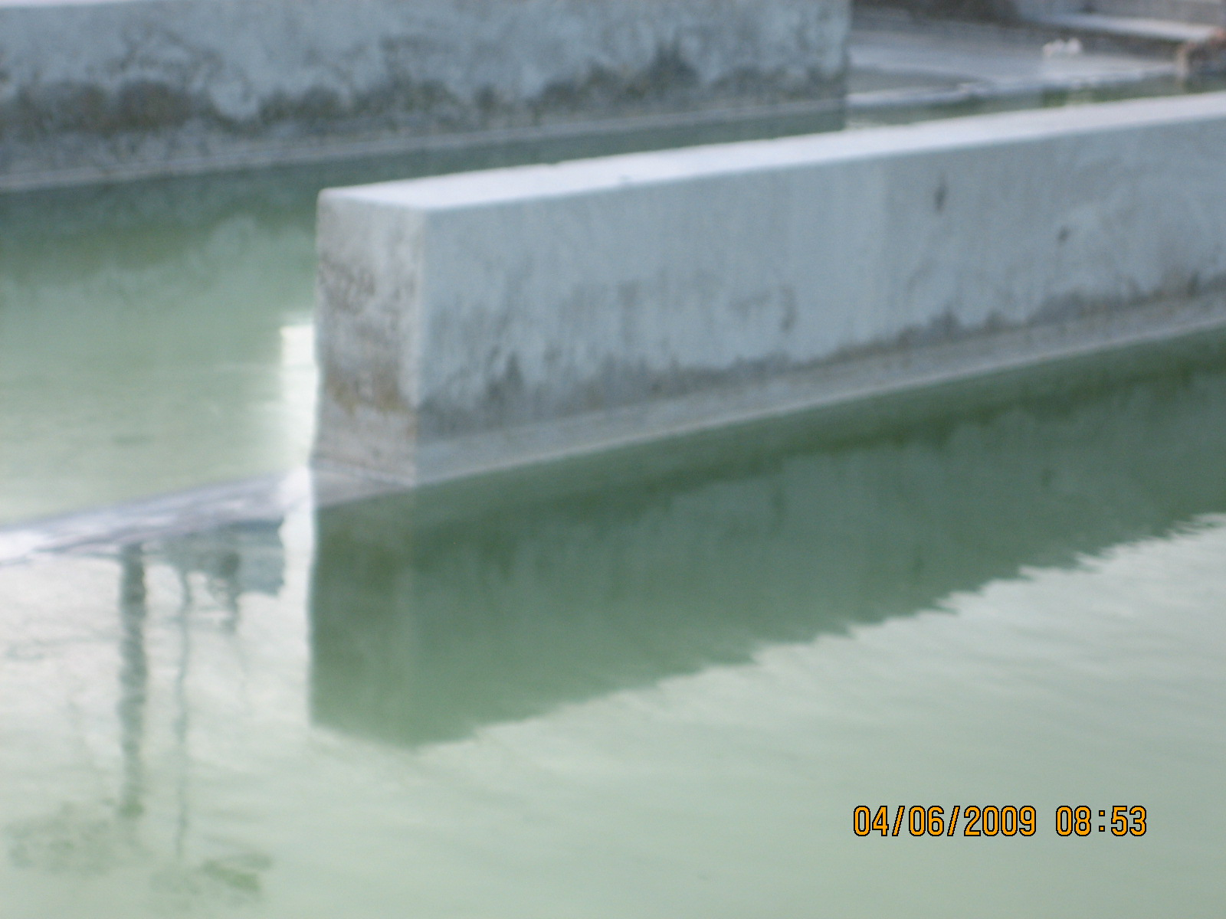
Water reclamation ponds.

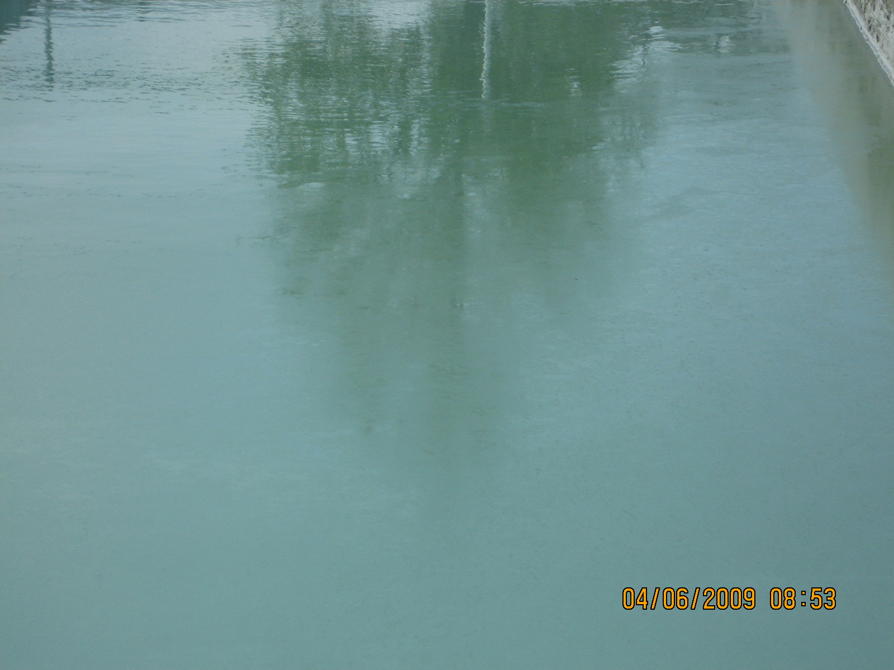
Water reclamation ponds.

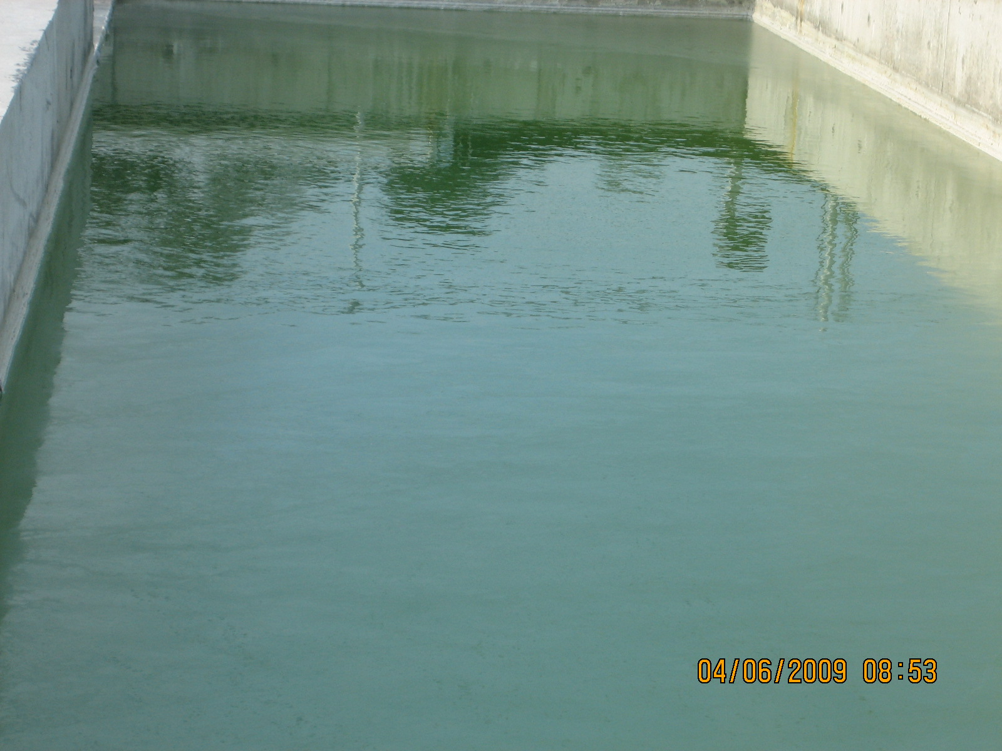
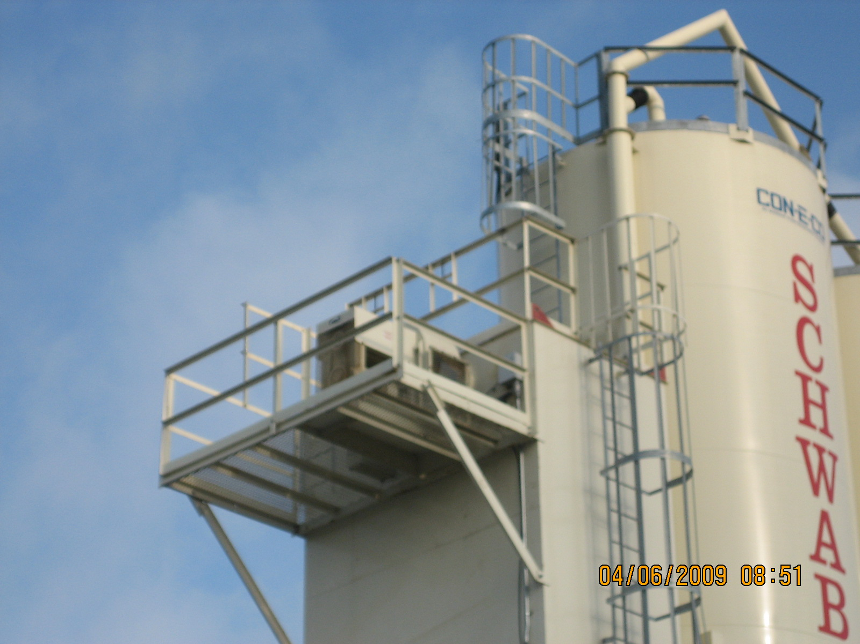

Central Dust Collector vent for Plant B… Dust collectors for Plant A and B on this site are identical.

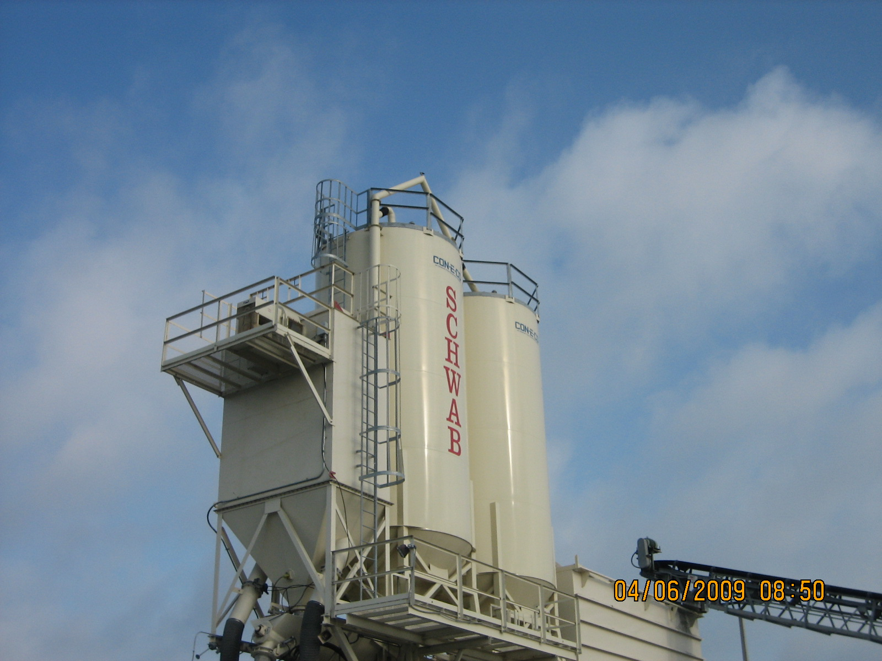
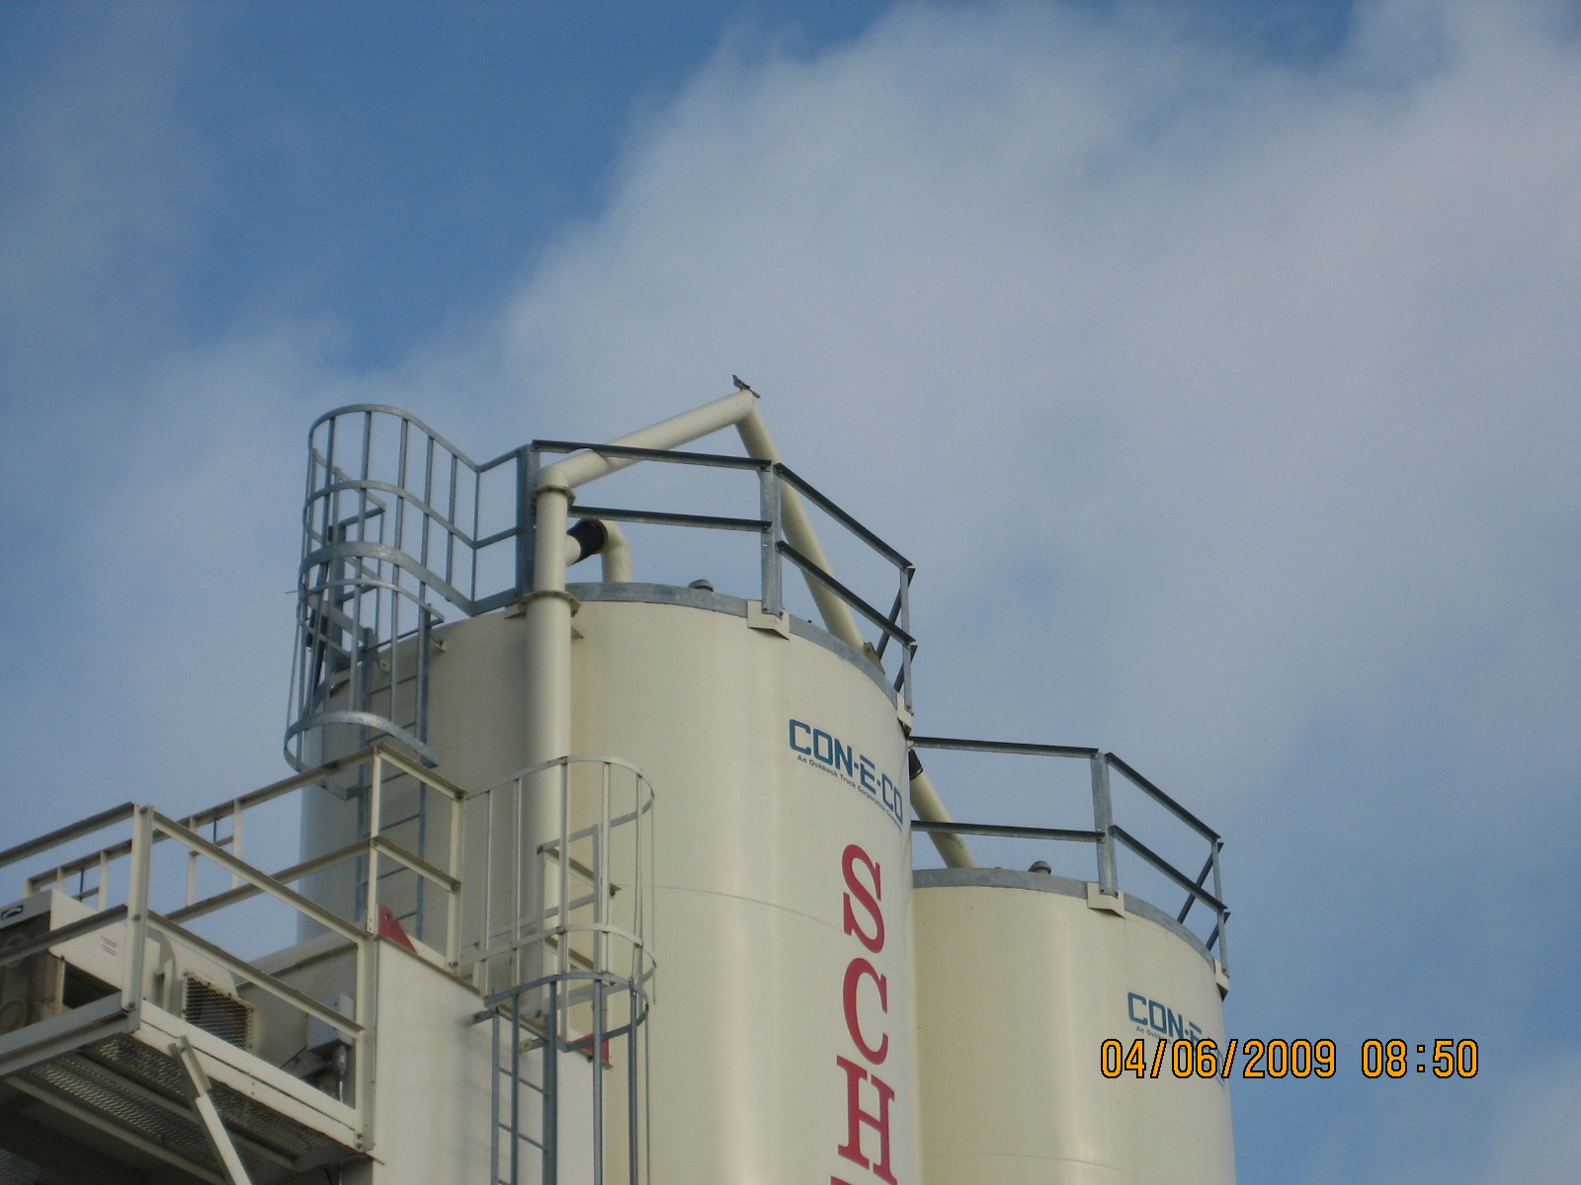
Dust collector vent for Plant A.

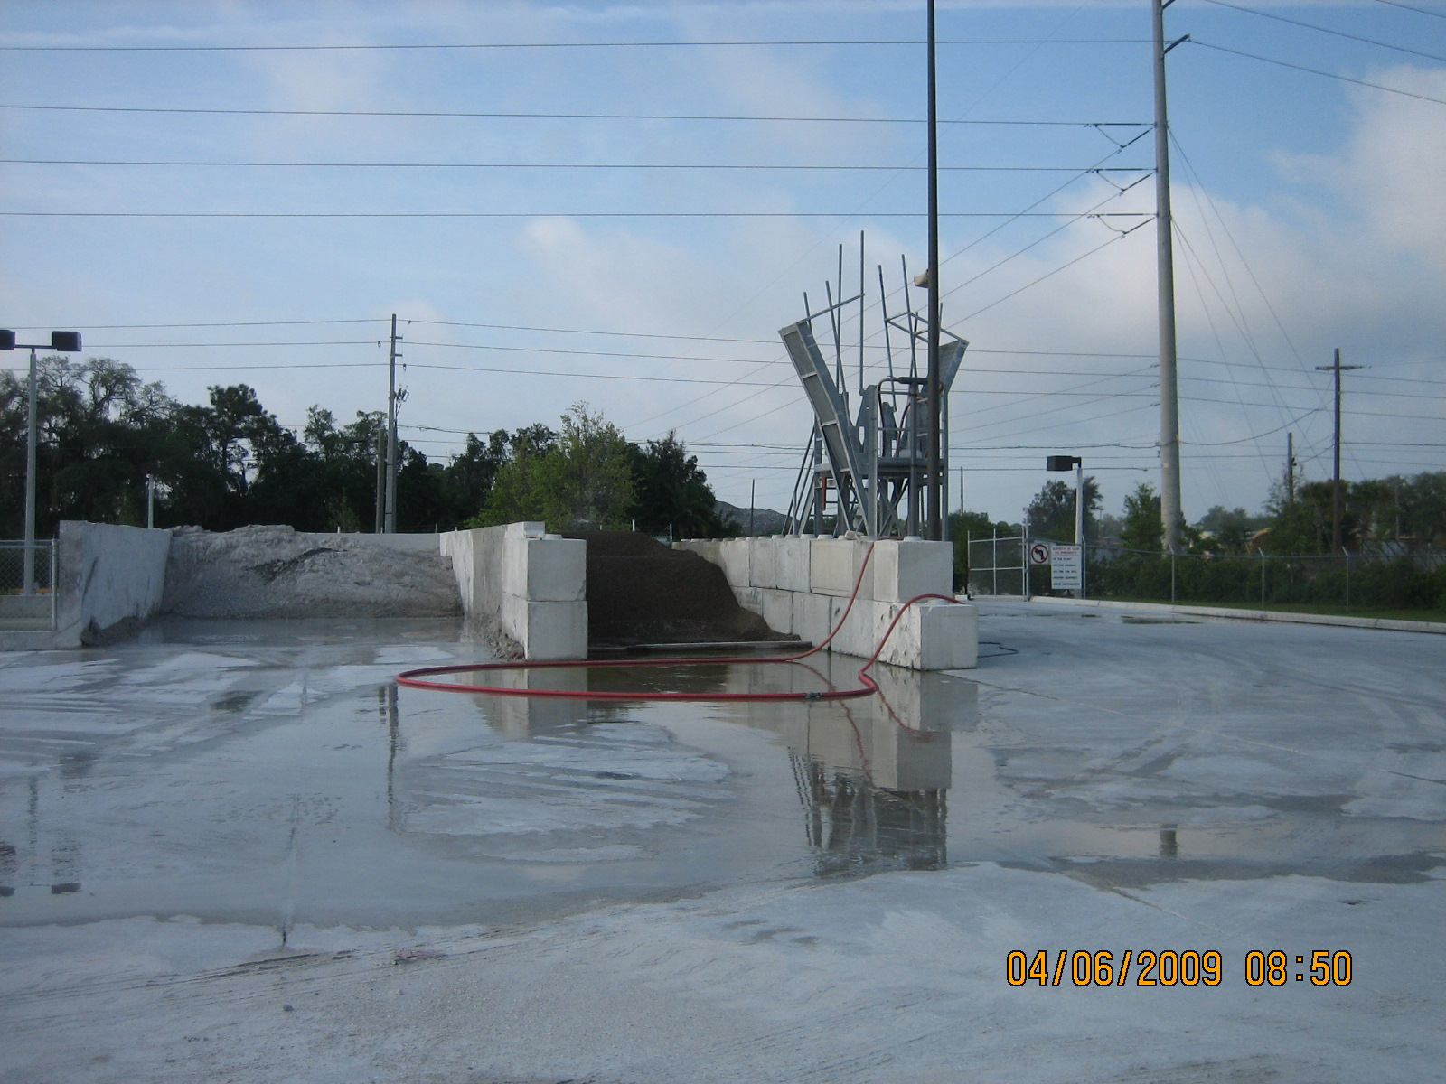
Truck wash.
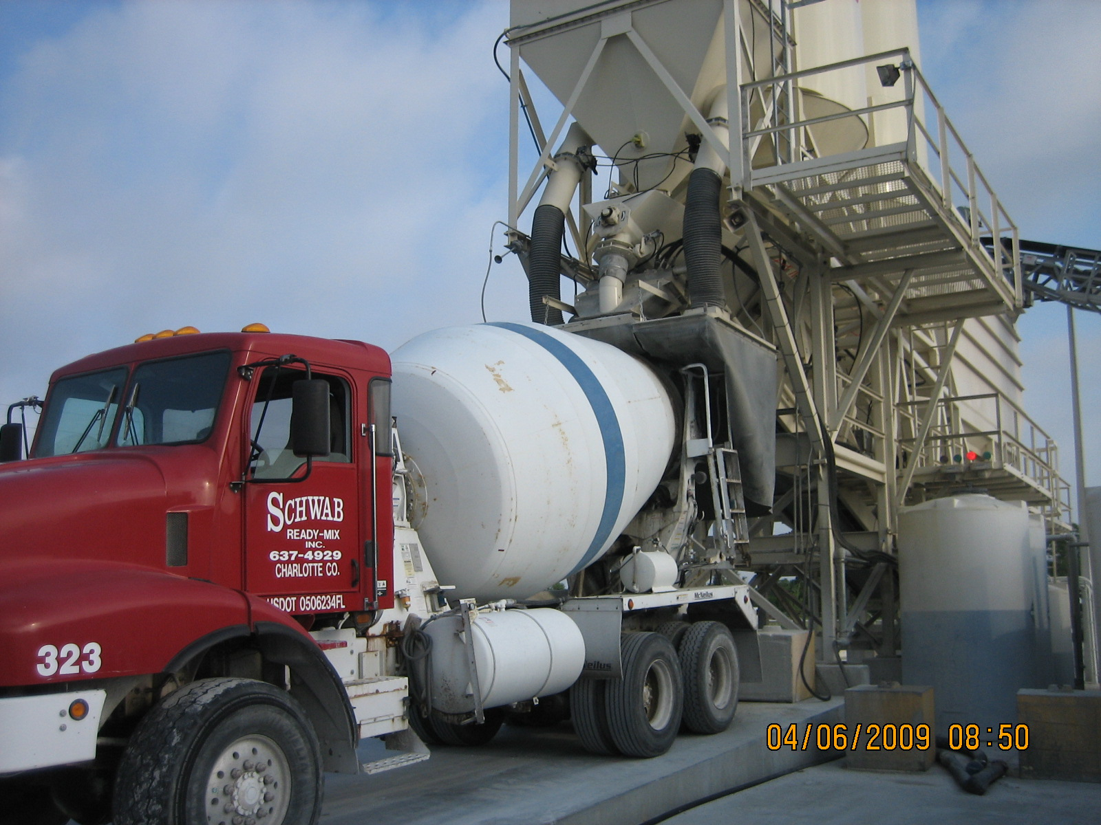
Plant B Truck load out…this is also controlled by the CDC.

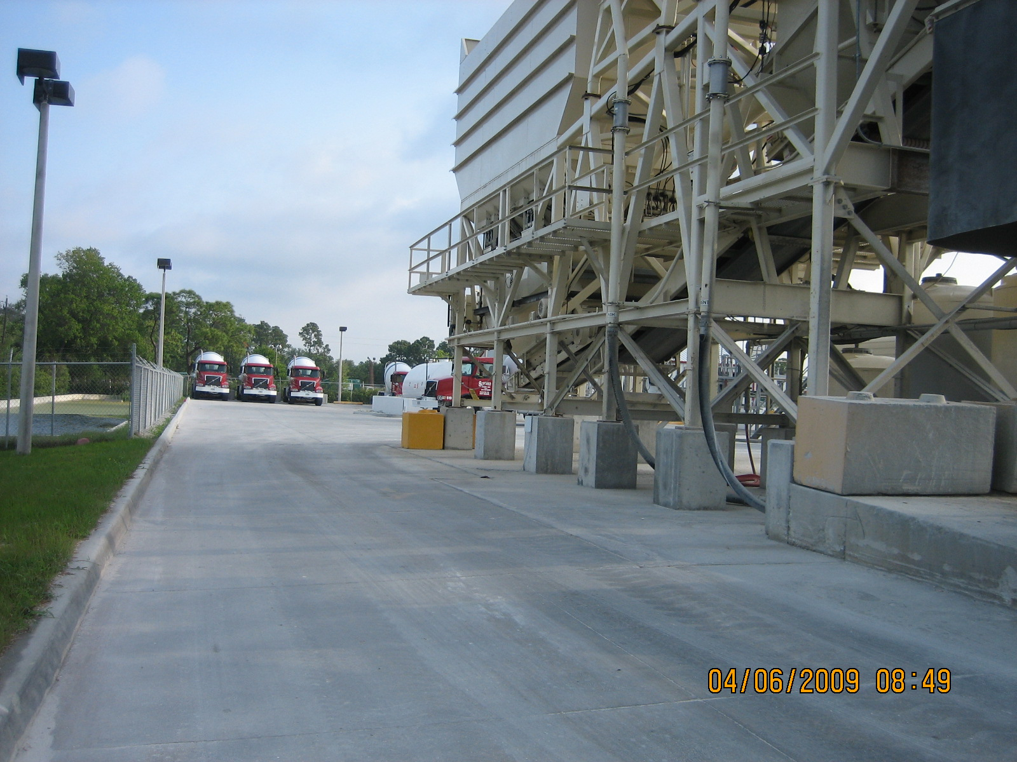
Drive area where truck traffic flows…area was clear of large amounts of particulate matter.

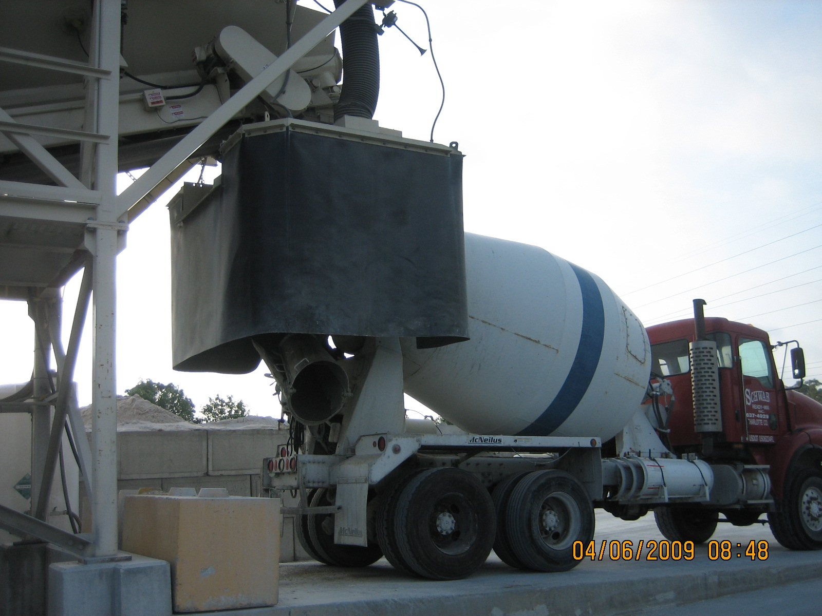
Truck load-out shroud.

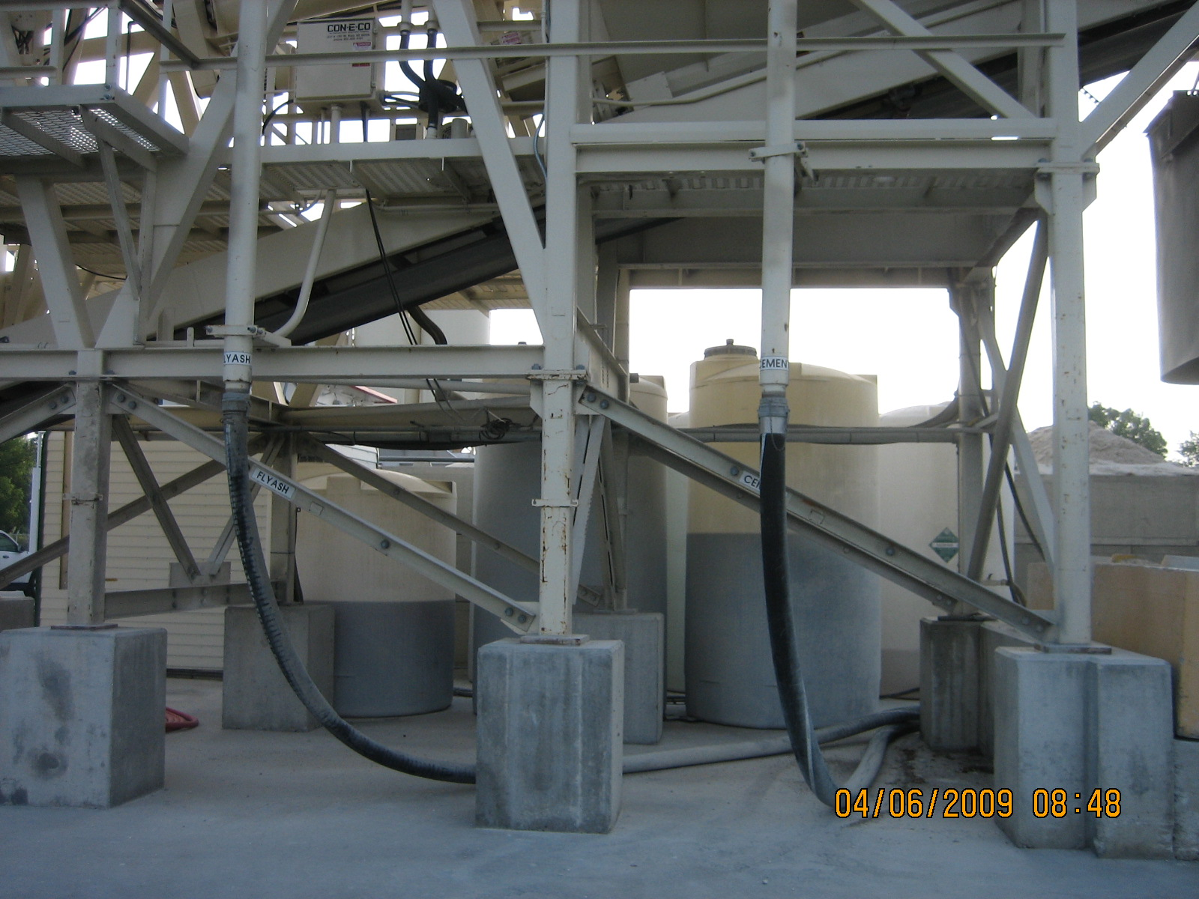
Flyash and Cement Silo Loading connections.

Schwab Ready Mix
INS 2: 04/06/2009 Facility Id # 7775439

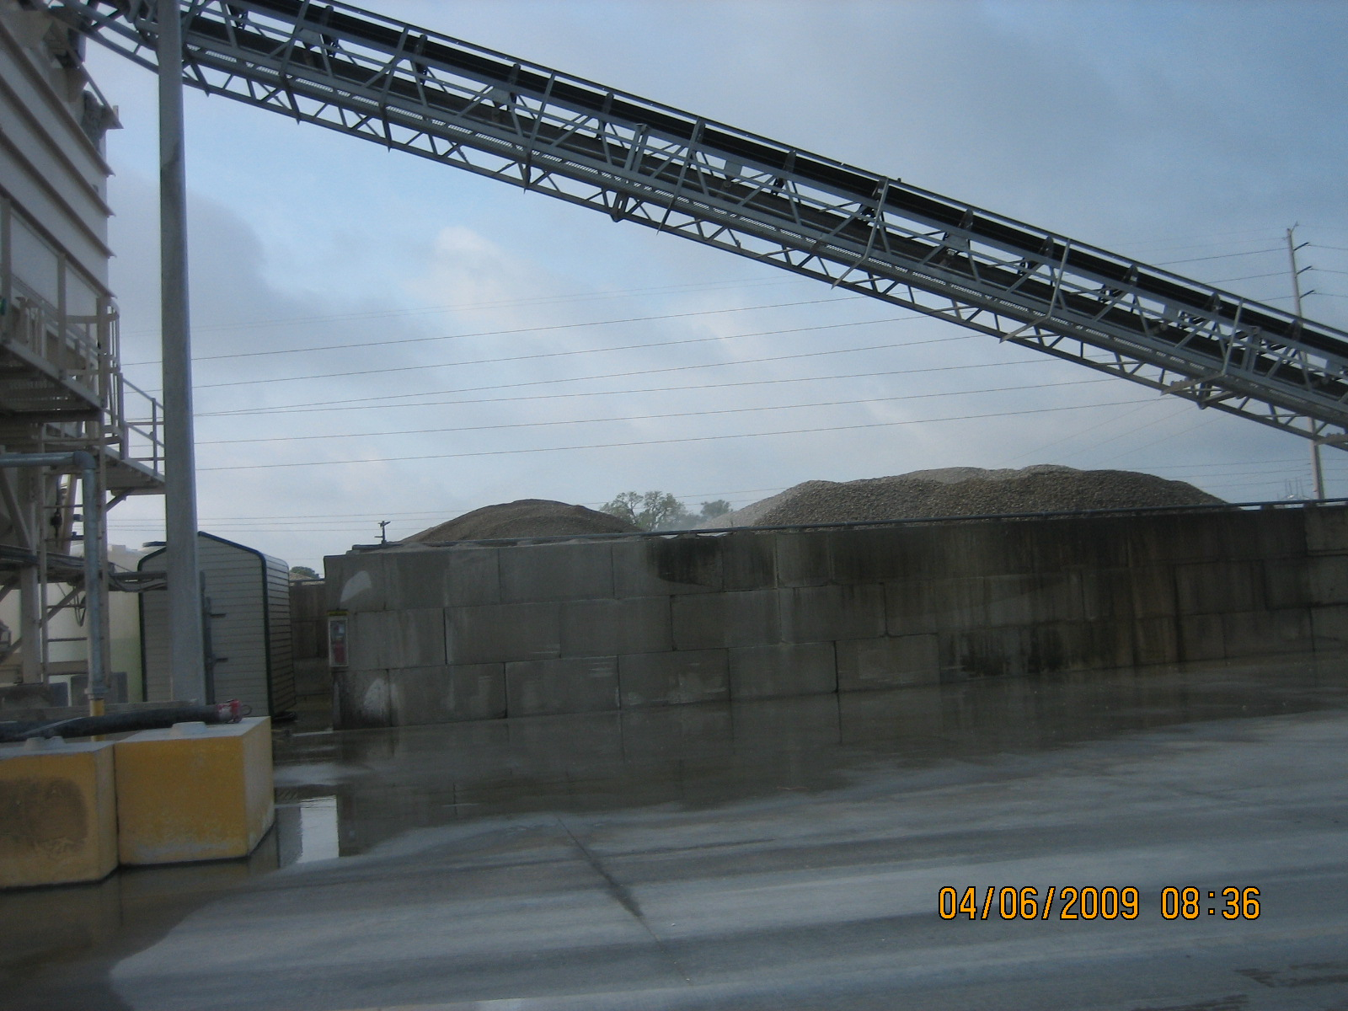
Sprinklers were in operation upon our arrival at facility.

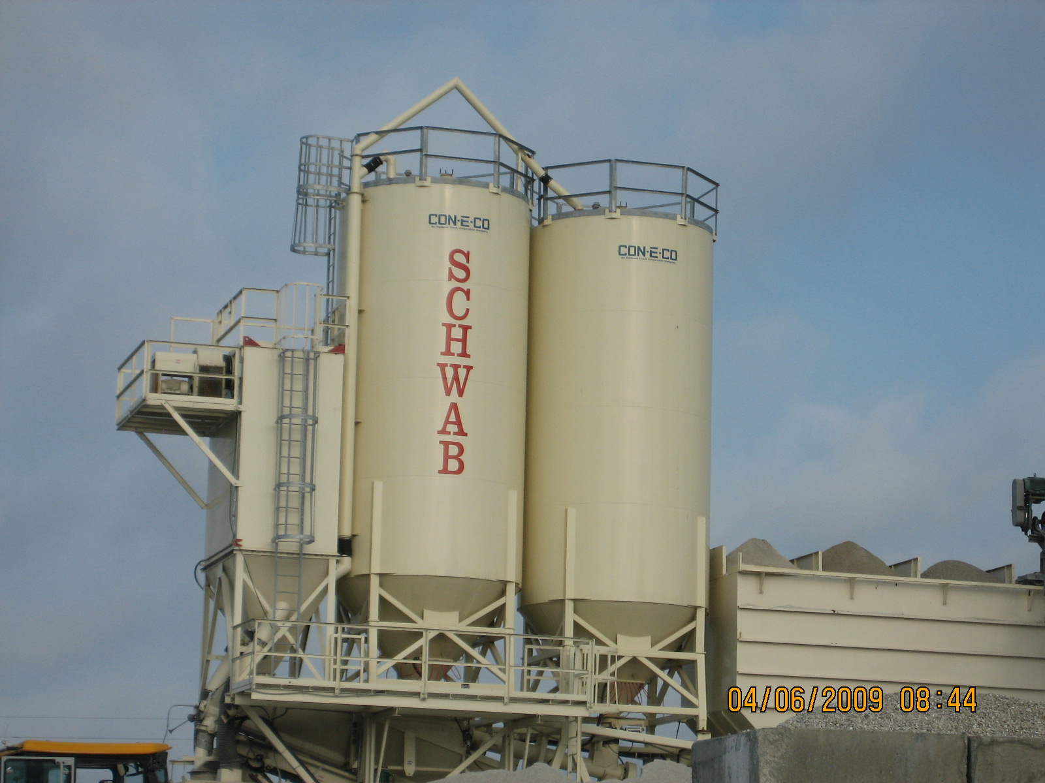

Plant B…2 silos and a central dust collector (CDC). The CDC controls loading of both silos, mixer’s batching, and truck load-out.
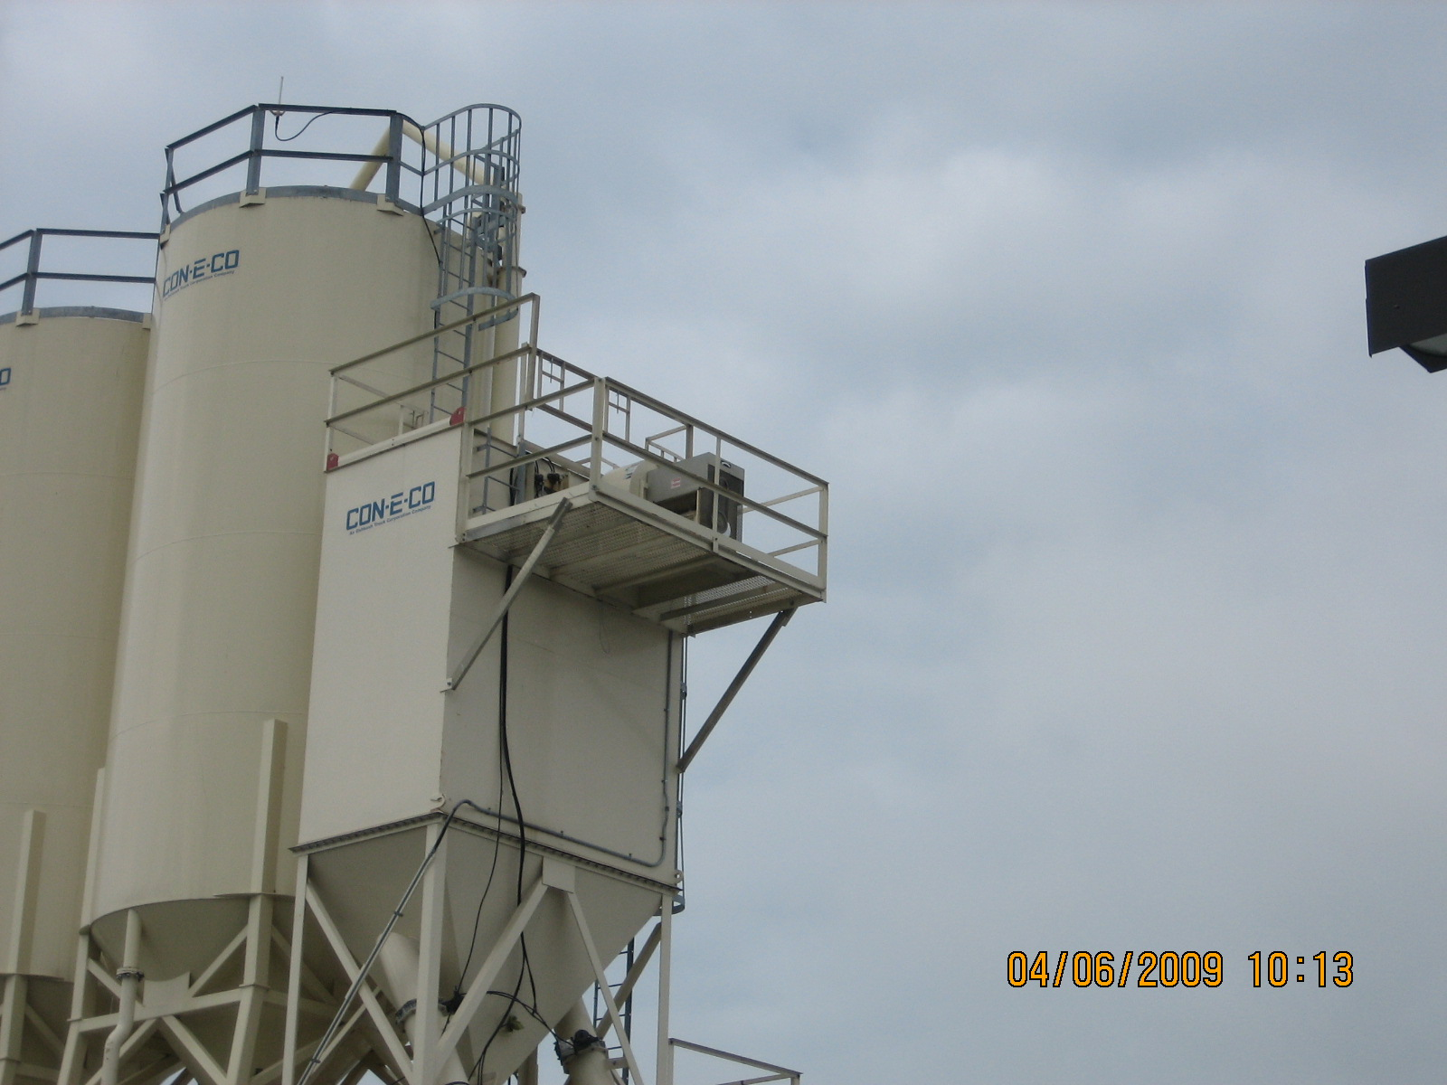
Central Dust Collector (CDC) for Plant A

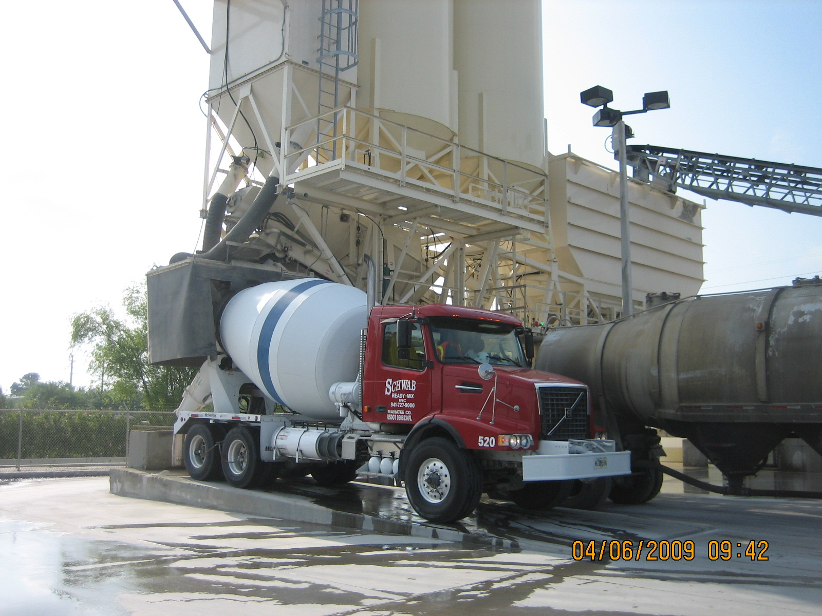
Truck Shroud for Plant A.

