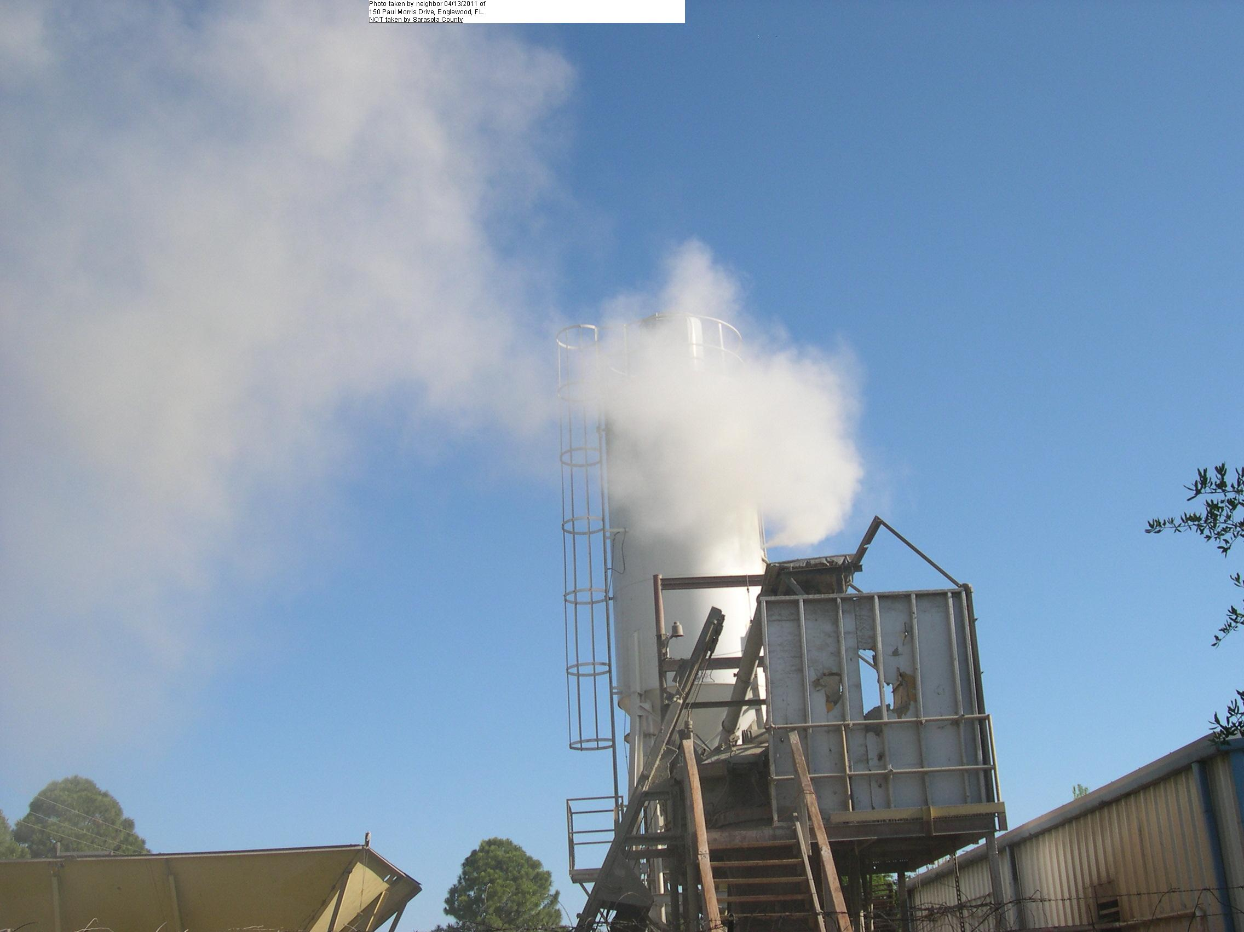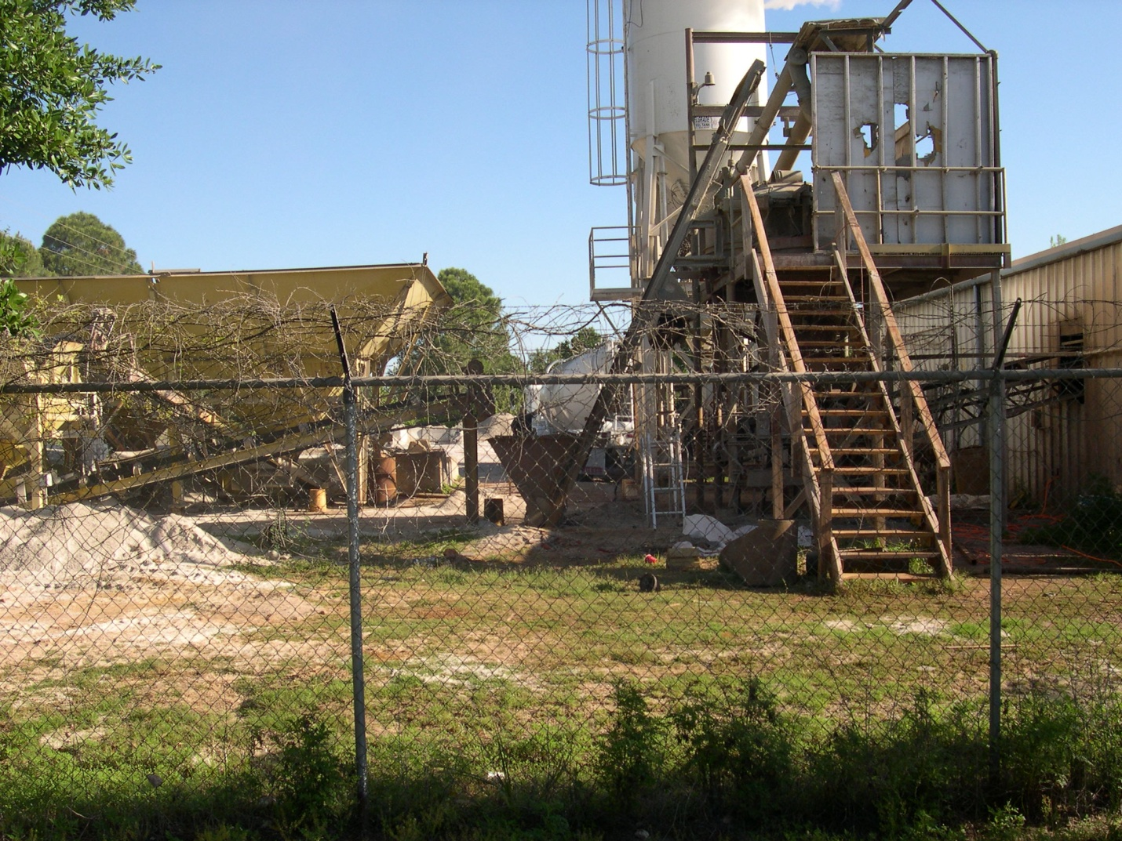

Photo taken by neighbor 04/13/2011 of 510 Paul Morris Drive, Englewood, FL.

Photo NOT taken by Sarasota County.

Photo taken by neighbor 04/13/2011 of 510 Paul Morris Drive, Englewood, FL.

Photo NOT taken by Sarasota County.

Photo taken by neighbor 04/13/2011 of 510 Paul Morris Drive, Englewood, FL.

Photo NOT taken by Sarasota County.

Photo taken by neighbor 04/13/2011 of 510 Paul Morris Drive, Englewood, FL.

Photo NOT taken by Sarasota County.

Photo taken by neighbor 04/13/2011 of 510 Paul Morris Drive, Englewood, FL.

Photo NOT taken by Sarasota County.