
1030516 001 84670
HUMAN CREMATORY

COMPLIANCE INSPECTION CHECKLIST
INSPECTION TYPE: ANNUAL (INS1, INS2) COMPLAINT/DISCOVERY (CI)
RE-INSPECTION (FUI) ARMS COMPLAINT NO:
FACILITY: Richard E. Sorensen Funeral Home, Inc. |  |  |  | DISTRICT:
DBA/Site Name: Gee & Sorensen Funeral Home and Crematory Services |  |  |  | Southwest
ADDRESS: 3180 30th. Avenue North |  |  |  | CONTACT PHONE:
St. Petersburg, FL |  |  |  | 727-323-5111
ARMS NO:  1030516 001 |  | PERMIT NO: |  | Expiration Date: 5/10/2012  Renewal Date: 4/10/2012
 |  | 1030516-002-AG |  | Expiration Date: 5/10/2012  Renewal Date: 4/10/2012
 |  |  |  | Test Date: 7/24/2000
EMISSION UNIT DESCRIPTION: Human Crematory: B&L Systems, Model Phoenix II-1. Must operate at 1,600 degrees F. in the secondary chamber. Nominal batch weight of 300 pounds. Larger weights require special operating procedures.

INSPECTION DATE: |  |  | INSPECTION COMPLIANCE STATUS (check  only one box)
11-8-2012 |  |  |  In Compliance;   Minor Non-Compliance;  Significant Non-Compliance
PART I: General Review:
1. | Permit File Review Yes No
2. | Introduction and Entry Yes No  Comments: This emission unit was inspected to determine the annual compliance status. I met with the crematory manager, Mr. Eric Drew’s and the owner, Richard Sorenson for the inspection of the facility and emission unit.
3. | Is the Authorized Representative still: Richard Sorensen? Yes No  Comments: Mr. Sorensen stills the Authorized Representative for the facility.  The e-mail address is: captscaf@aol.com
4. | Is the facility contact still: Richard Sorensen? Yes No  Comments: Mr. Sorenson stills the facility contact.  The e-mail address is: captscaf@aol.com
5. | If the answer to 3 or 4 is “No”, did the facility provide an administrative update within 30 days? Yes No  [62-210.310(2)(d), F.A.C.]

PART II: TESTING REQUIREMENTS – Rule 62-296. 401(5), F.A.C.
(check  appropriate box(es), if a shaded box is checked, this would indicate noncompliance)
Compliance Demonstration [62-296.401(5)(h), F.A.C.]
1. New Facility / New Process Equipment–
Did this facility demonstrate initial compliance no later than 30 days after beginning operation?------------ Yes No

2. Existing Facilities
Was an annual visible emissions compliance test conducted on each crematory unit for each calendar year: ----- Yes No

Test Reports
1. Does the submitted visible emission test(s) demonstrate compliance with the 5 percent opacity, six-
minute average, except that visible emissions not exceeding 15% opacity shall be allowed for up to
six minutes in any one-hour period? [62-296.401(5)(b)1., F.A.C.] Yes No
The last visible emission test resulted in an opacity of __0__% for the highest six minute average.

2. Was the test conducted with the unit operating at a capacity of one (1) adult-sized cadaver? [62-296.401(5)(g)] Yes No
3. Was the department notified at least 15 days prior to the test? [62-297.310(4)(a)9. F.A.C.] Yes No
4. Was the required test report filed with the department as soon as practical, but no later than 45 days after the
test was completed? [62-297.310(8)(b) Yes No
5. Was the facility visible emissions test(s) conducted according to EPA Method 9? [62-297.401(9)(c), F.A.C] Yes No

6. Was a visible emissions test(s) conducted by the inspector during this site visit according to EPA Method 9? Yes No
a) The visible emission test resulted in an opacity of ___n/a____% for the highest six minute average.
b) Did the test indicate the facility is operating in compliance with the opacity standard? Yes No
7. Is there any reason to ask for a special test to determine compliance with the PM and CO standards? Yes No

PART III: OPERATING/RECORDKEEPING REQUIREMENTS
(check  appropriate box(es), if a shaded box is checked, this would indicate noncompliance)
1. Were there any objectionable odor(s) detected? Yes No
An upwind/downwind survey of the facility was conducted. The observed parameters were:
Downwind odor level detected- 4 ; Wind direction - NE Upwind odor level detected-0 (1-10)
Note: I detected moderate (4) Burnt-like odor off Gee & Sorensen incinerator on southwest side of the facility at ~11:45 AM.
2. Continuous Monitoring System – [62-296.401(5)(i), F.A.C.]
a) Is a continuous temperature monitoring system installed on each unit to record temperatures in the
secondary chamber in accordance with the manufacturer’s instructions? Yes No
b) Is the temperature probe properly placed, at least at the distance where the 1.0 second gas residence
time at 1,800¹ 1,600² degrees was determined? Yes No
c) Are the following records kept on file, available for inspection for at least two years following the
recording of such measurements, maintenance, reports and records?
1) All temperature measurements Yes No
2) All continuous monitoring systems, monitoring devices, and performance testing measurements;
monitoring system all continuous performance evaluations Yes No
3) All CEMS or monitoring device calibration checks (last performed on ( 2-20-12 ) Yes No
4) Adjustments Yes No
5) Preventive maintenance performed on systems/devices Yes No
6) Corrective maintenance performed on systems/devices Yes No
7) Are the temperature charts properly documented with operator name, operator indication of
when cremation in the primary chamber was begun, date, time, and temperature markings Yes No
8) Are all the above records available for at least 2 years? Yes No
a) Date range for records reviewed: From: ____11-1-11____ To: ______11-8-12___________
9) Was the crematory unit installed after 2/1/07? If yes, go to 9) a) – c) Yes No
a) Is the crematory unit equipped and operated with a pollutant monitoring system to automatically
control combustion based on continuous in-stack opacity measurement? Yes No
b) Is the system calibrated to restrict combustion in the primary chamber whenever any opacity
exceeds 15% opacity ? Yes No
c) Has the opacity measurement system been cleaned and checked for proper operation in
accordance with the manufacturer’s recommended maintenance schedule? Yes No
1 – Application received on or after 8/30/89; 2 – Application received prior to 8/30/89
3. Was this crematory unit application to construct: [62-296.401(5)(c), F.A.C.] (check only one  box)
a) BEFORE August 30, 1989? (If this box checked, continue on to #4 and skip #5)
b) ON or AFTER August 30, 1989? (If this box checked, skip #4 and continue on to #5)
4. If the application to construct was BEFORE August 30, 1989 is the:
a) secondary chamber combustion zone providing at least a 1.0 second gas residence time @ 1600ºF? Yes No
b) actual operating temperature of the secondary chamber combustion zone no less than 1400ºF
throughout the combustion process in the primary chamber? Yes No
c) cremation in the primary chamber begun after the secondary chamber combustion zone temperature
is equal to or greater than 1400ºF? Yes No
5. If the application to construct ON or AFTER August 30, 1989 is the:
a) volume in the secondary combustion zone sufficient to provide at least a 1.0 second gas residence time
@ 1800º F? Yes No
b) actual operating temperature of the secondary chamber combustion zone no less than 1600ºF
throughout the combustion process in the primary chamber? Yes No
c) secondary chamber combustion zone temperature equal to or greater than 1600ºF before the cremation
process begins in the primary chamber? Yes No

6. Are appropriate cremation containers containing no more than 0.5 % (percent) by weight chlorinated
plastics used during the cremation of dead human bodies, as demonstrated by MSD sheet? Yes No
[62-296.401(5)(d), F.A.C.]
a) If the answer to question 6 above is YES, is certifying documentation from the manufacturer that they
are composed of 0.5% or less by weight chlorinated plastics kept on file at the site for the duration of
their use and for at least two years after their use? Yes No
b) Are there any other materials, including biomedical wastes (Rule 62-210.200, FAC) incinerated at
this location? Yes No

PART IV: Equipment Maintenance
(check  appropriate box(es), if a shaded box is checked, this would indicate noncompliance)
Equipment Maintenance: – [62-296.401(5)(e), F.A.C.]
1. Is the crematory unit maintained in accordance with the manufacturer’s specifications? Yes No
2. Are there maintenance/repair/adjustment records kept onsite for at least 2 years? Yes No
3. Is there a written plan onsite which addresses the operating procedures during startup,
shutdown and malfunction? Yes No
4. Does the crematory allow for a visible check on the flame characteristics? Yes No
If yes go to a) – b)
a) Was the flame characteristic visually checked at least once during each operating shift? Yes No
b) Was the flame adjusted when necessary? Yes No

PART V: Special Conditions And Procedures
(check  appropriate box(es), if a shaded box is checked, this would indicate noncompliance)
Administrative Changes:
1. Were there any change in the name, address, or phone number of the facility or authorized representative
not associated with a change in ownership or with a physical relocation of the facility or any emissions
units or operations comprising the facility; or any other similar minor administrative change at the facility Yes No
2. If yes, did the facility provide written notification within 30 days of the change? [62-210.310(2)(d), F.A.C.] Yes No
Permit Effective Period – [62-210.310(3)(a), F.A.C.]
1. Is the general permit for this facility still within the 5 year effective period? Yes No
2. Did the facility submit the new re-registration form at least 30 days prior to permit expiration? Yes No
New or Modified Process Equipment or Change in Ownership - [62-210.310 (2)(b)2, F.A.C]
C.. Since the last registration form submittal has there been
a) Installation of any new process equipment? - Yes No
b) Alterations to existing process equipment without replacement? Yes No
c) Replacement of existing equipment with equipment that is substantially different? Yes No
d) A change in ownership? Yes No
If the any of the answers to 1a) – 1)d is Yes to any, a new registration form and appropriate fee should
have been submitted 30 days prior to the change.----------- Yes No
Noncompliance Notice: - [62-210.310(3)(i), F.A.C.]
- Did the facility have any instances where they were unable comply with or will be unable to comply with any condition or limitation of the air general permit? Yes No
If the answer is Yes, proceed to a) and b).
  - Did the owner or operator provide immediate notification to the Department? Yes No
  - Did the notification include:
1. A description of and cause of noncompliance?- Yes No
2. Dates and times of noncompliance; or if not corrected, the anticipated time noncompliance is expected to continue
and steps being taken to reduce, eliminate, and prevent recurrence of the noncompliance? ---------------------- Yes No

PART VI: Comments
An AQD VE test was not performed because the emission unit was not in operation. I detected moderate (4) Burnt-like odor off Gee.
& Sorensen incinerator on southwest side of the facility at ~12:00 PM. Reviewed temperature charts for the months of 11/01/2010
through 10/06/2011 indicated emission unit in compliance. Moderate (4) burnt like odors, with the same characteristics detected
When inspector was present onsite, ~ 3 feet from the emissions units. Certifying documentation from the manufacturer that cremation
container are composed of 0.5% or less by weight chlorinated plastic was kept onsite. The emission unit was calibrated on 2-20-12.
See attached calibration data sheets.
Exit Interview: During the closing conference, I explained to Mr. Sorensen that I detected moderate (4) Burnt-like odor off his
emission units. I informed Mr. Richard Sorensen, facility appears to be in compliance at this time.

Mike Ojo Thomas 11-8-12
Inspector’s Name Date of Inspection

Inspector’s Signature Approximate Date of Next Inspection

/tmp/lo/0000.doc

Odor Survey Map
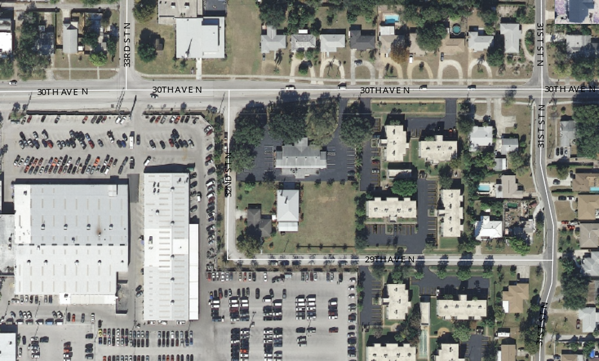
4
42
4
0
0
0
0
Comments: Odor survey conducted by inspector Mike Ojo Thomas on 11/8/12 beginning at approximately 11:30 AM and ending at 12:00 PM. I detected moderate (4) burnt-like odor off Gee & Sorensen crematory incinerators property on south west of the facility at ~11:45 AM.

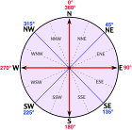

Complainant

Respondent

Wind Direction

41
Odor Intensity

0
No Odor Detected

/tmp/lo/0000.doc

