Forristall Materials, Inc.
Permit # 7775329-001-AG
INS-2 02/18/2009 by Wendy D. Simmons

Hopper/Feeder
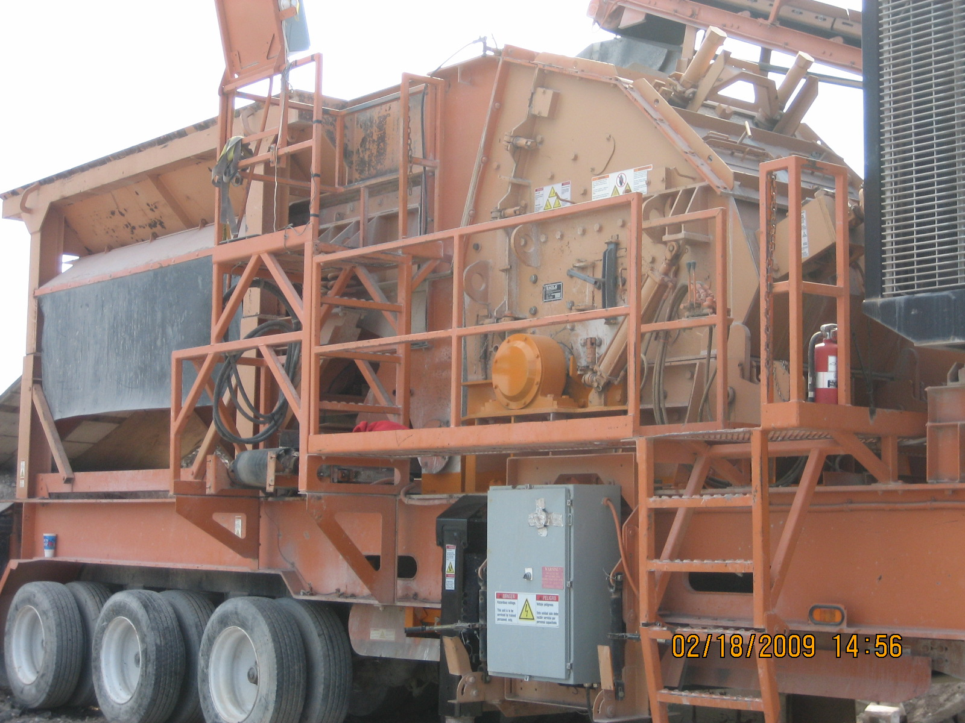
Crusher
Oversize By-Pass Belt to Hopper
Crossover Belt to Oversize By-Pass Belt

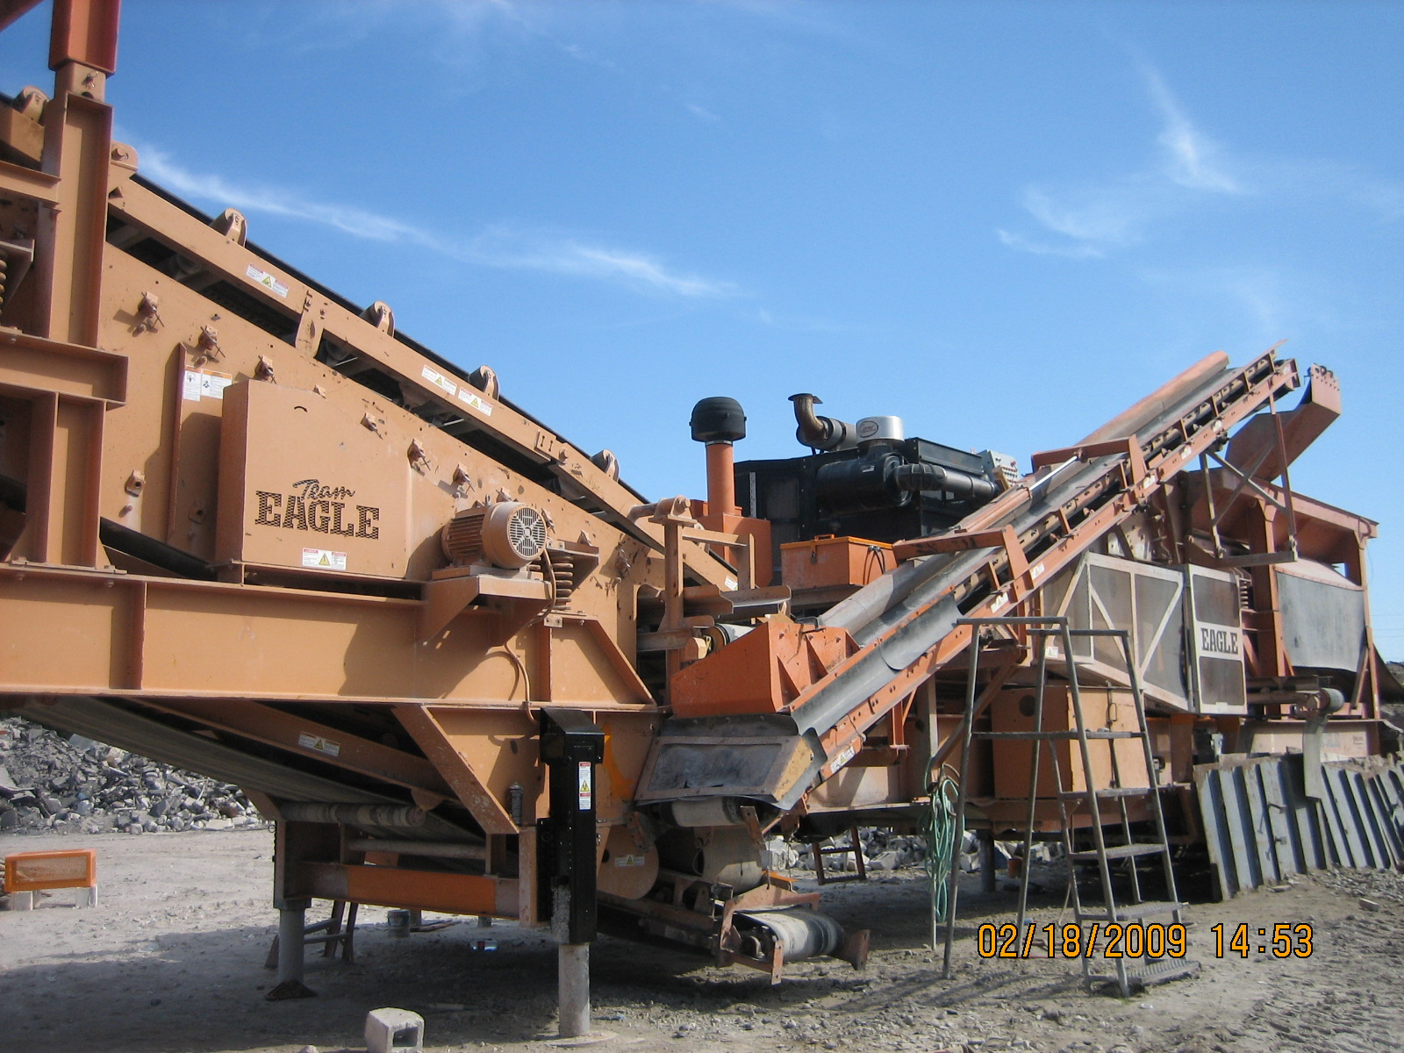
Dirt Discharge Belt…not used.

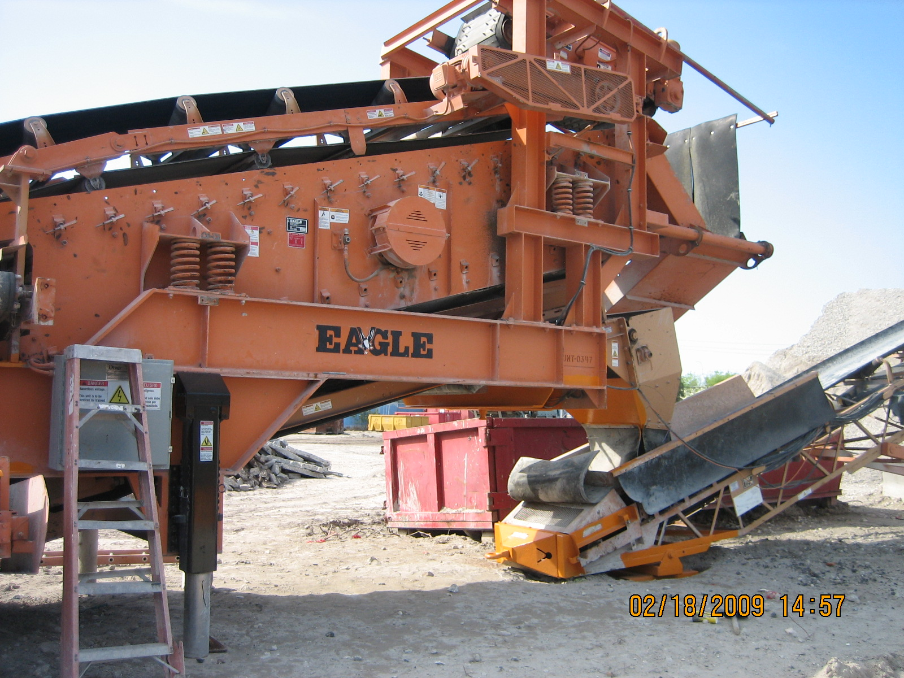
Stacker Feed Belt to Stacker Belt

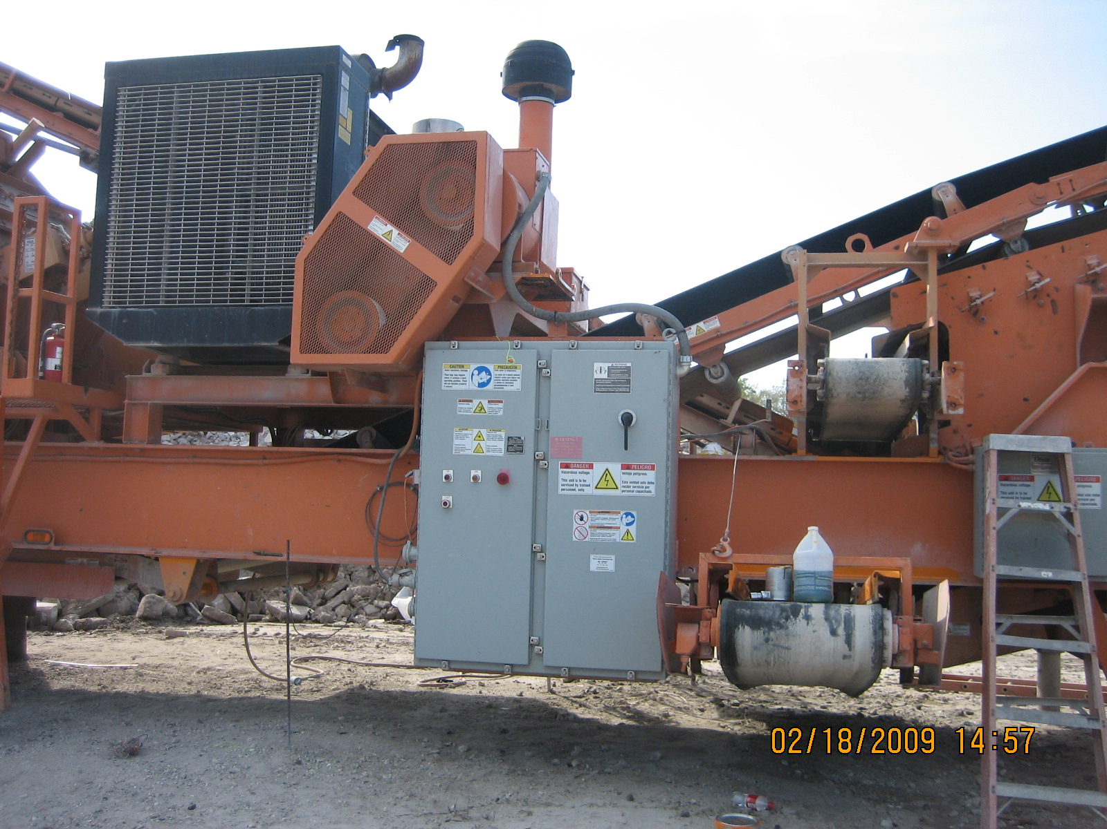
Stack belt for second deck…this belt is not used.
Back side of Crossover belt.

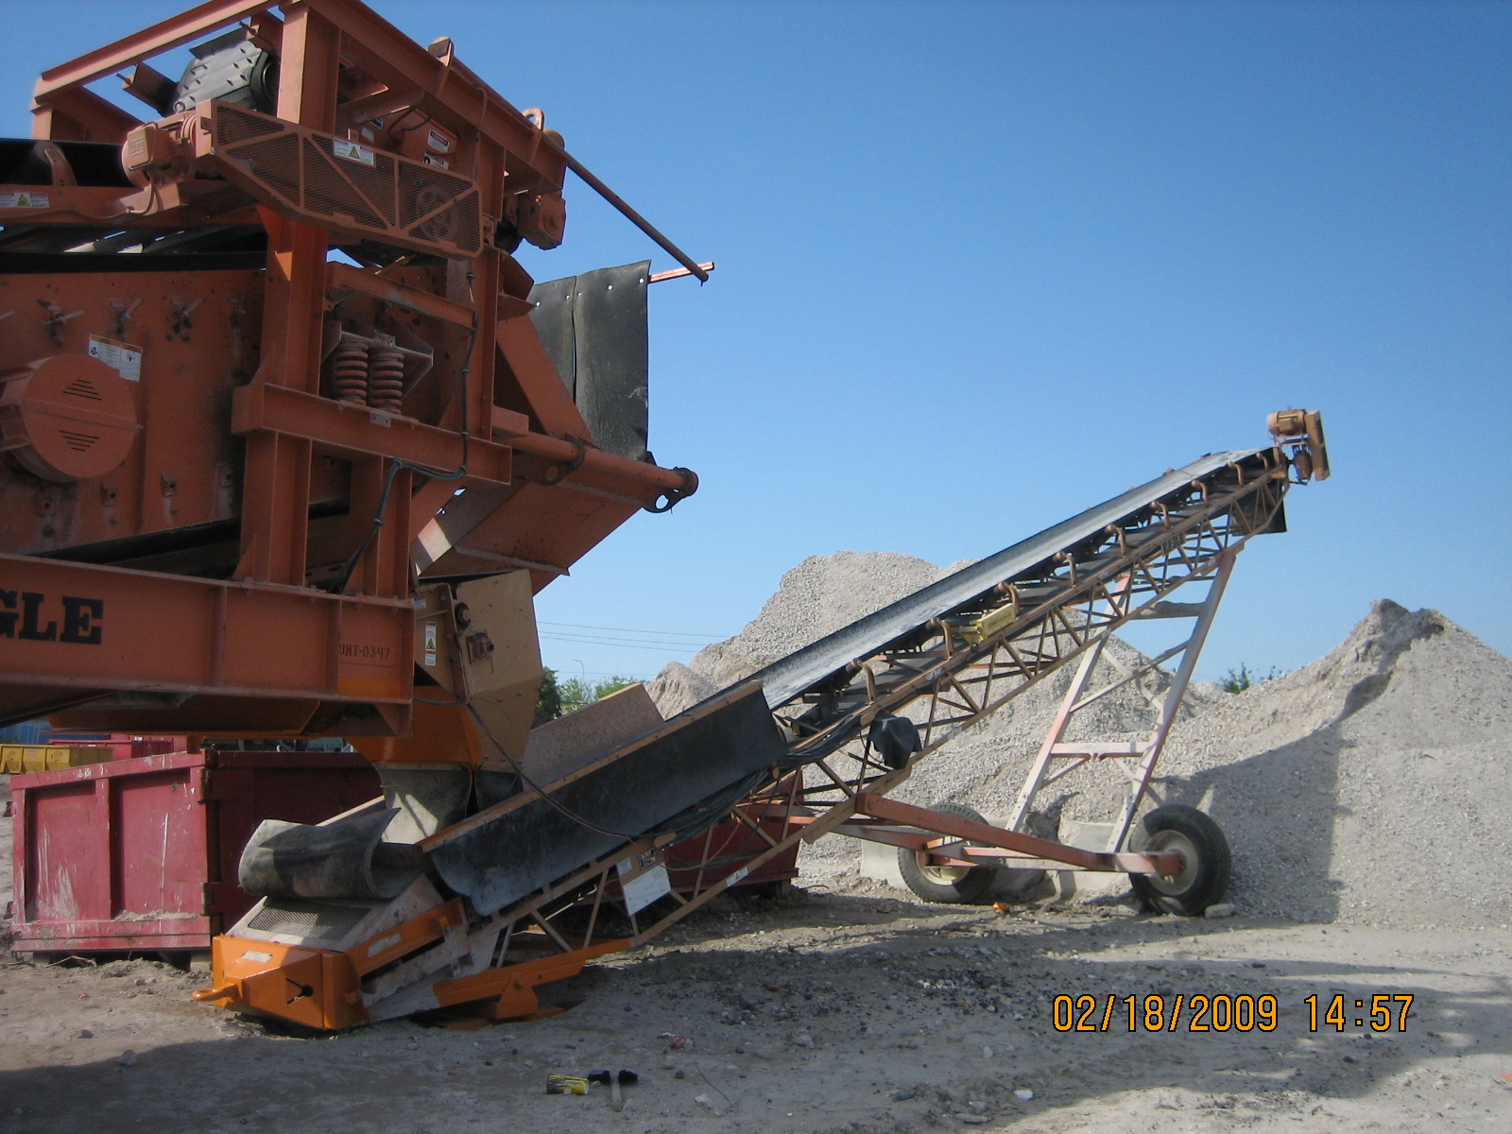
Stacker belt

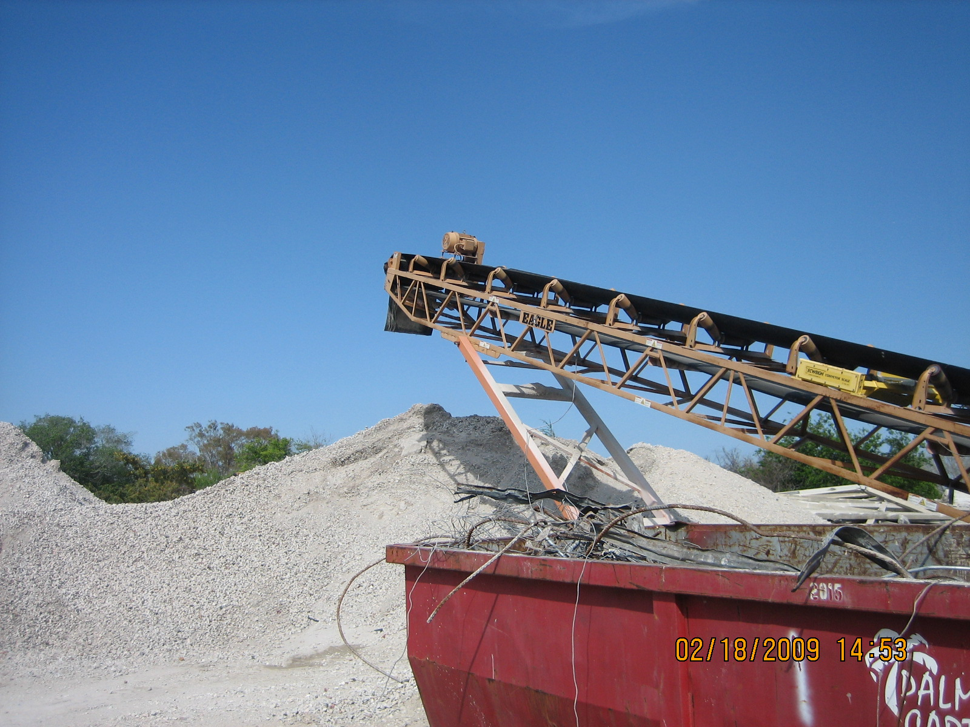
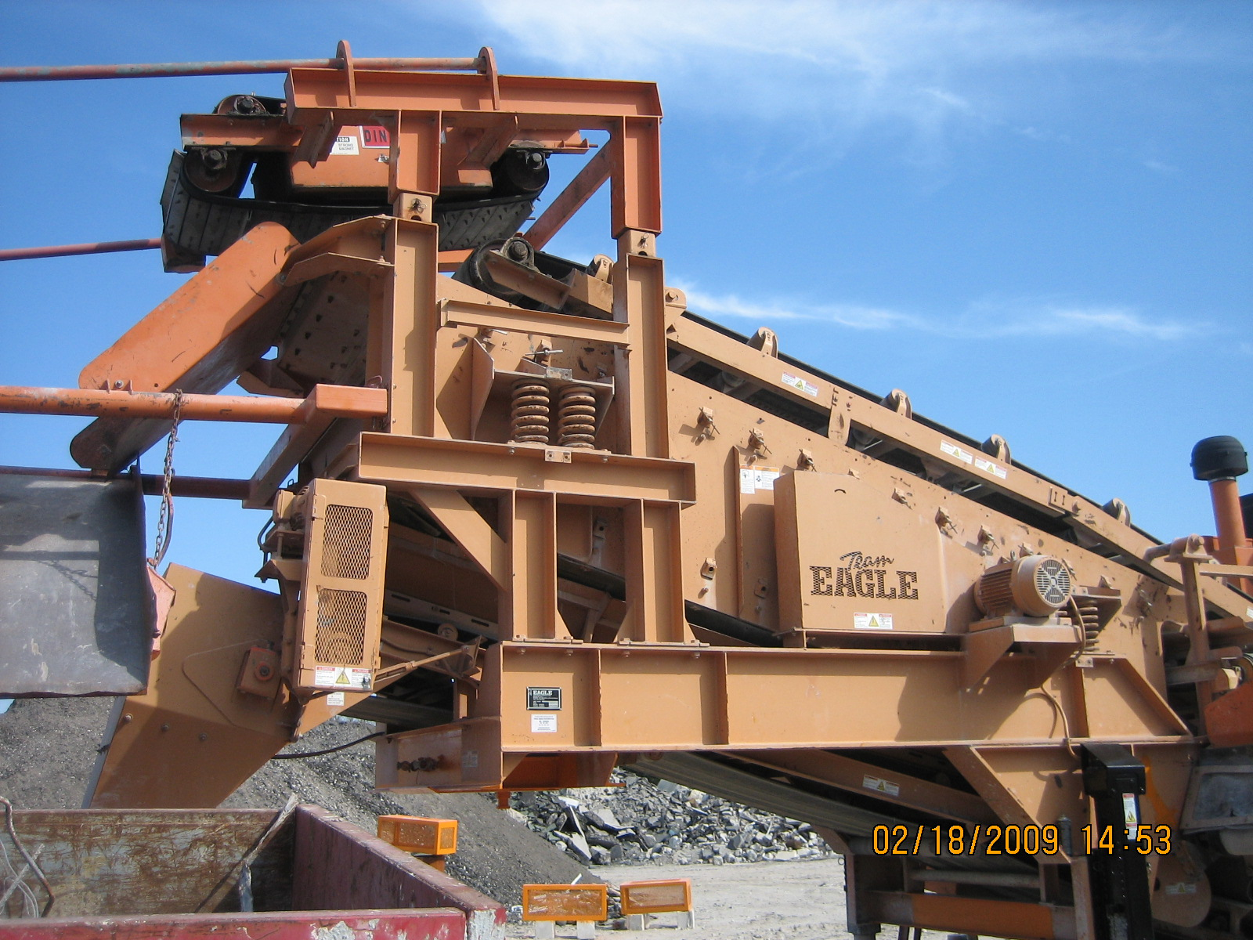
Screening/Sizing area.

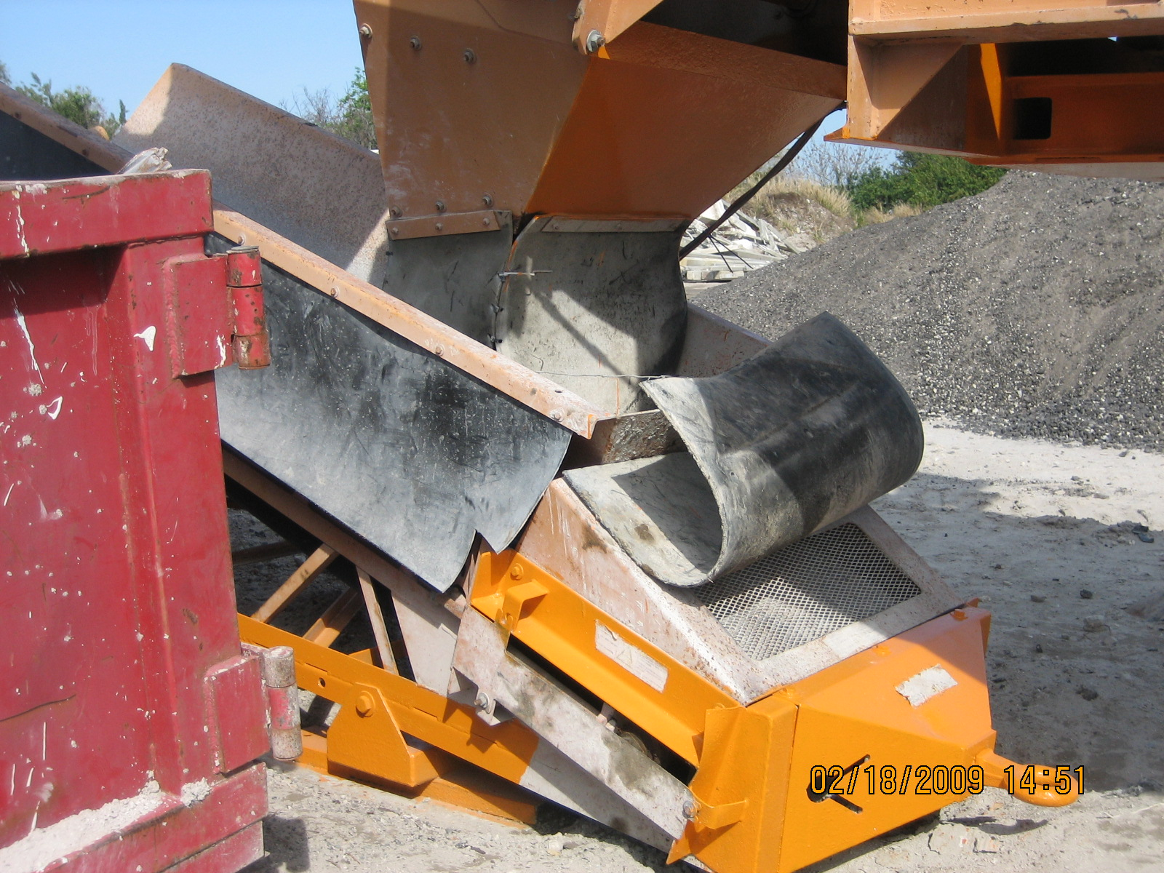
Stacker feed belt to stacker belt drop point.
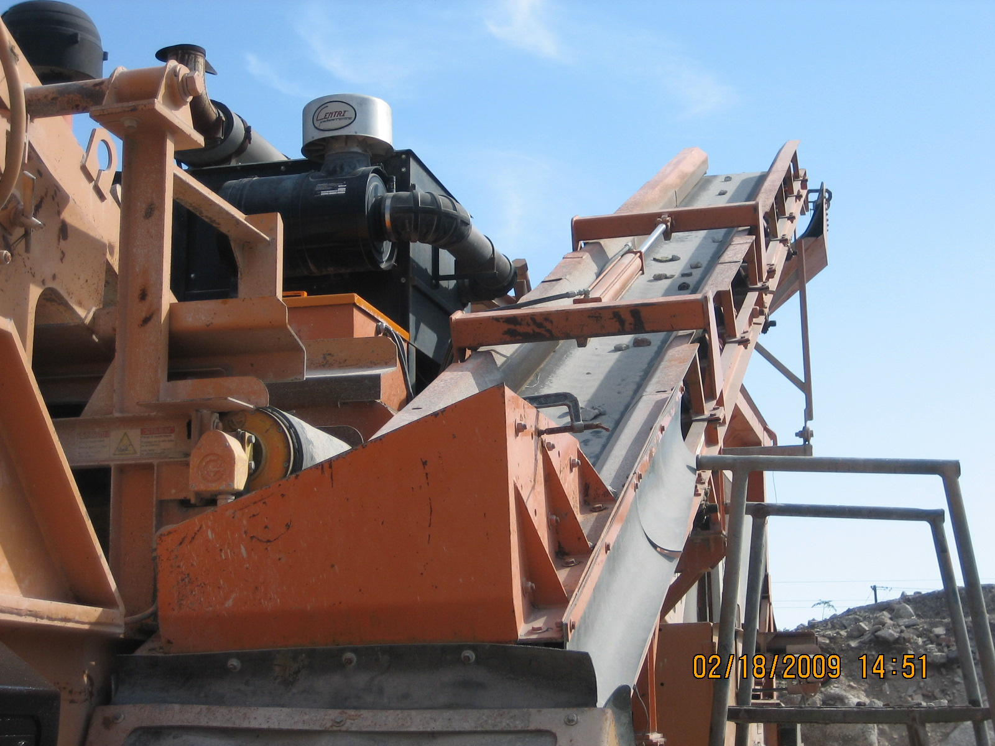
Crossover Belt to Oversize By-Pass Belt drop point.
Oversize By-Pass Belt to Hopper drop point.

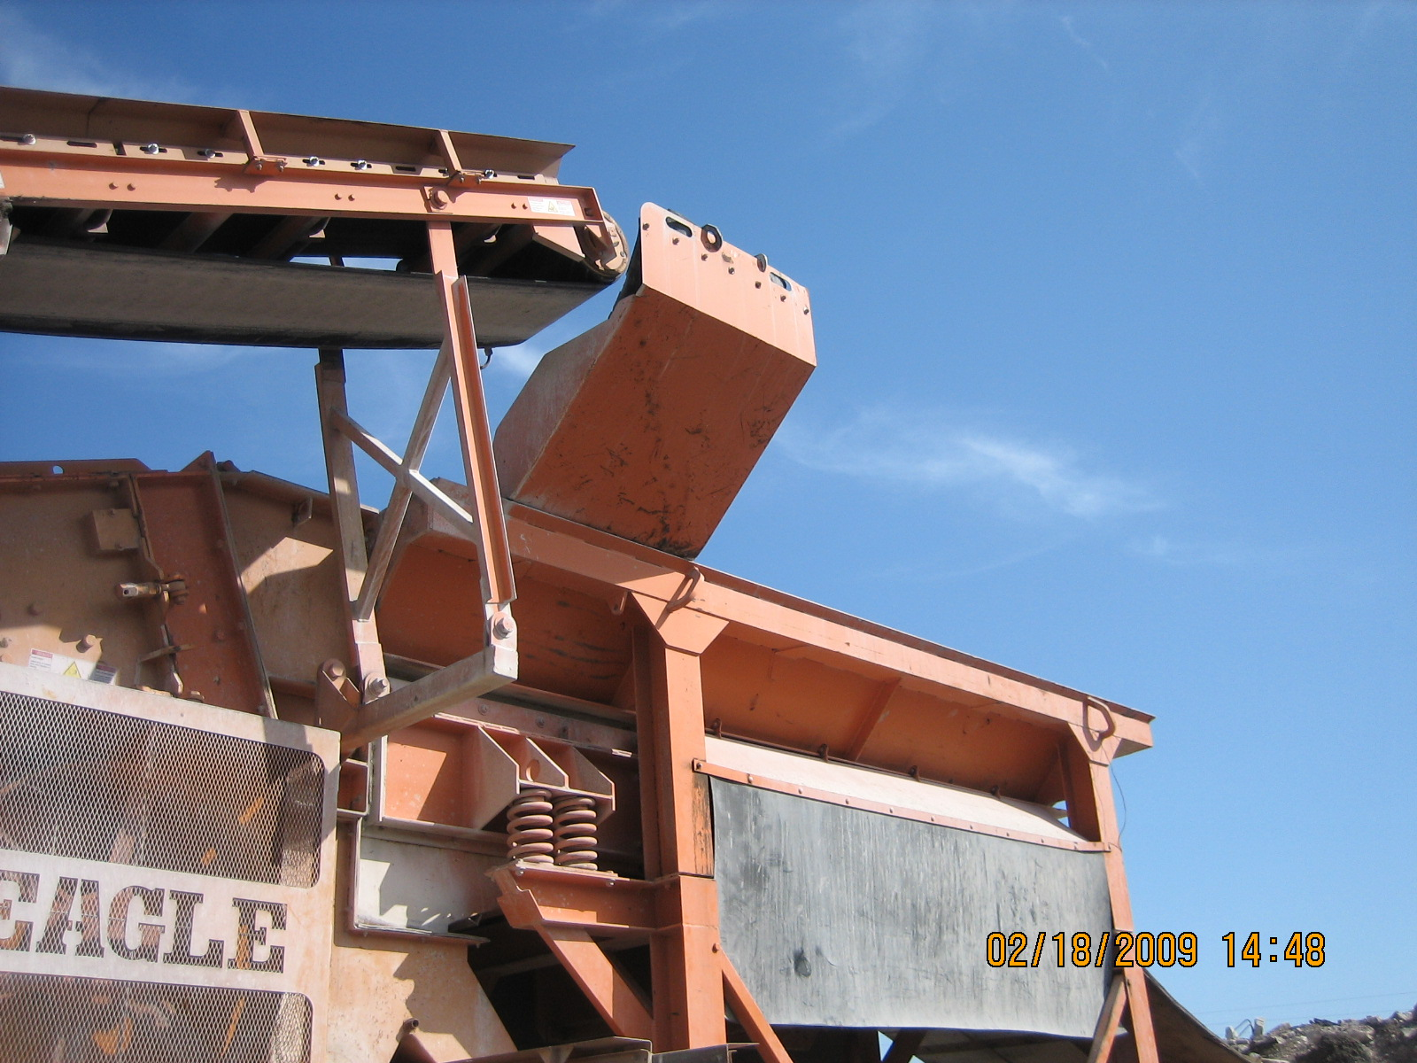
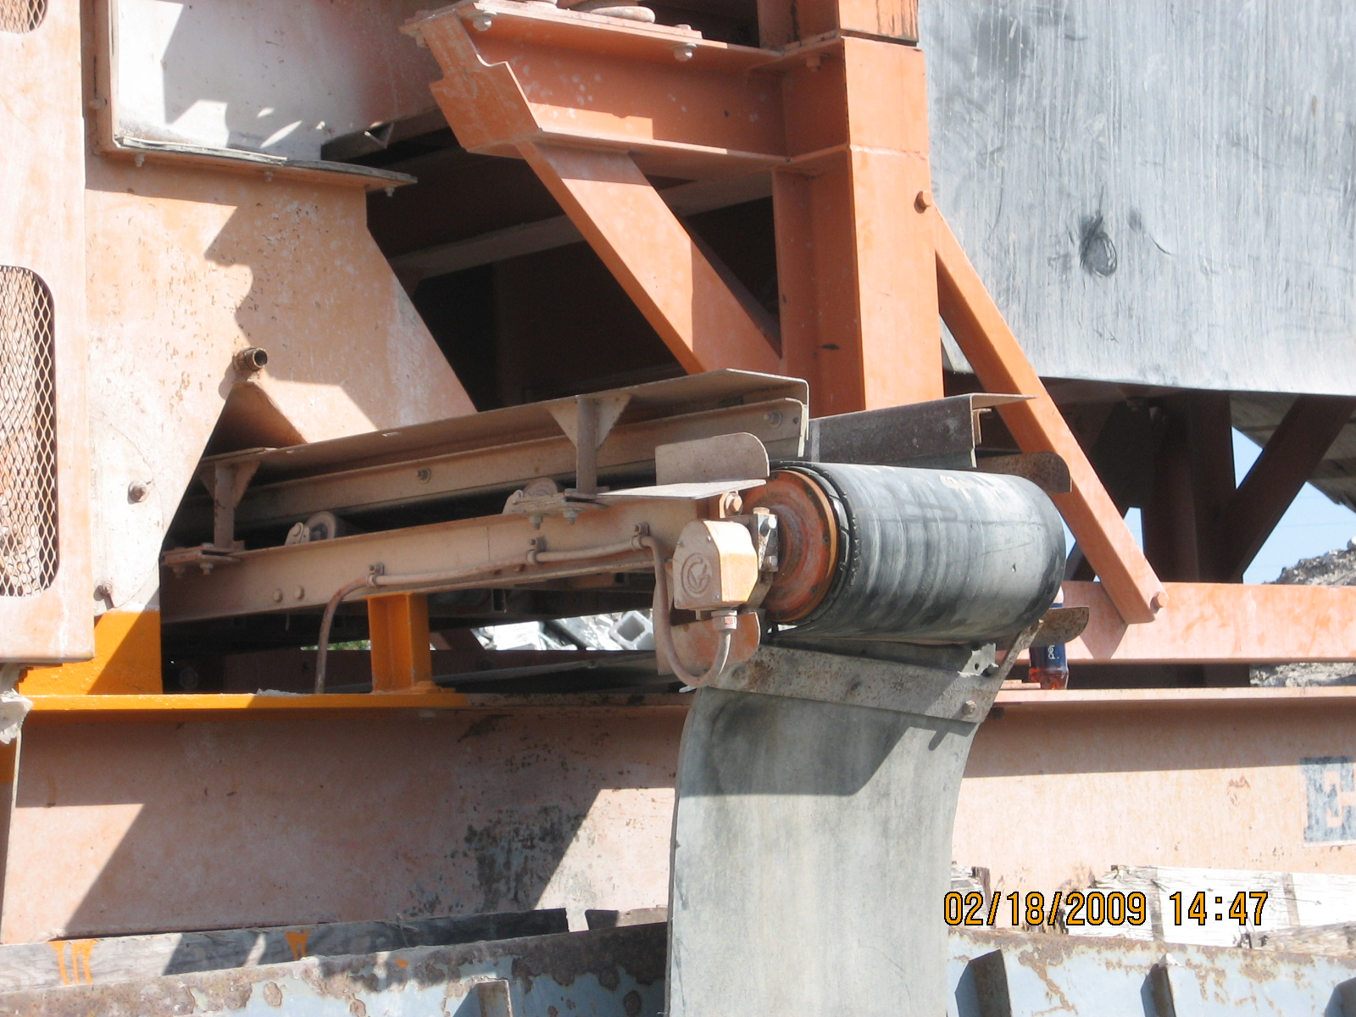
Dirt Discharge Belt…not used because facility has a stand- alone screening unit.

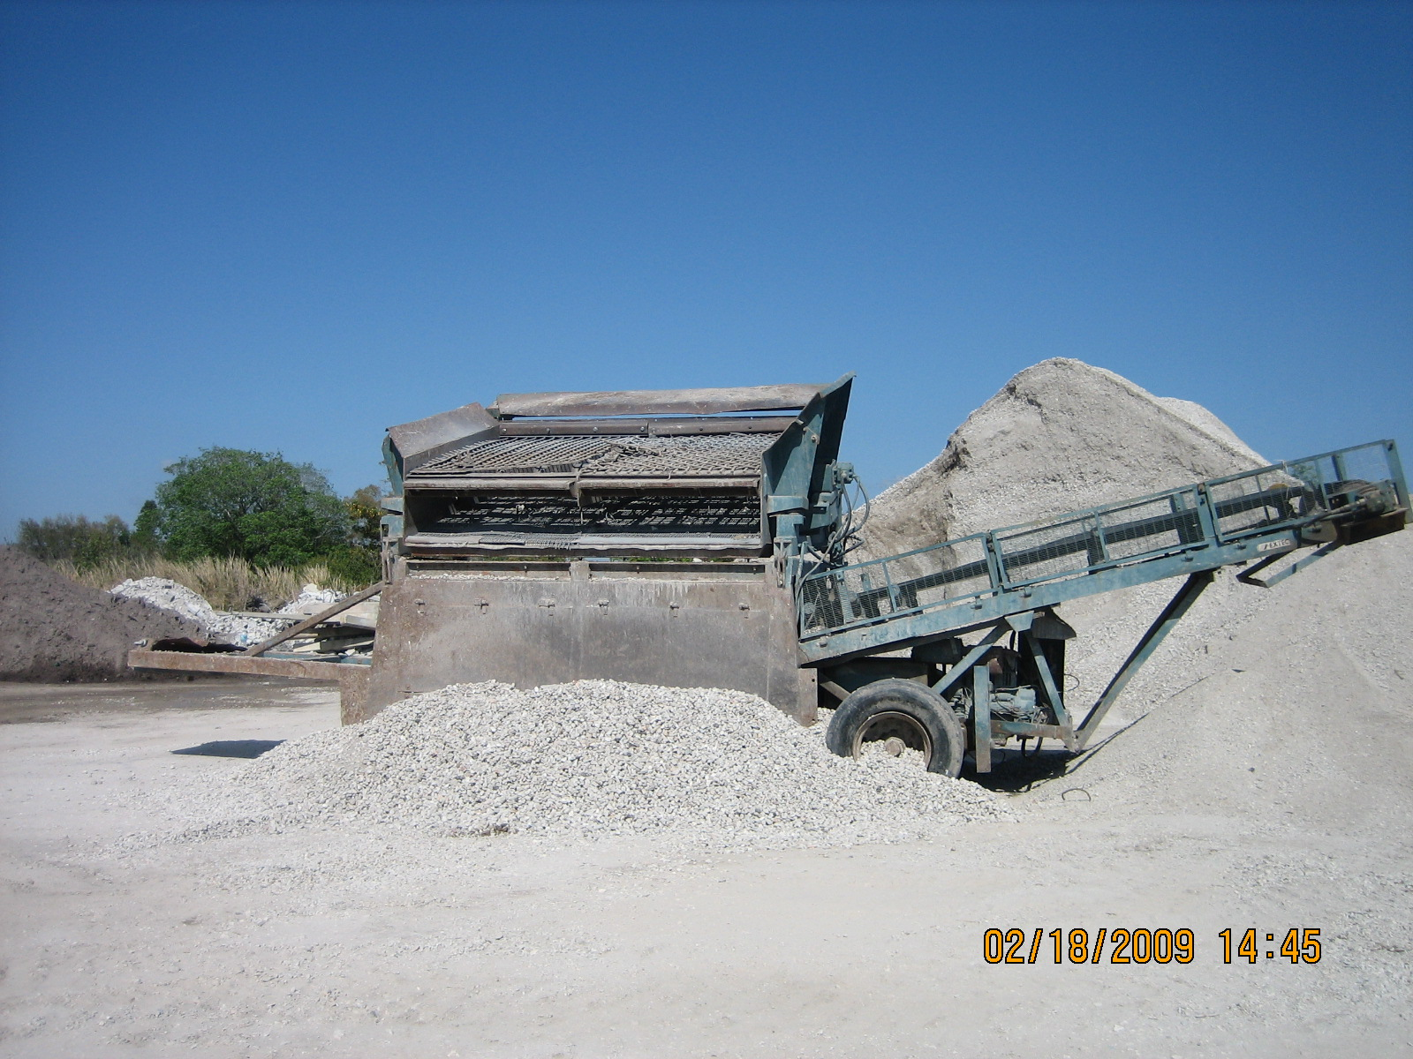
Stand-alone screening unit.
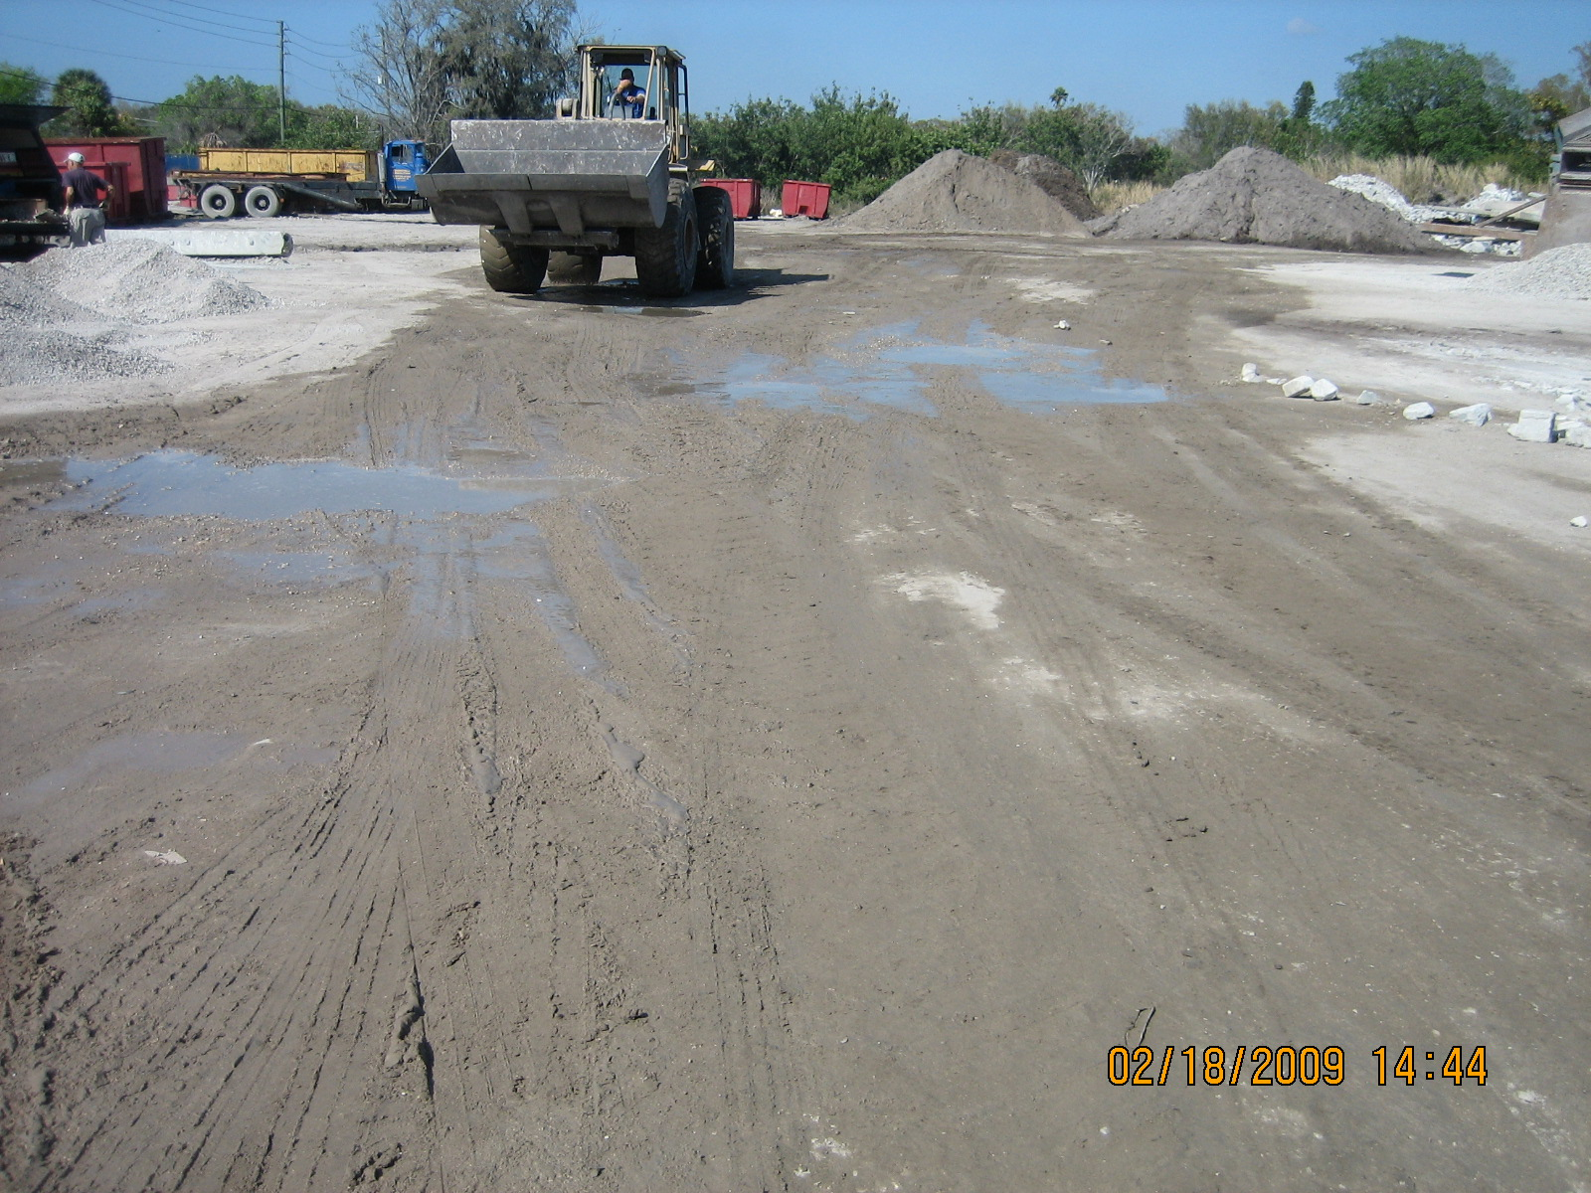
Unpaved roadways were wet…evidence of application of water for reduction of fugitive particulate.

