Dana Site Development-7775258
INS 2 Photos---01/27/2009
By Wendy D. Simmons

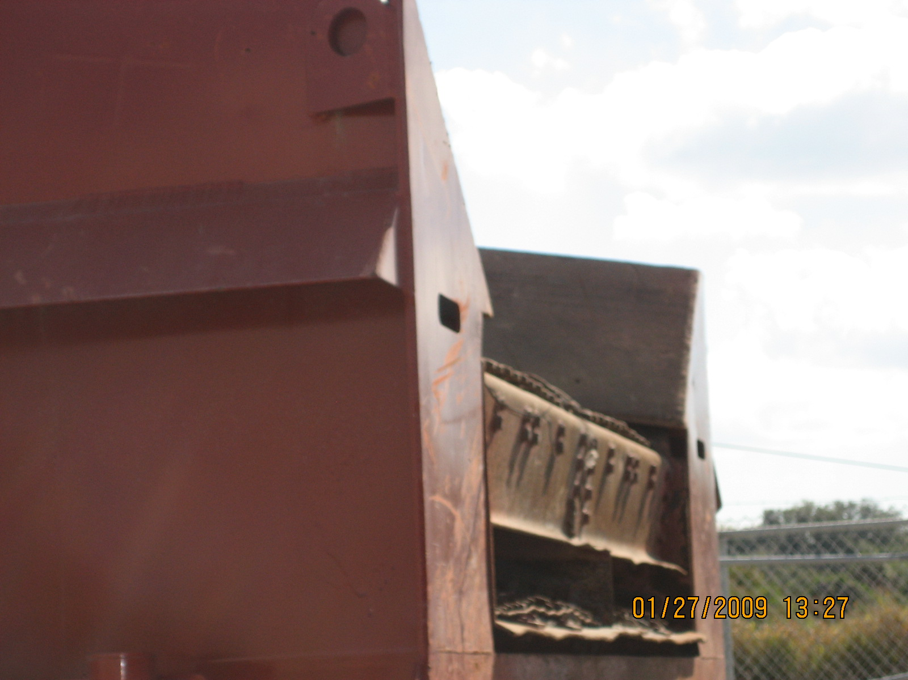
Free standing screening unit…not in operation during this visit.

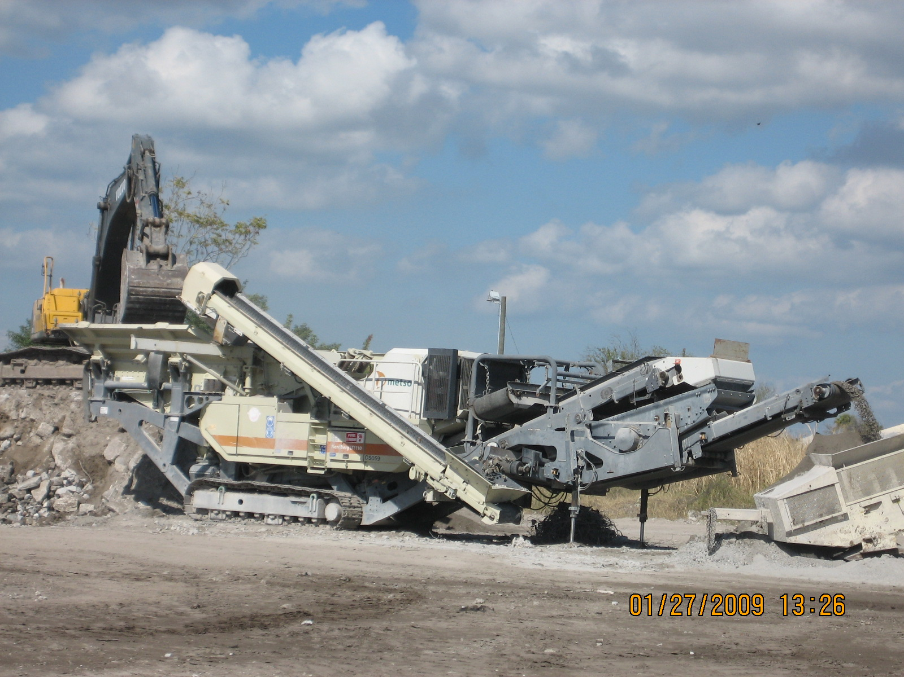
Metso Crusher with built in screener and return belt.
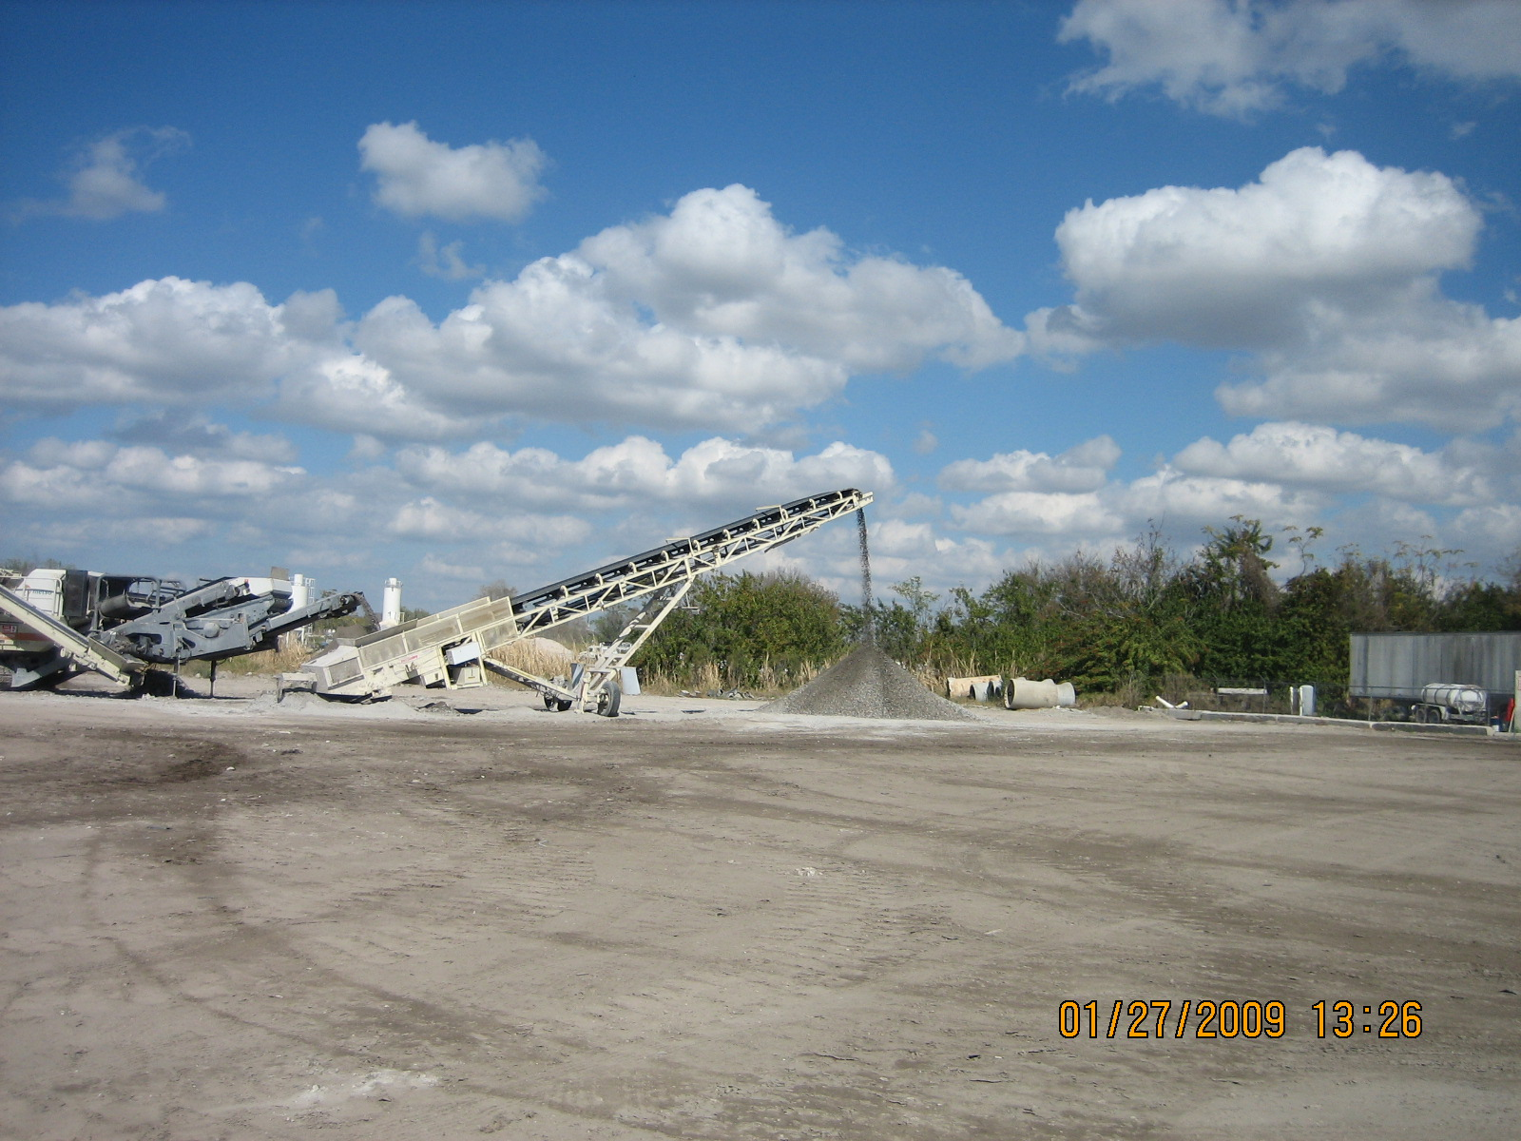
Conveyor belt from crusher in operation, no VE’s noted.

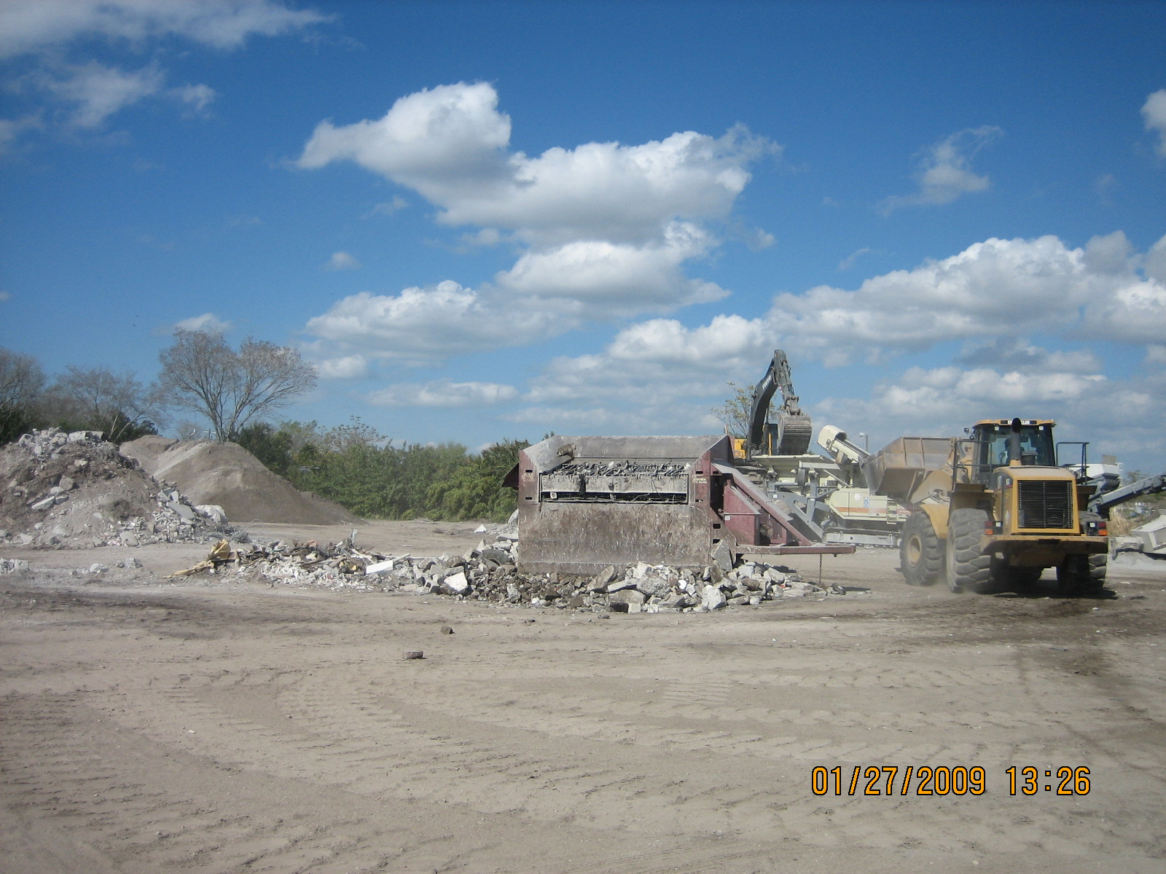
Stand alone screener that is not in current facility registration.
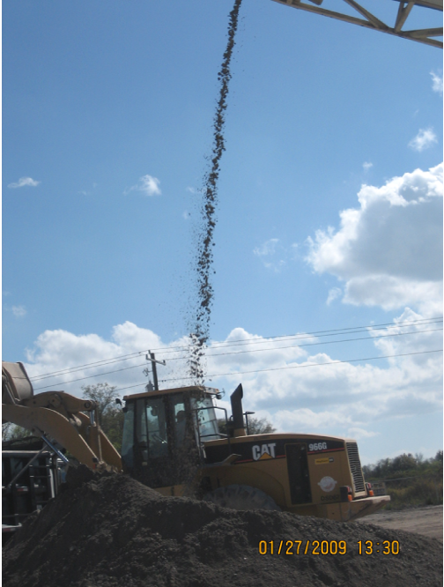
Product drop point from conveyor to pile.

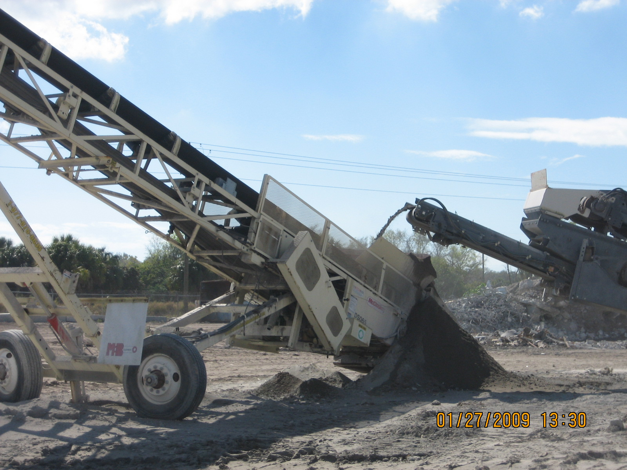
Product from conveyor to conveyor drop point.
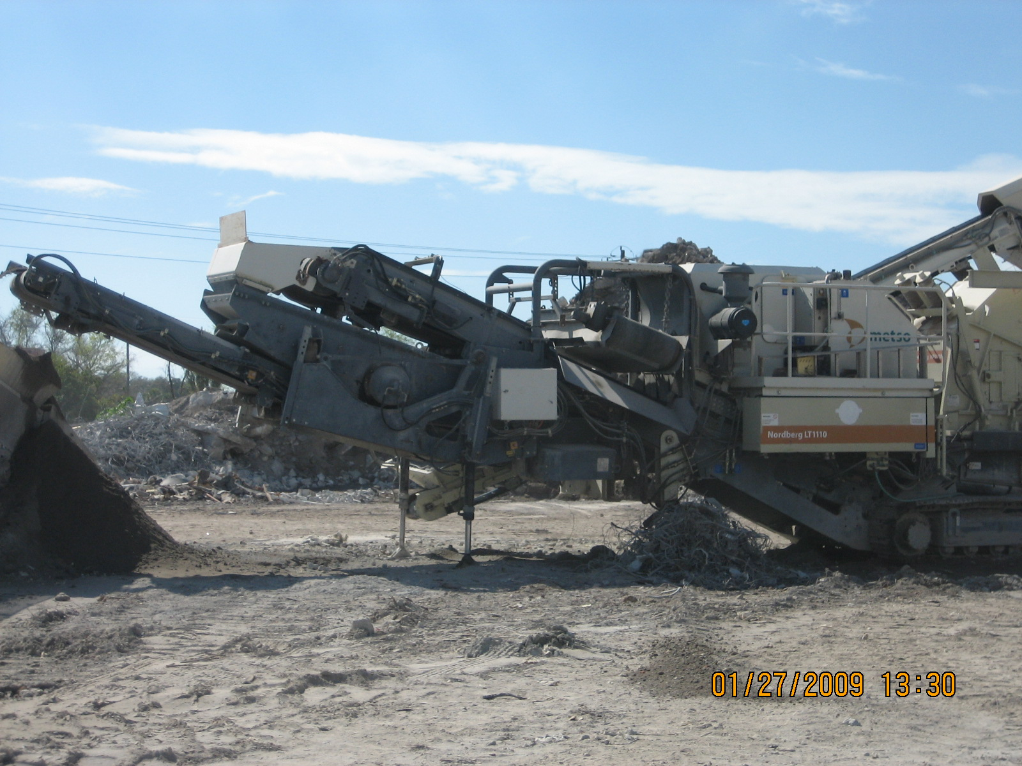
This photo was taken to show belt described as steel wire belt Emission Point #4.

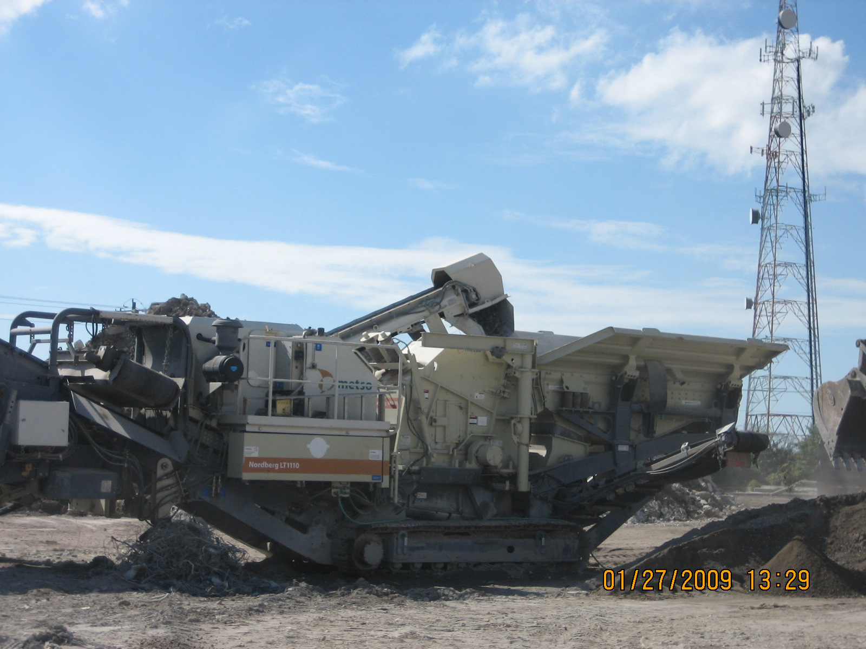
This photo was taken to show fines belt and return belt.

