Photographs of Nautical Furnishings-2/23/2011
Located @ 3111 West McNab Road
Pompano Beach, Fl 33069

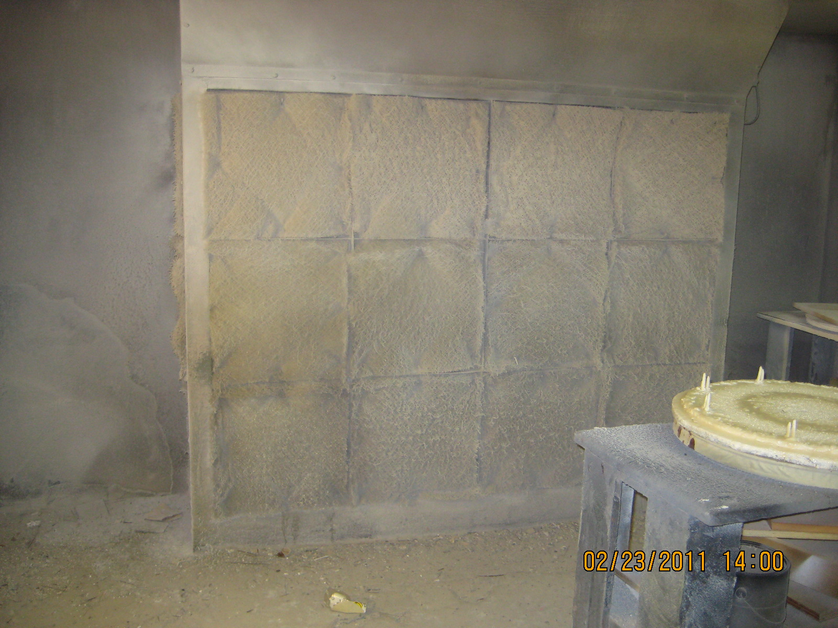
Spray Booth bank at Nautical Furnishings

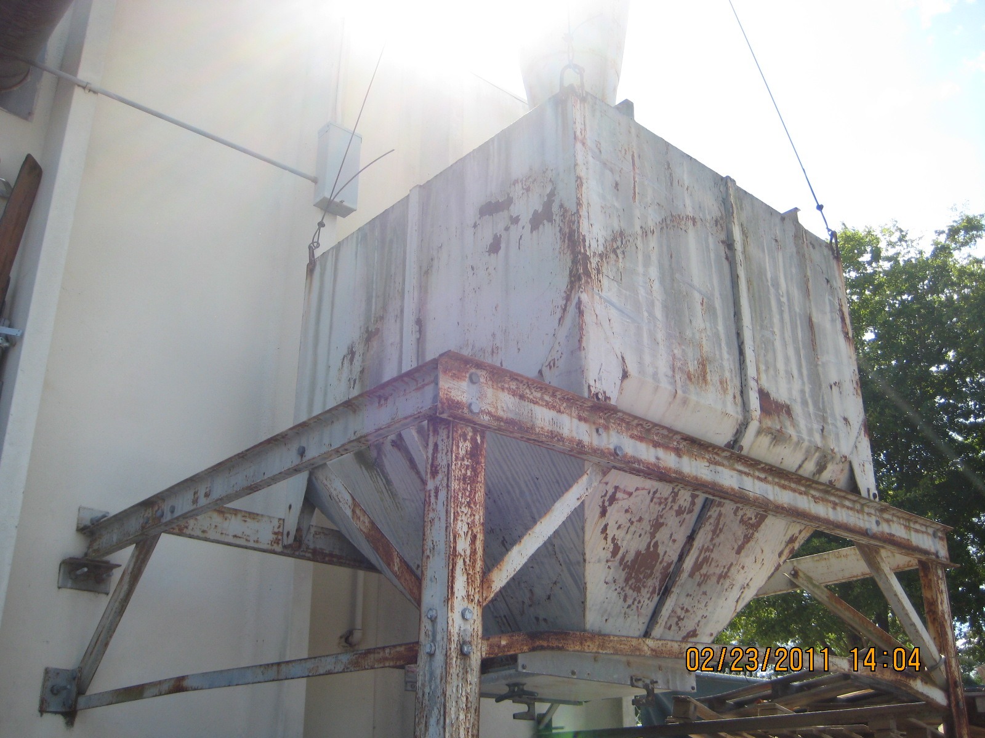
Dust Collector @ Nautical Furnishings

