DIGITAL PHOTOGRAPHIC LOG

- Facility Name: T. Bower Enterprises, Inc.
- County / AIRS ID No: Polk / 1050348-003-AG
- Inspection Type: INS2
- Inspection Date: 01/17/2012
- Date Photo Log was completed: 01/18/2012
- Type of Camera Used: Olympus Camedia Digital Camera, 5.0 Megapixel, C-50 ZOOM, S/N 115248297
- Digital Recording Media: FUJIFILM xD-Picture Card, 128 MB, S/N DPC-128, R31695 5RZ7, 0244 MAD
- All Digital Photos Were Copied To: Digital Photographic Log
- Original Copy Is Stored In/On: Hard disk on computer, DEP143271
- Were the photos altered?: NO__X__ YES_____ explain yes:
- Photographer: Amaury Betancourt
- Signature of Photographer:______________________________________________

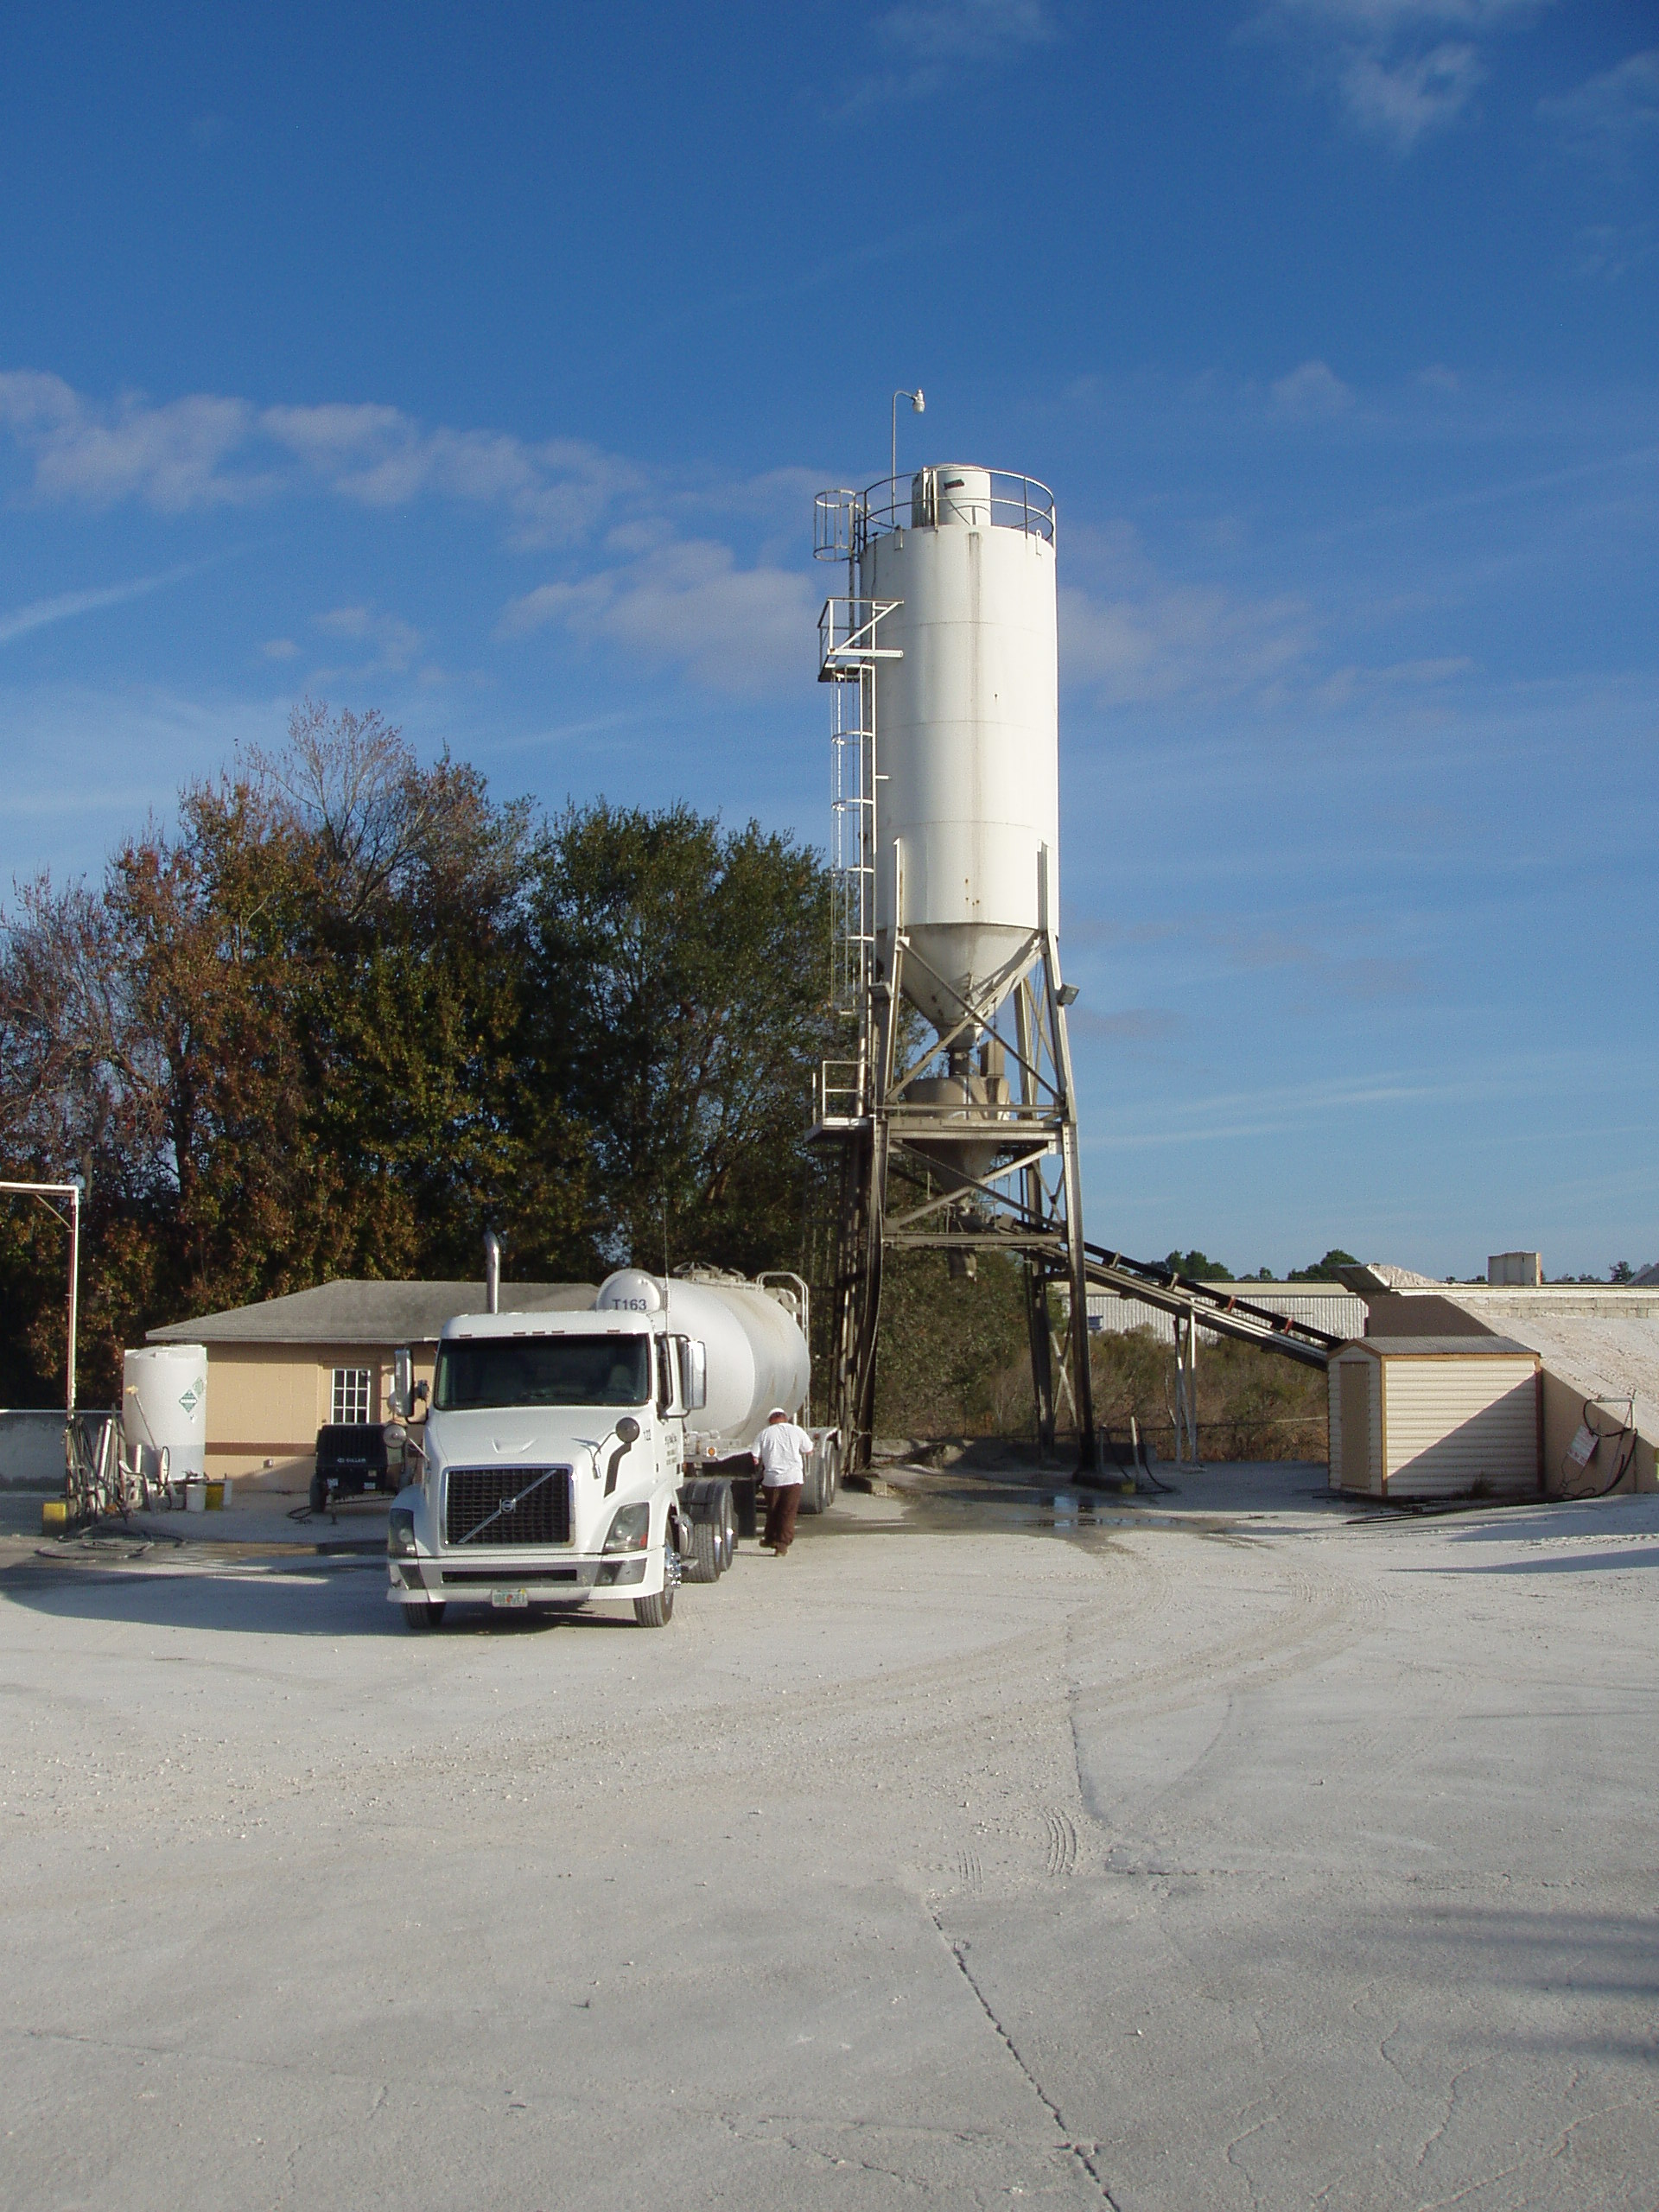
Photo ID No: P01172012-1/Time – approx. 09:05 A.M. Silo at T. Bower Enterprises, Inc., facility. Silo is split internally with two sections: one for cement and one for fly ash. During inspection (approx. 08:30 to 09:05 A.M. on 01/17/2012.), cement was being loaded into silo. No visible emissions (VE) were observed during the VE test. FDEP inspectors did not witness the VE test on 01/17/2012. The fly ash section of the silo had been filled with cement on an earlier date and has not had its VE test conducted yet for the year 2011. (photo 01/17/2012).

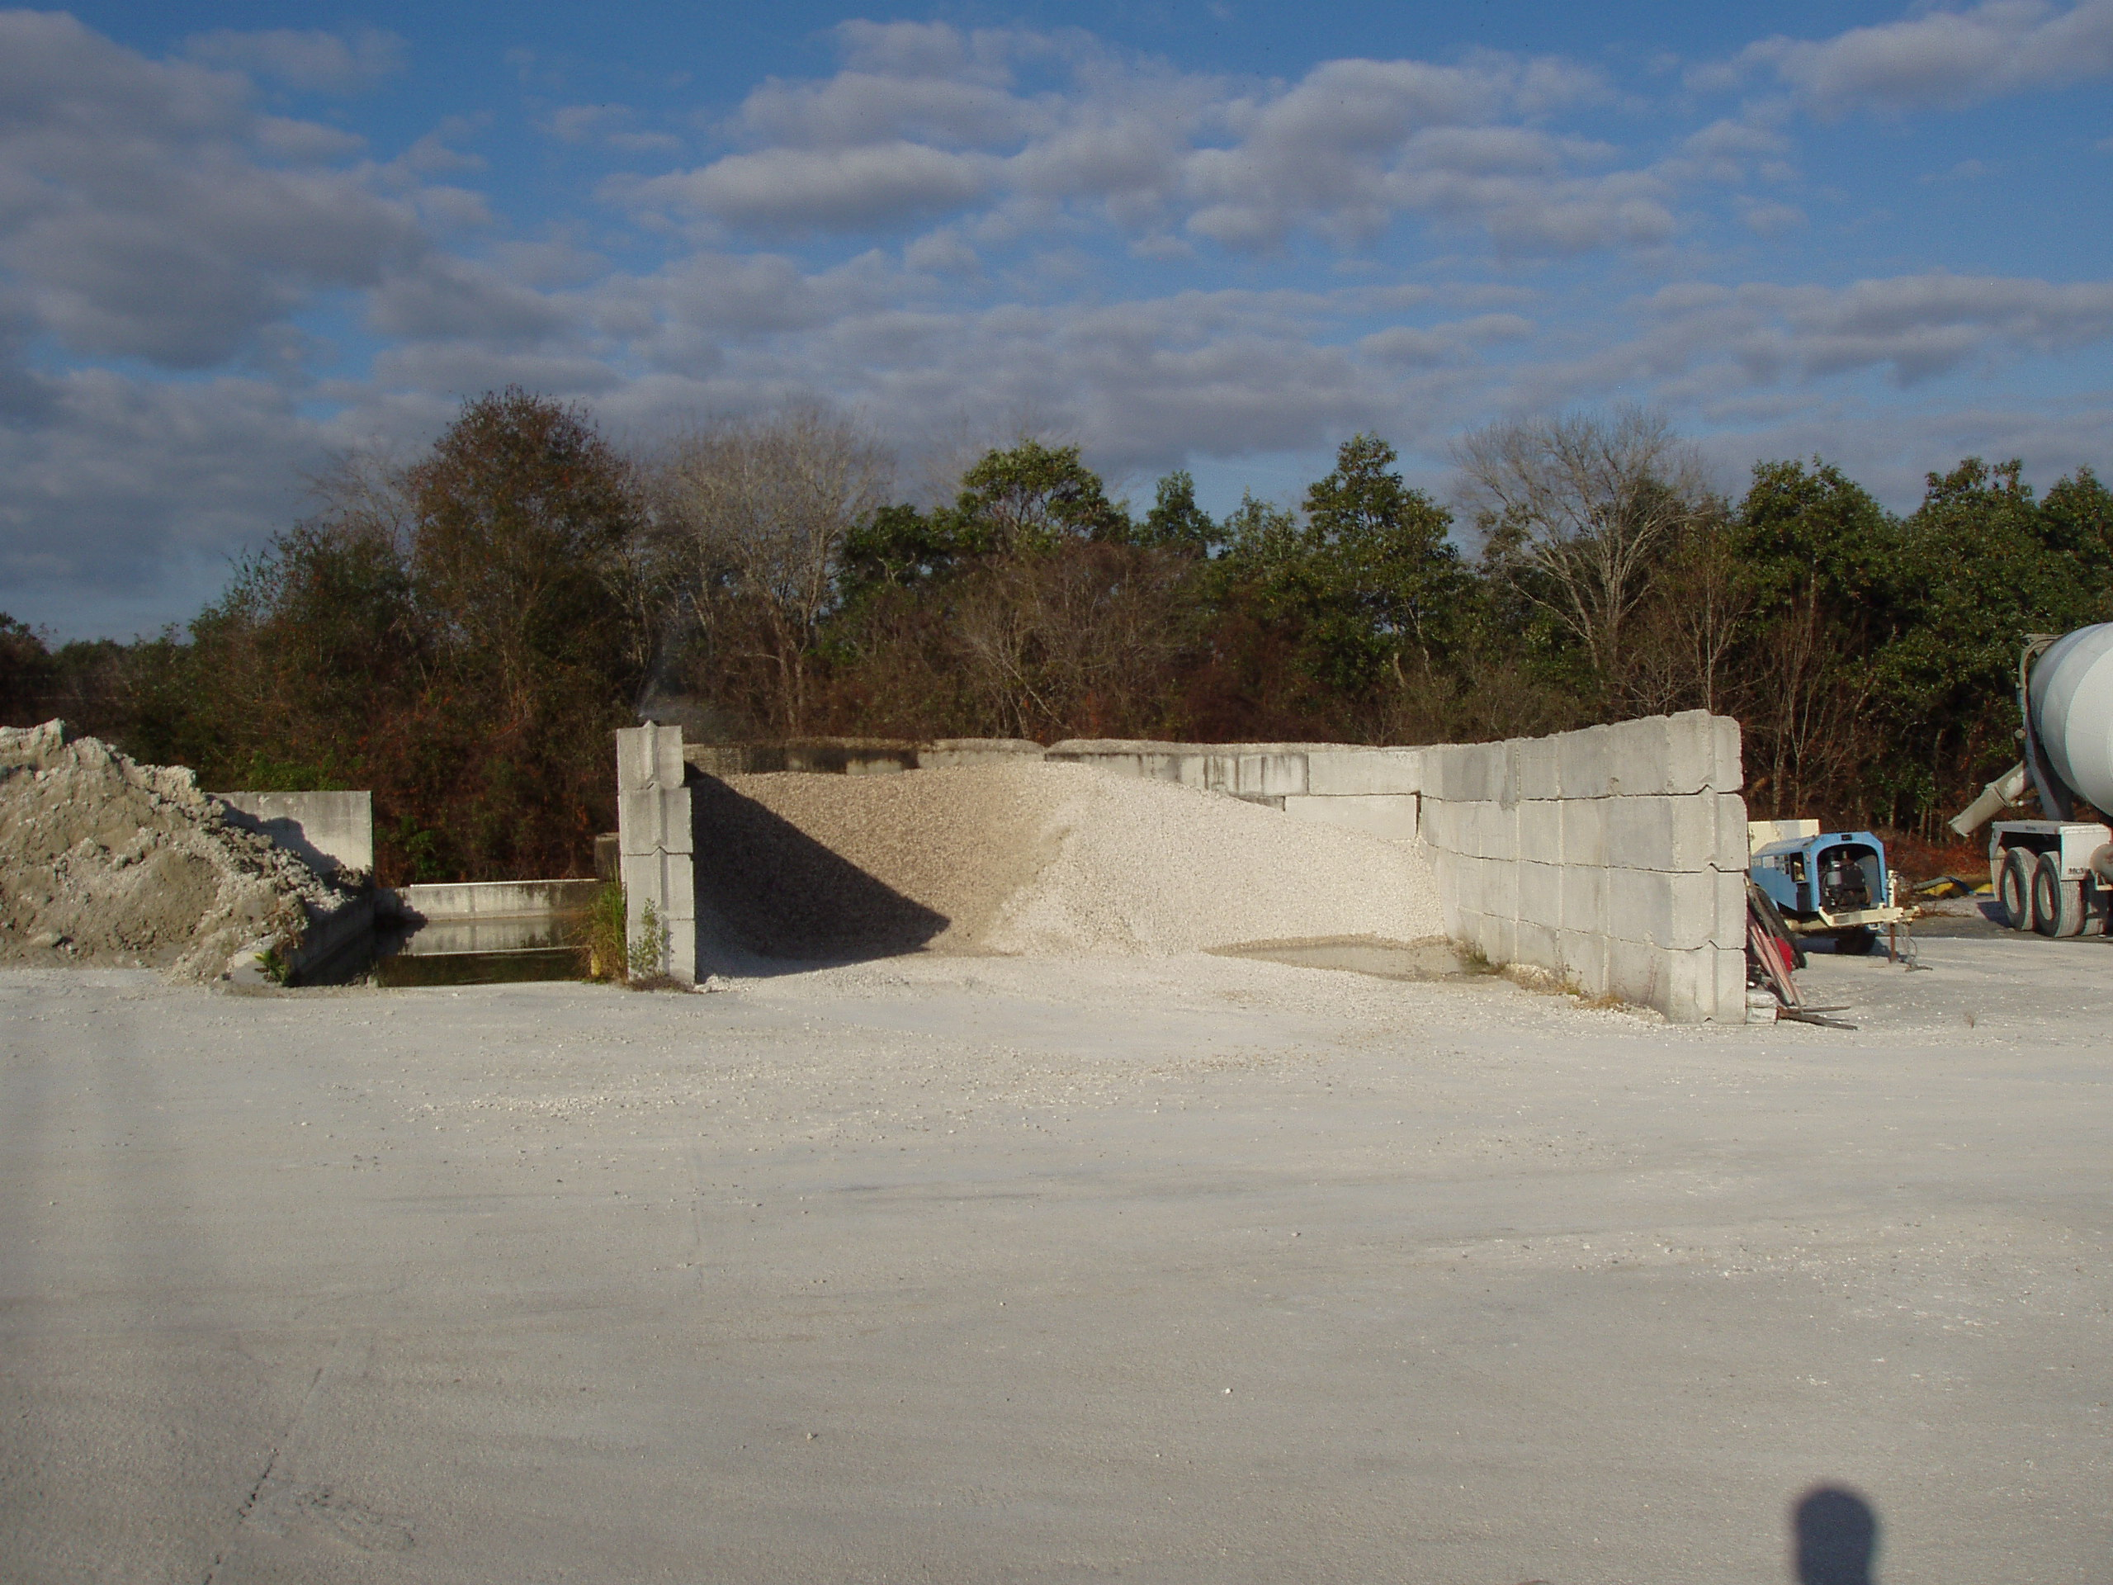
Photo ID No: P01172012-2/Time – approx. 09:05 A.M. T. Bower Enterprises, Inc., facility. (photo 01/17/2012).

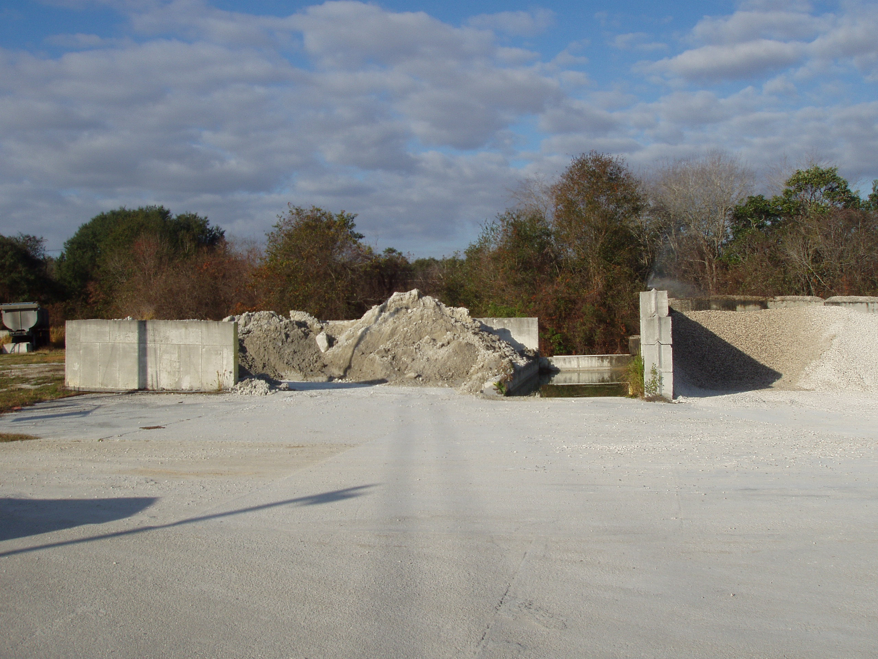
Photo ID No: P01172012-3/Time – approx. 09:05 A.M. T. Bower Enterprises, Inc., facility. (photo 01/17/2012).

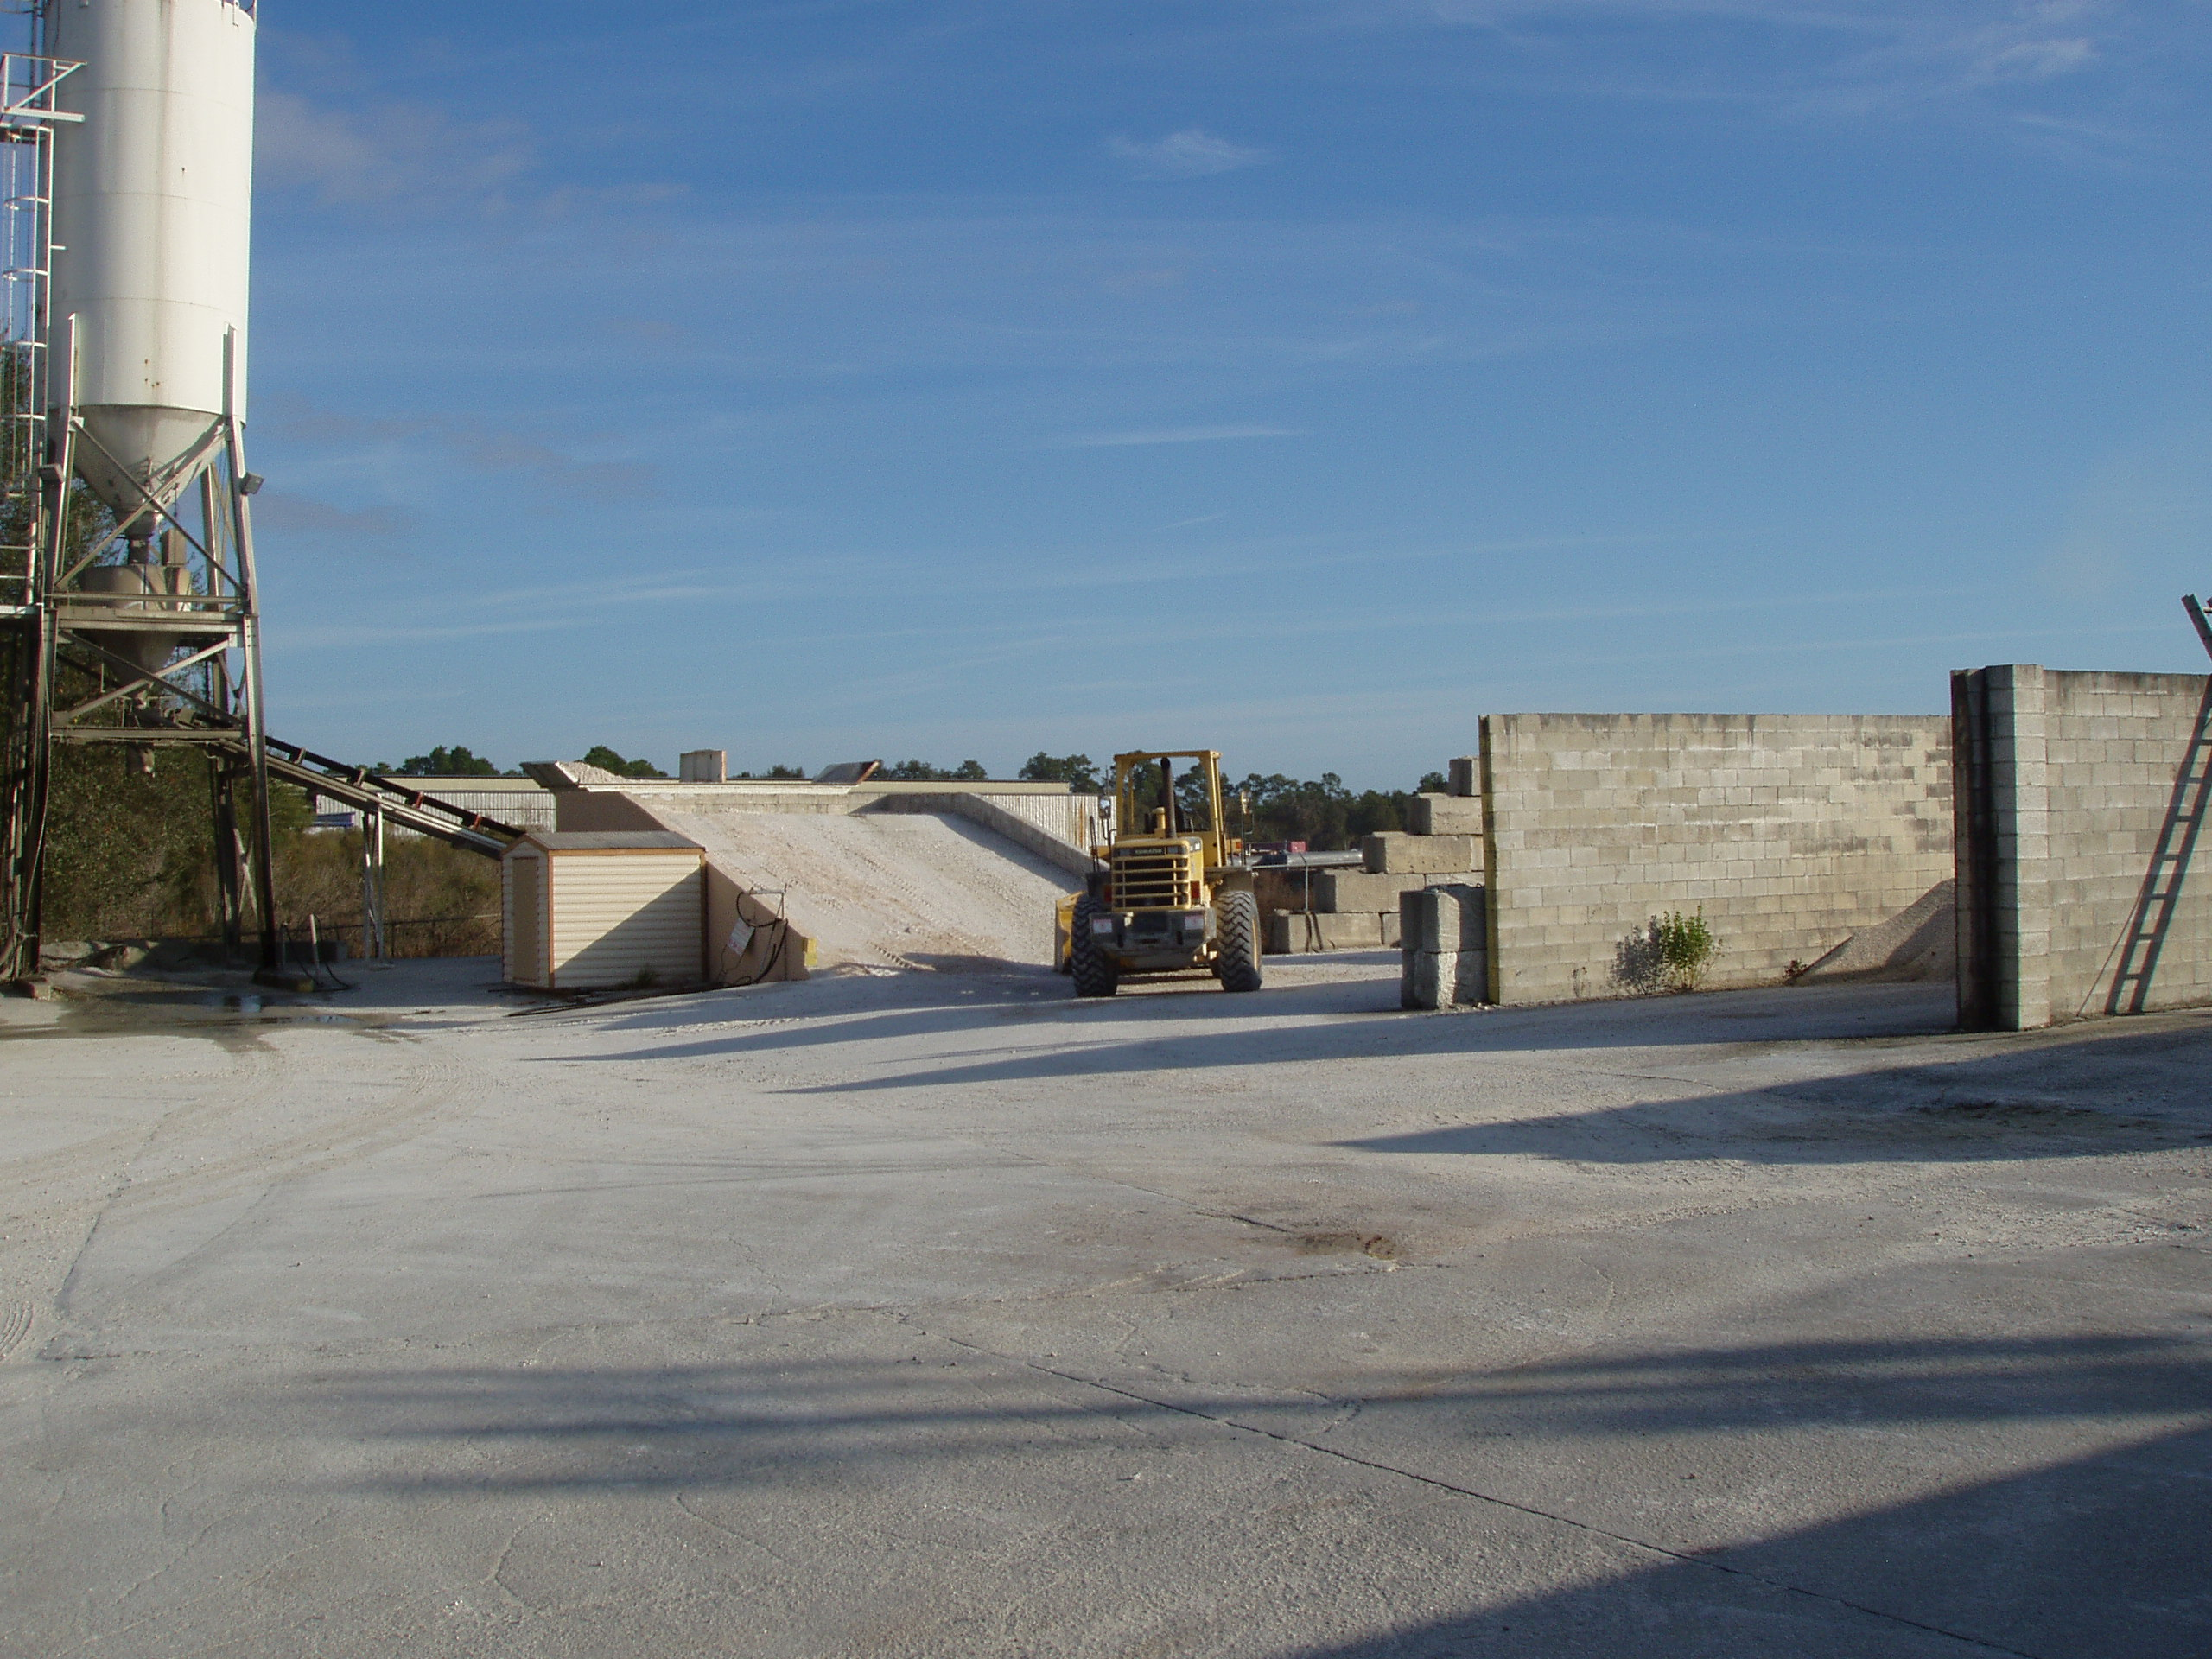
Photo ID No: P01172012-4/Time – approx. 09:05 A.M. T. Bower Enterprises, Inc., facility, with view of silo on left side of photograph. (photo 01/17/2012).

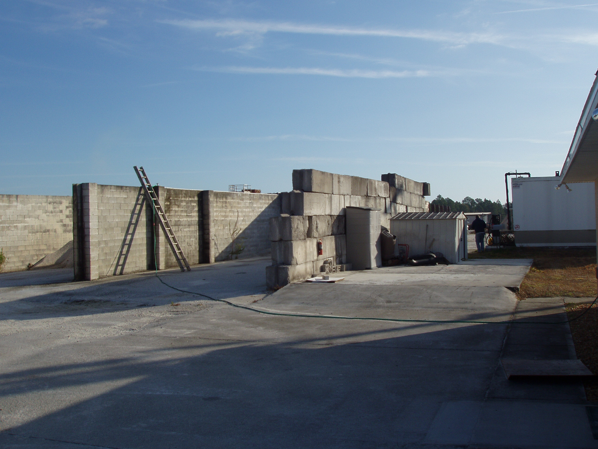
Photo ID No: P01172012-5/Time – 09:05 A.M. T. Bower Enterprises, Inc., facility. Next to where a man is standing in the photograph, there appears to be a diesel pump. (photo 01/17/2012).

####

