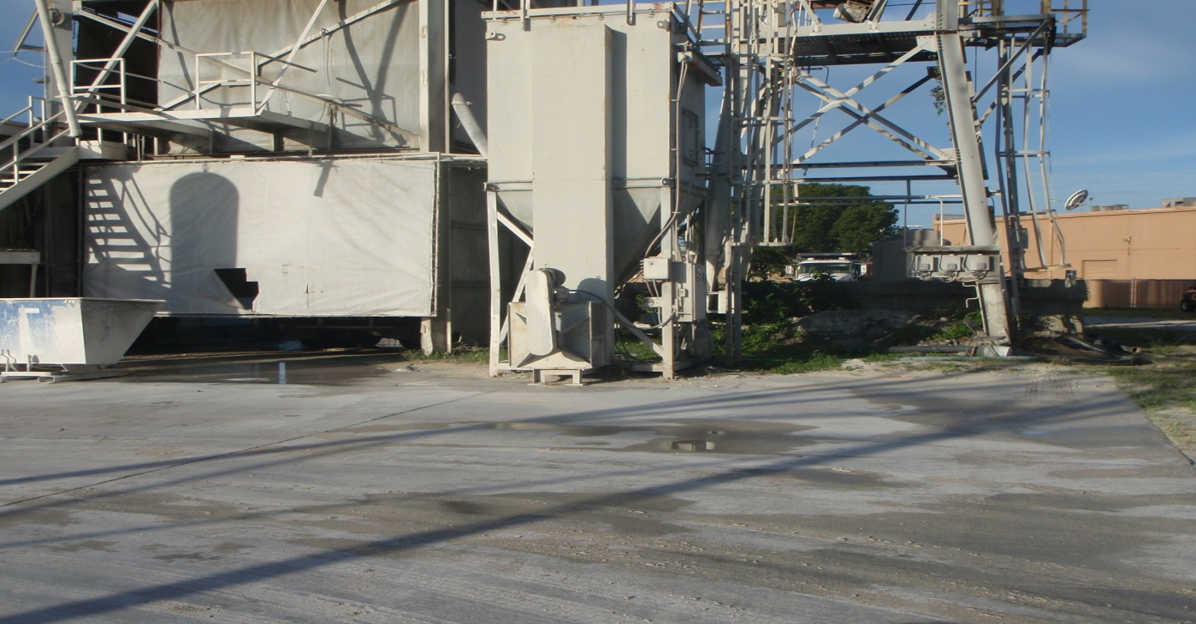
Tarmac Stuart EU-001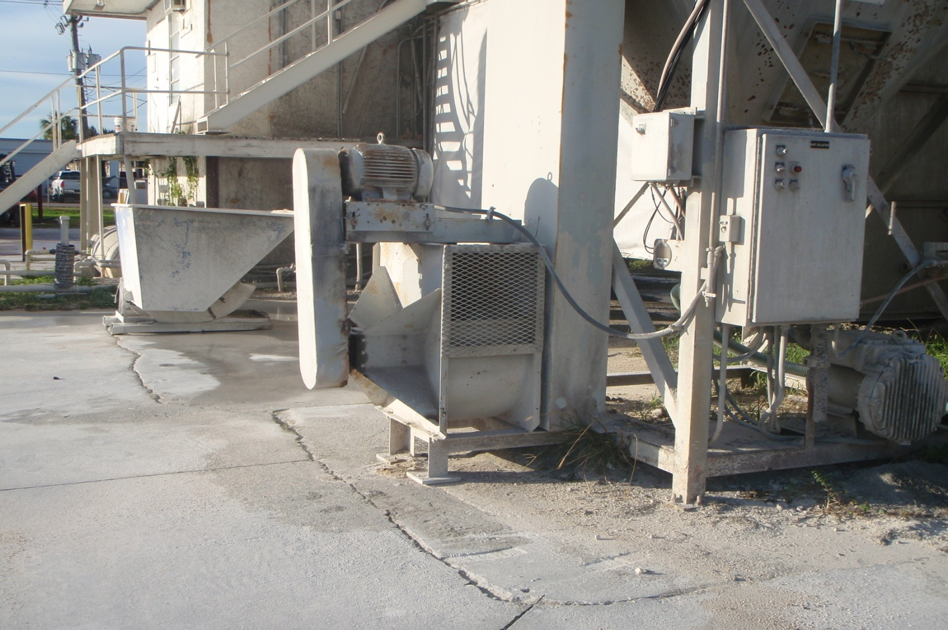
Tarmac Stuart EU-001 Emission Point

