CEMEX Construction Materials
Facility Id# 1050114 09/23/2008 INS 2
By Wendy D. Simmons

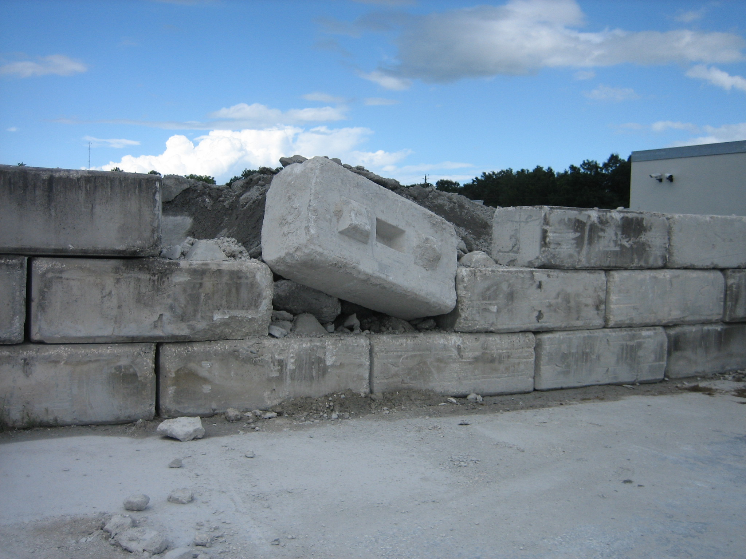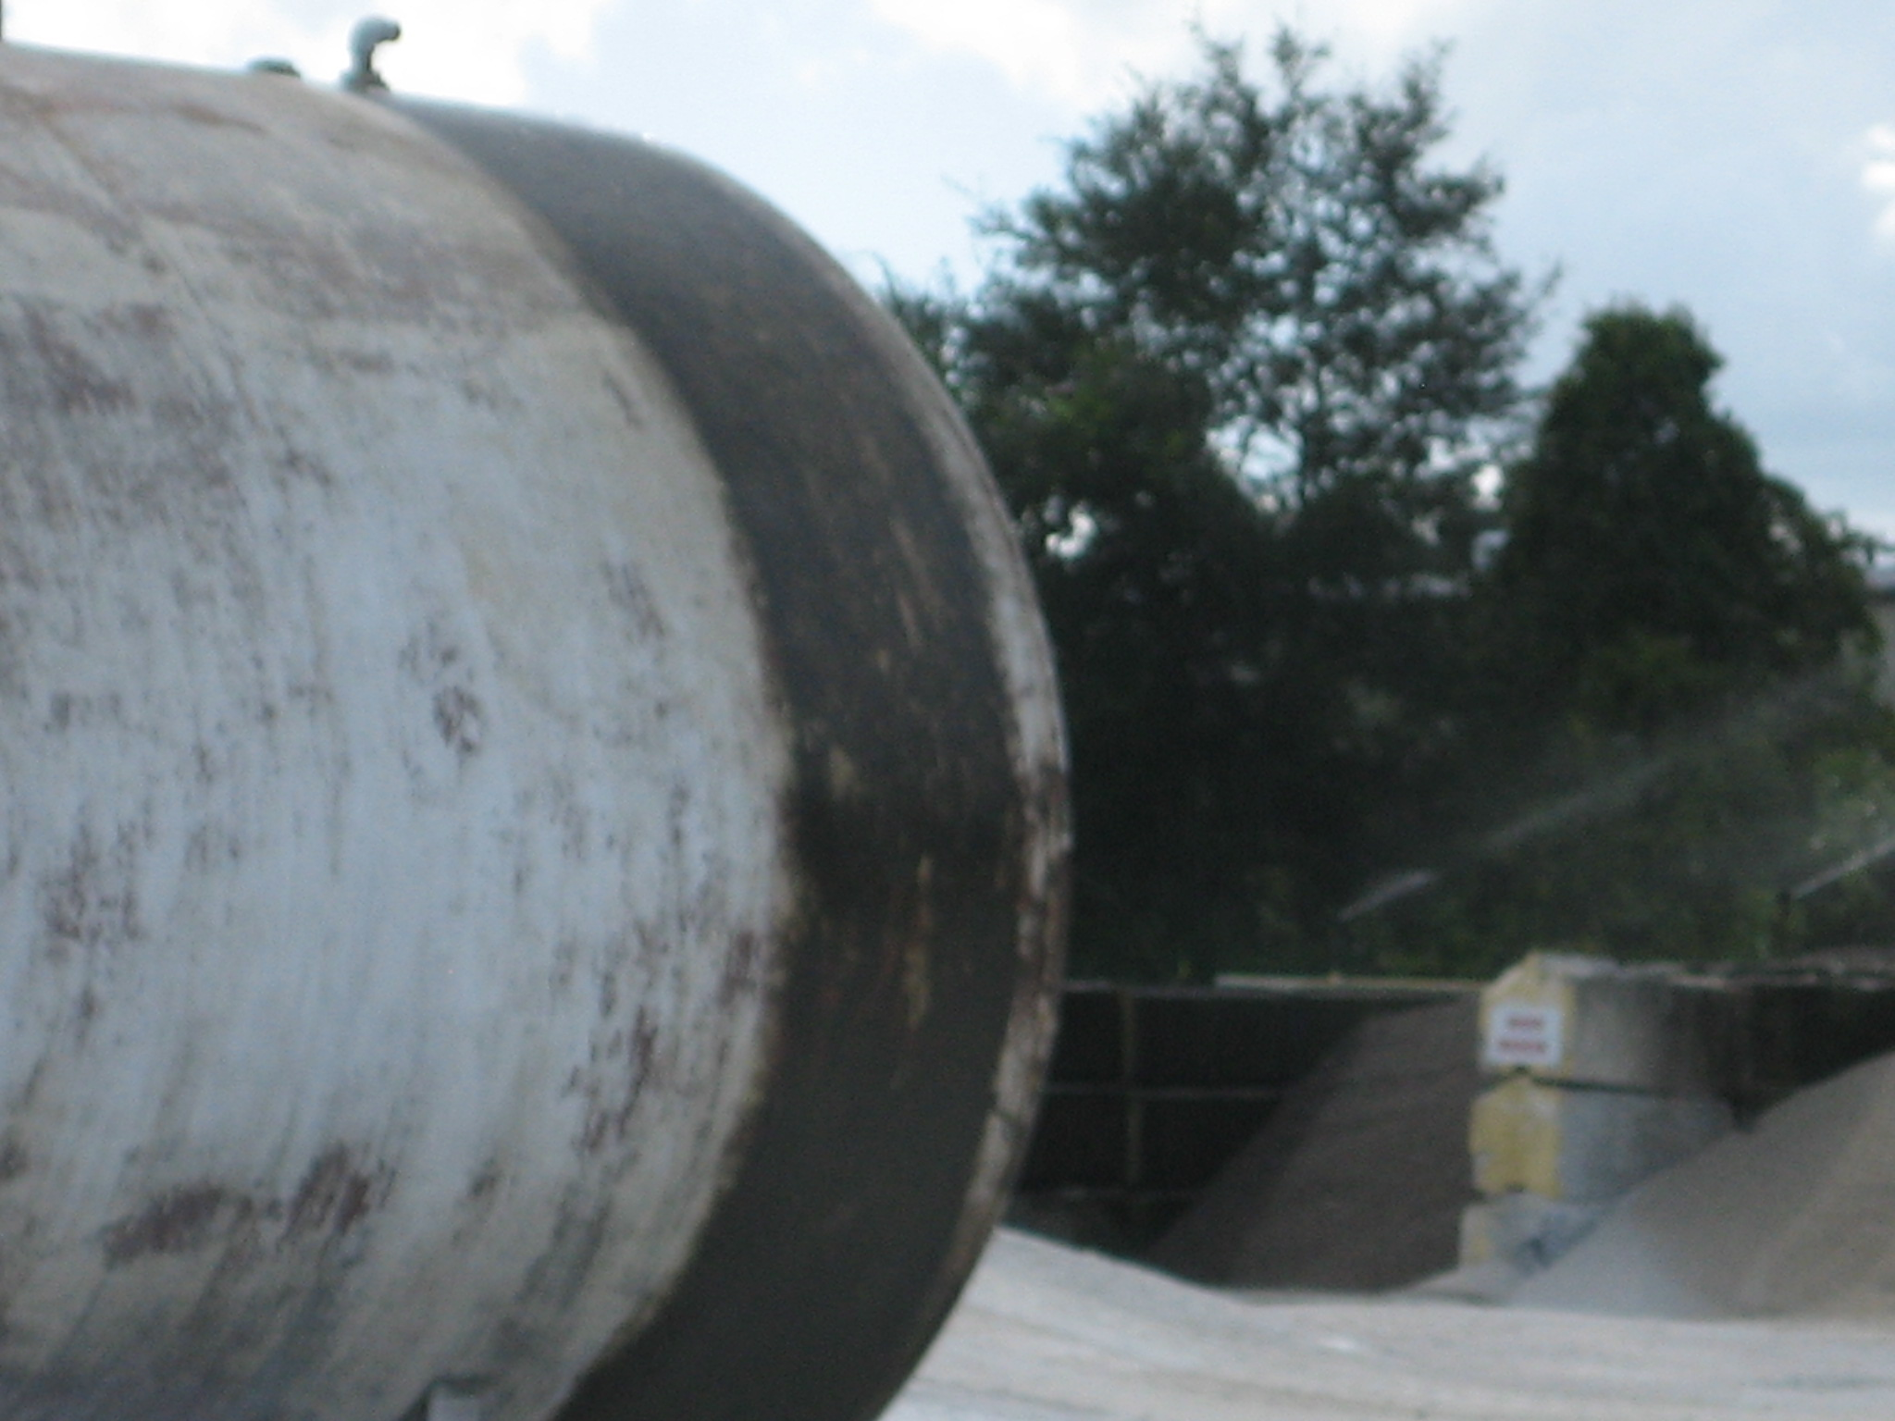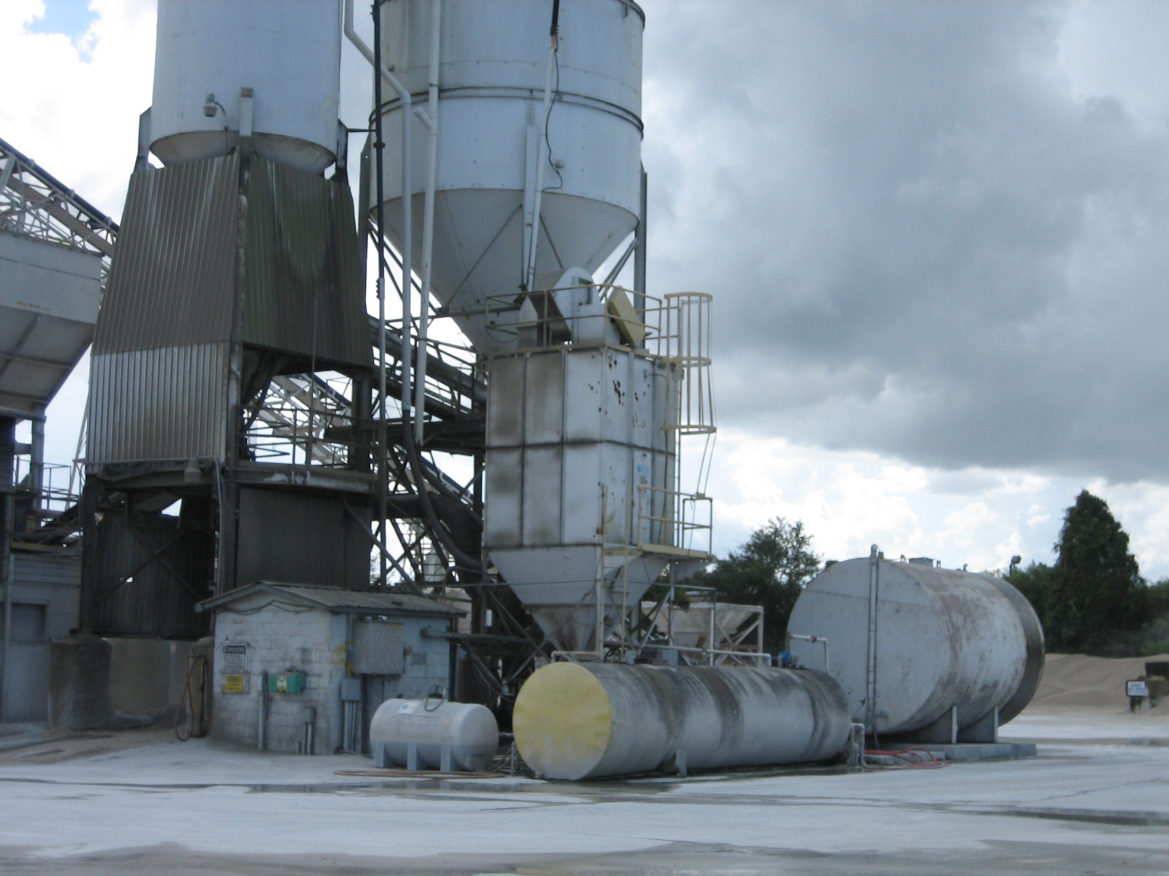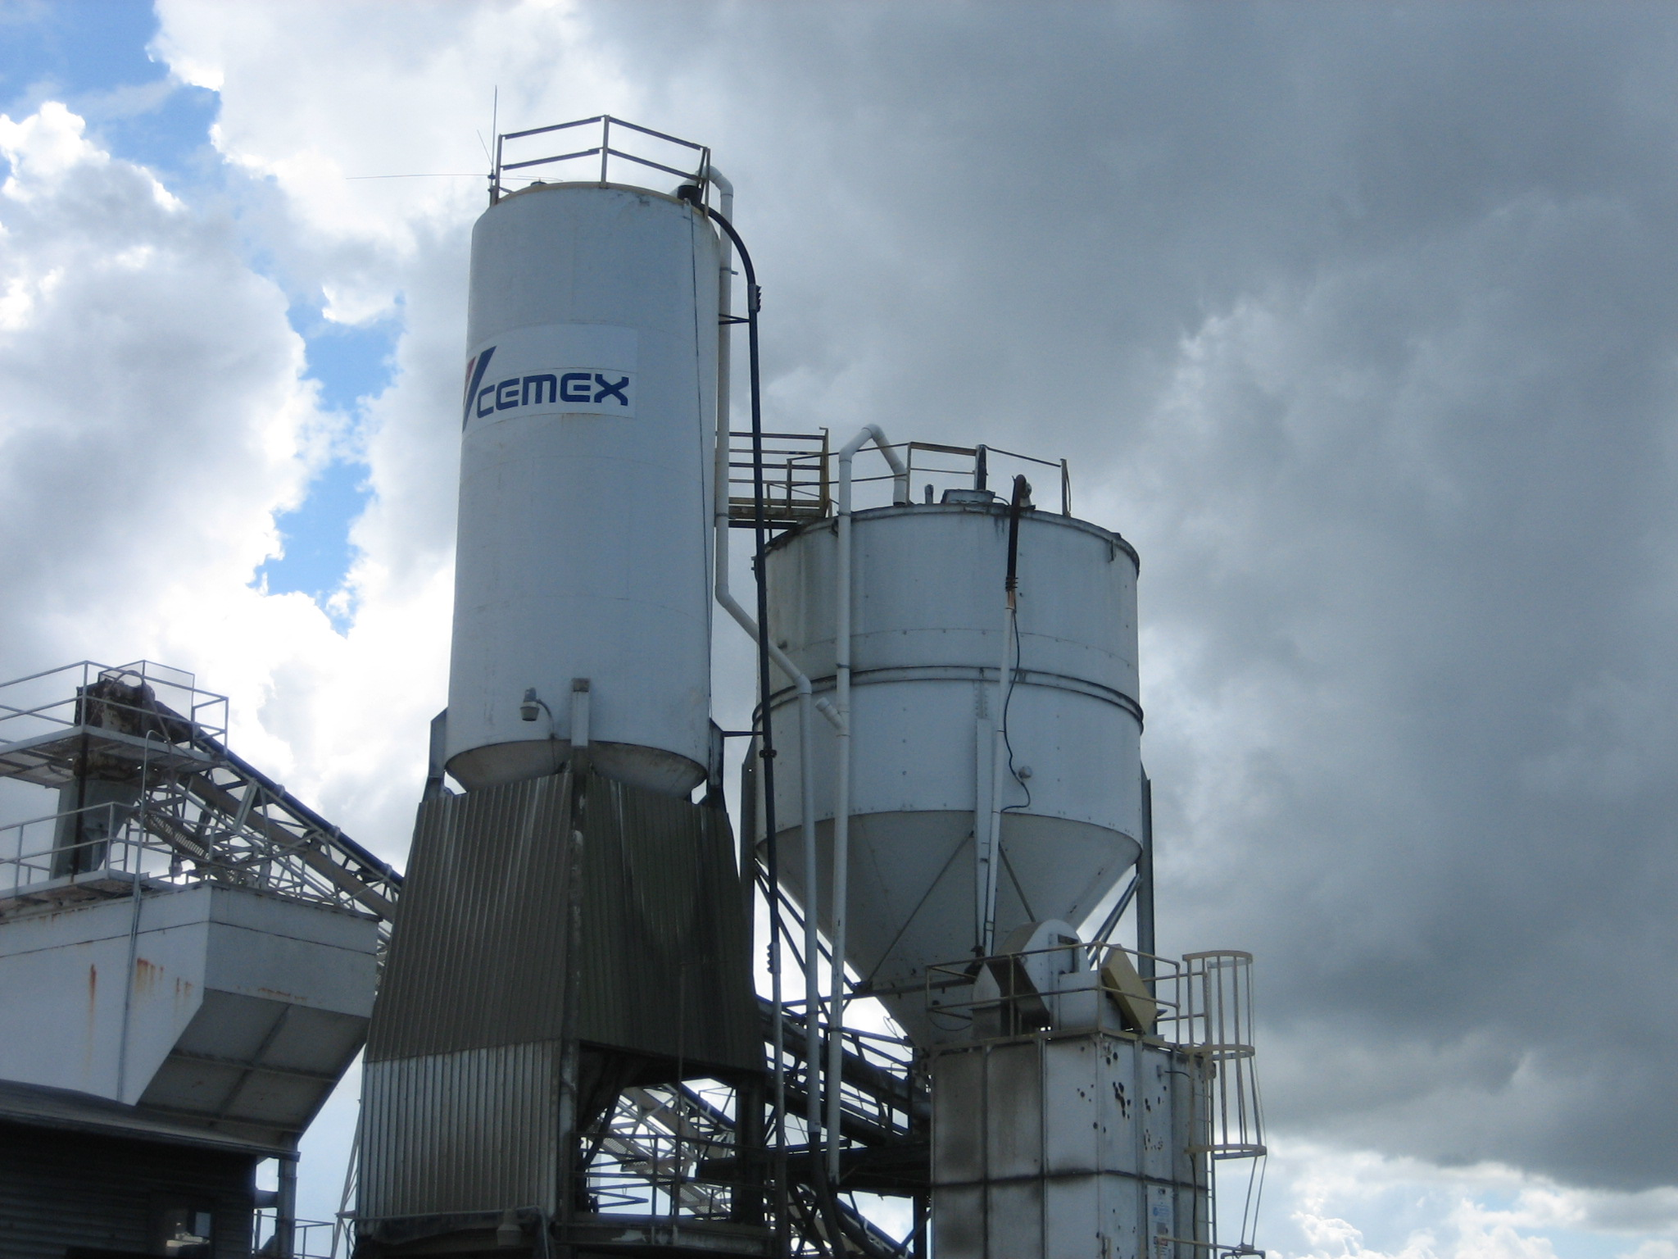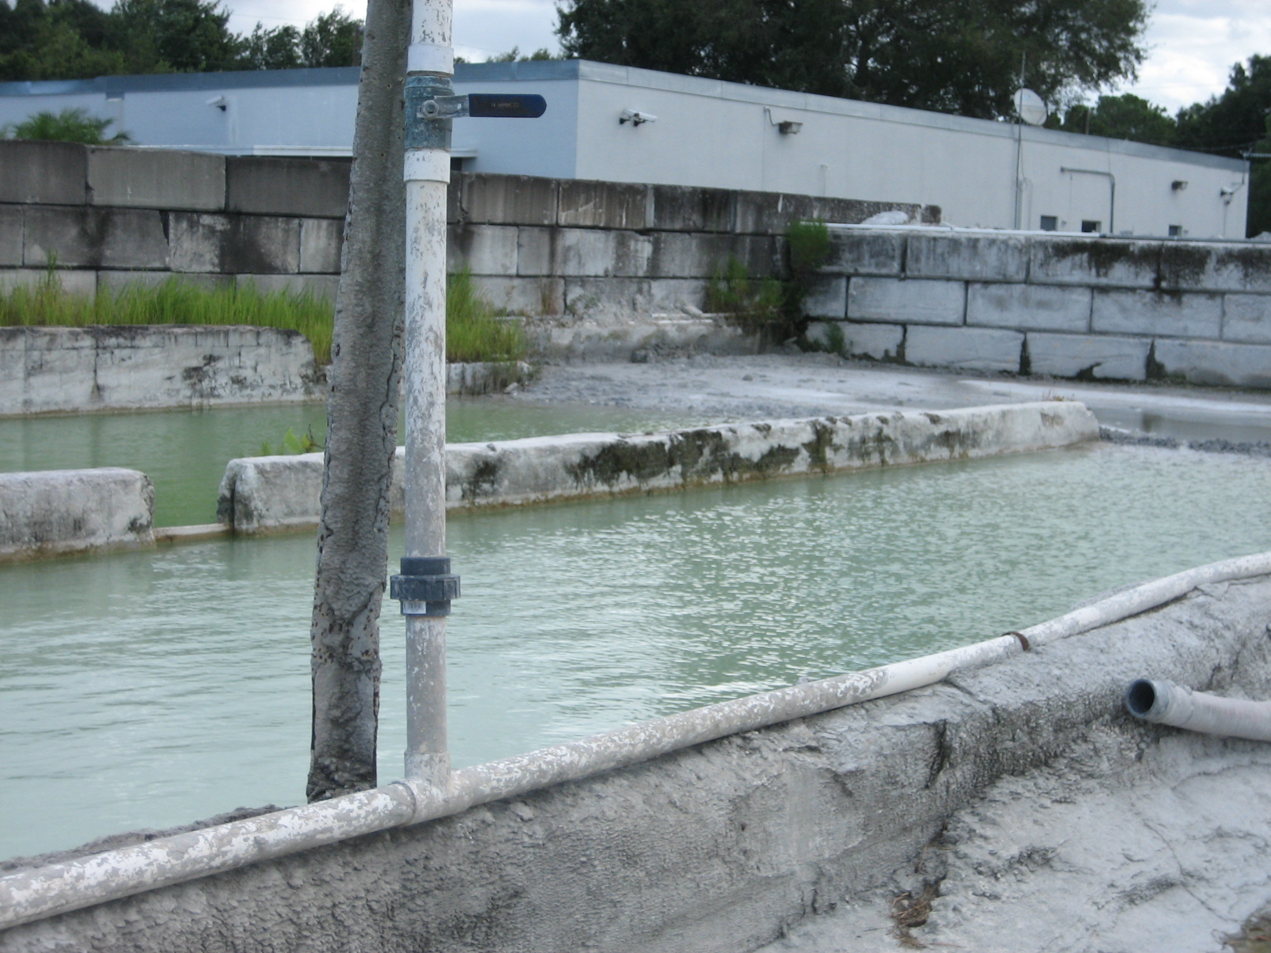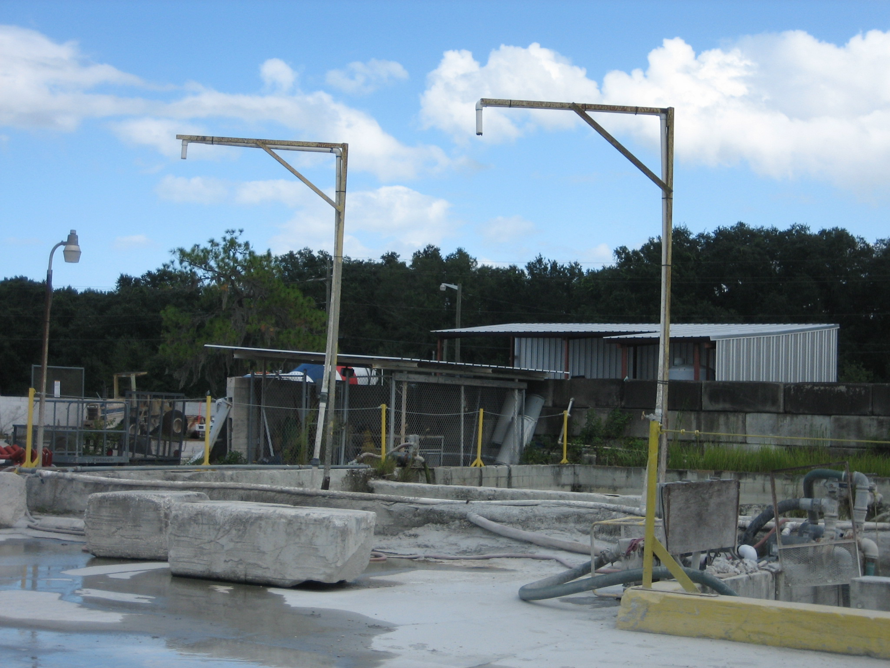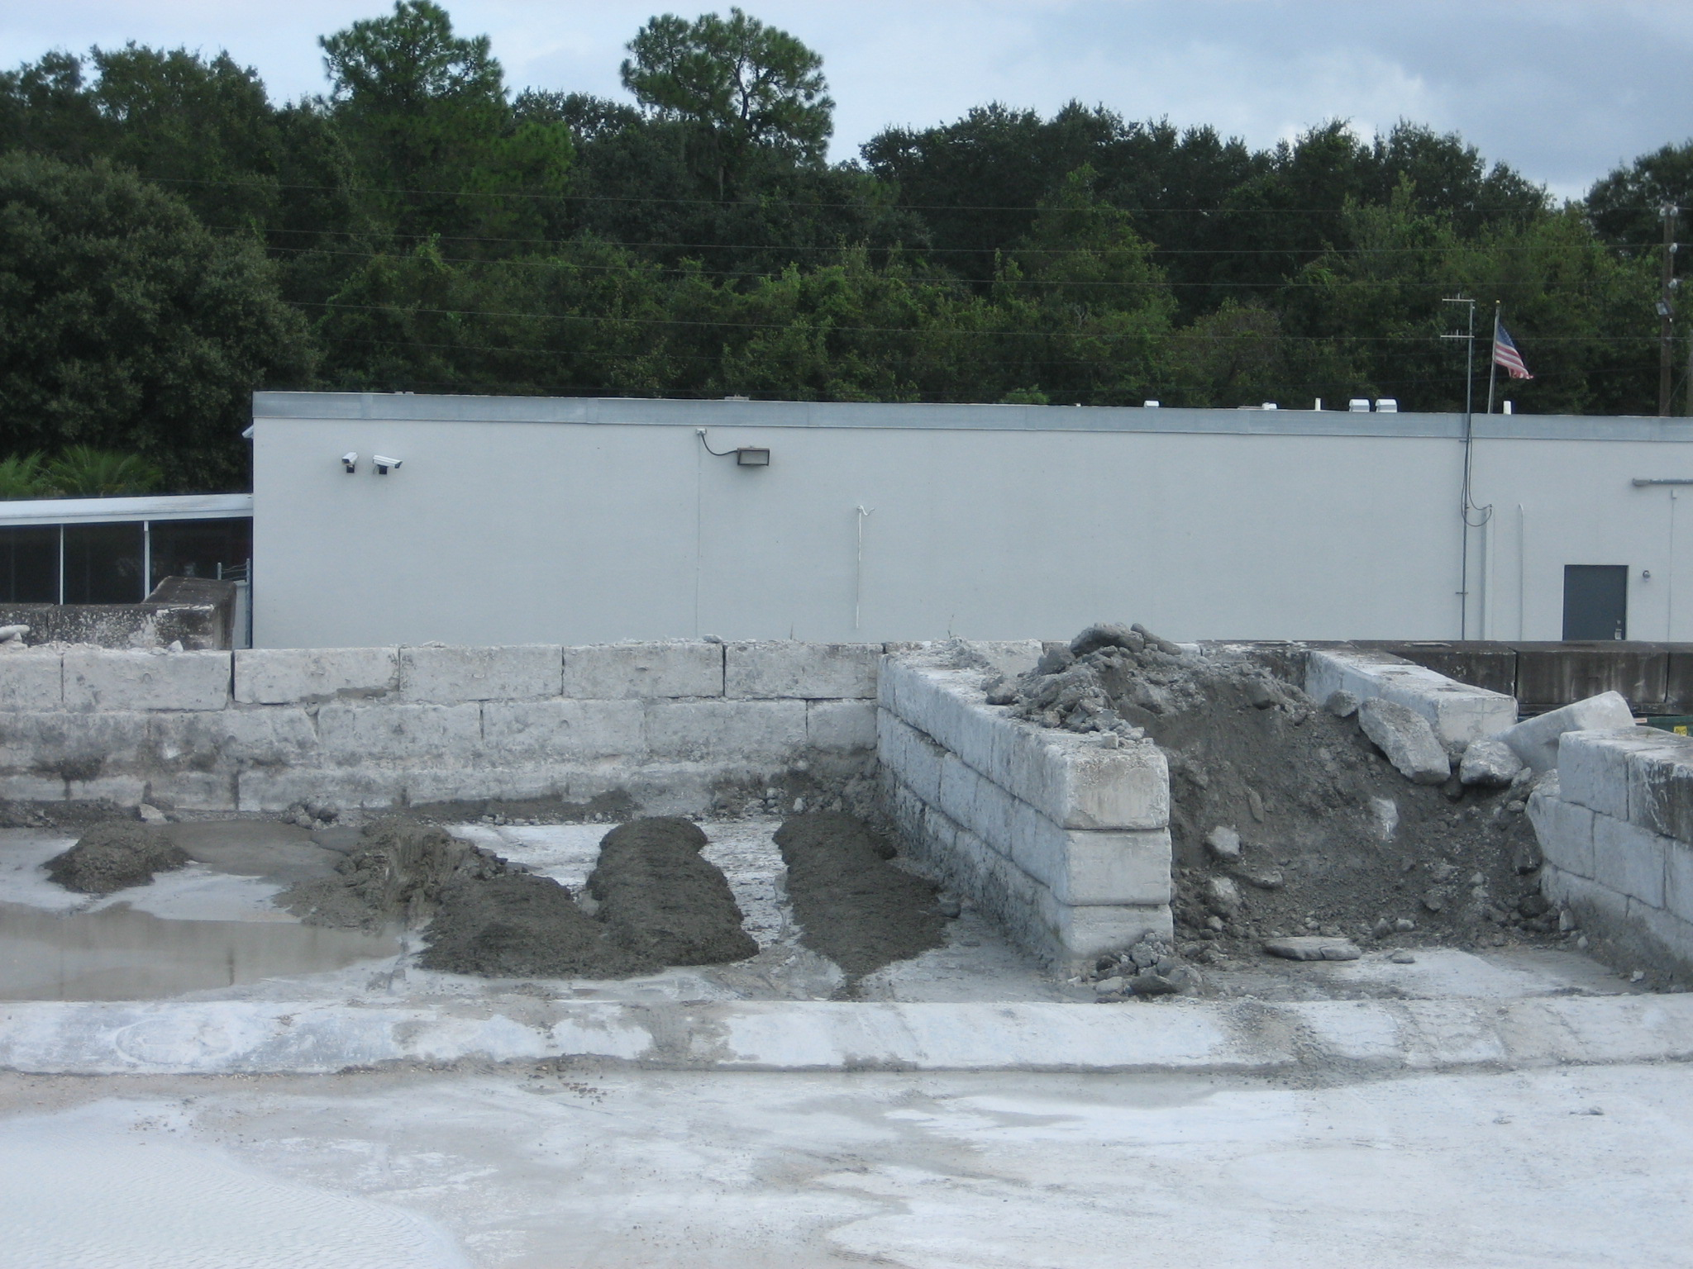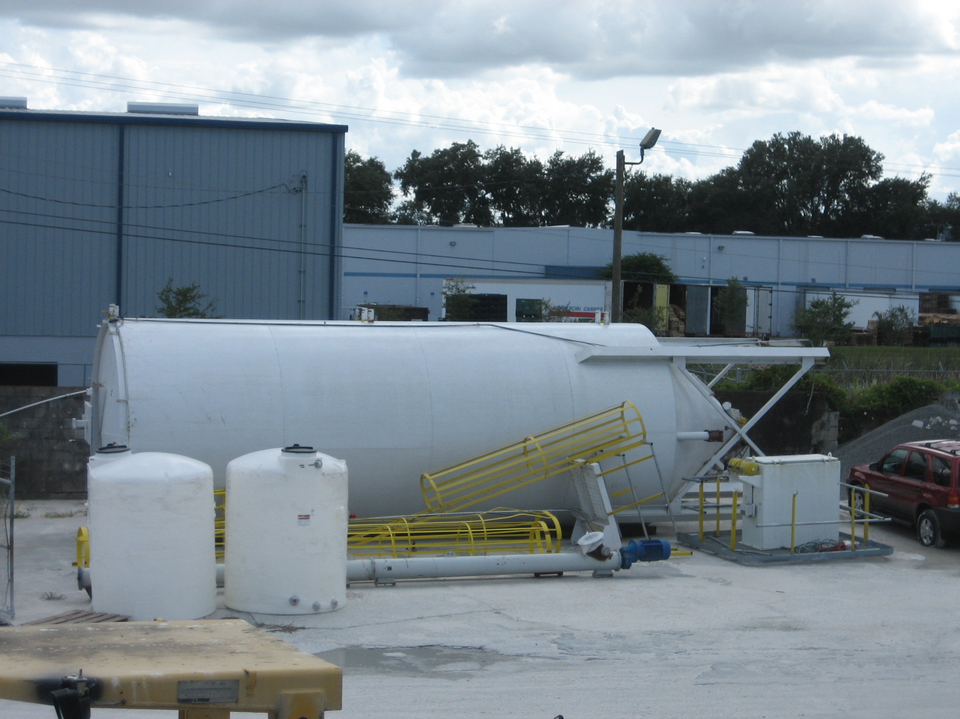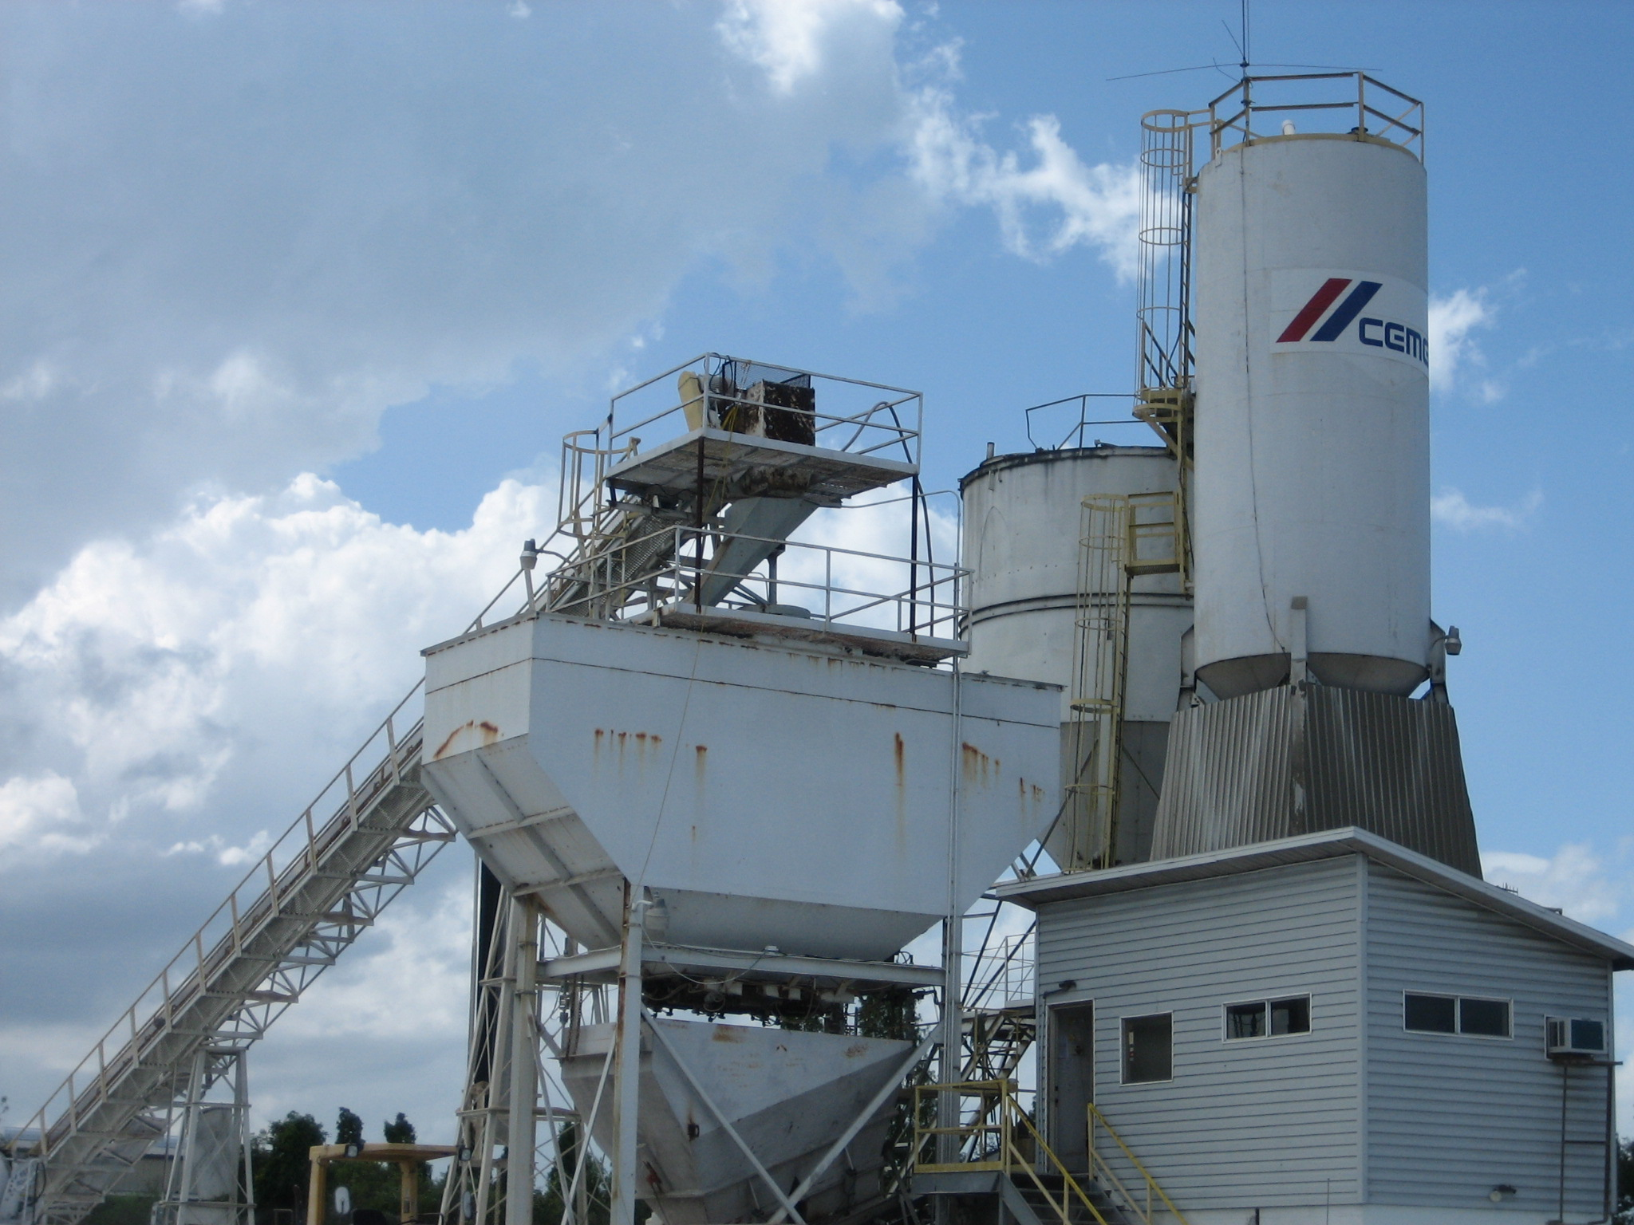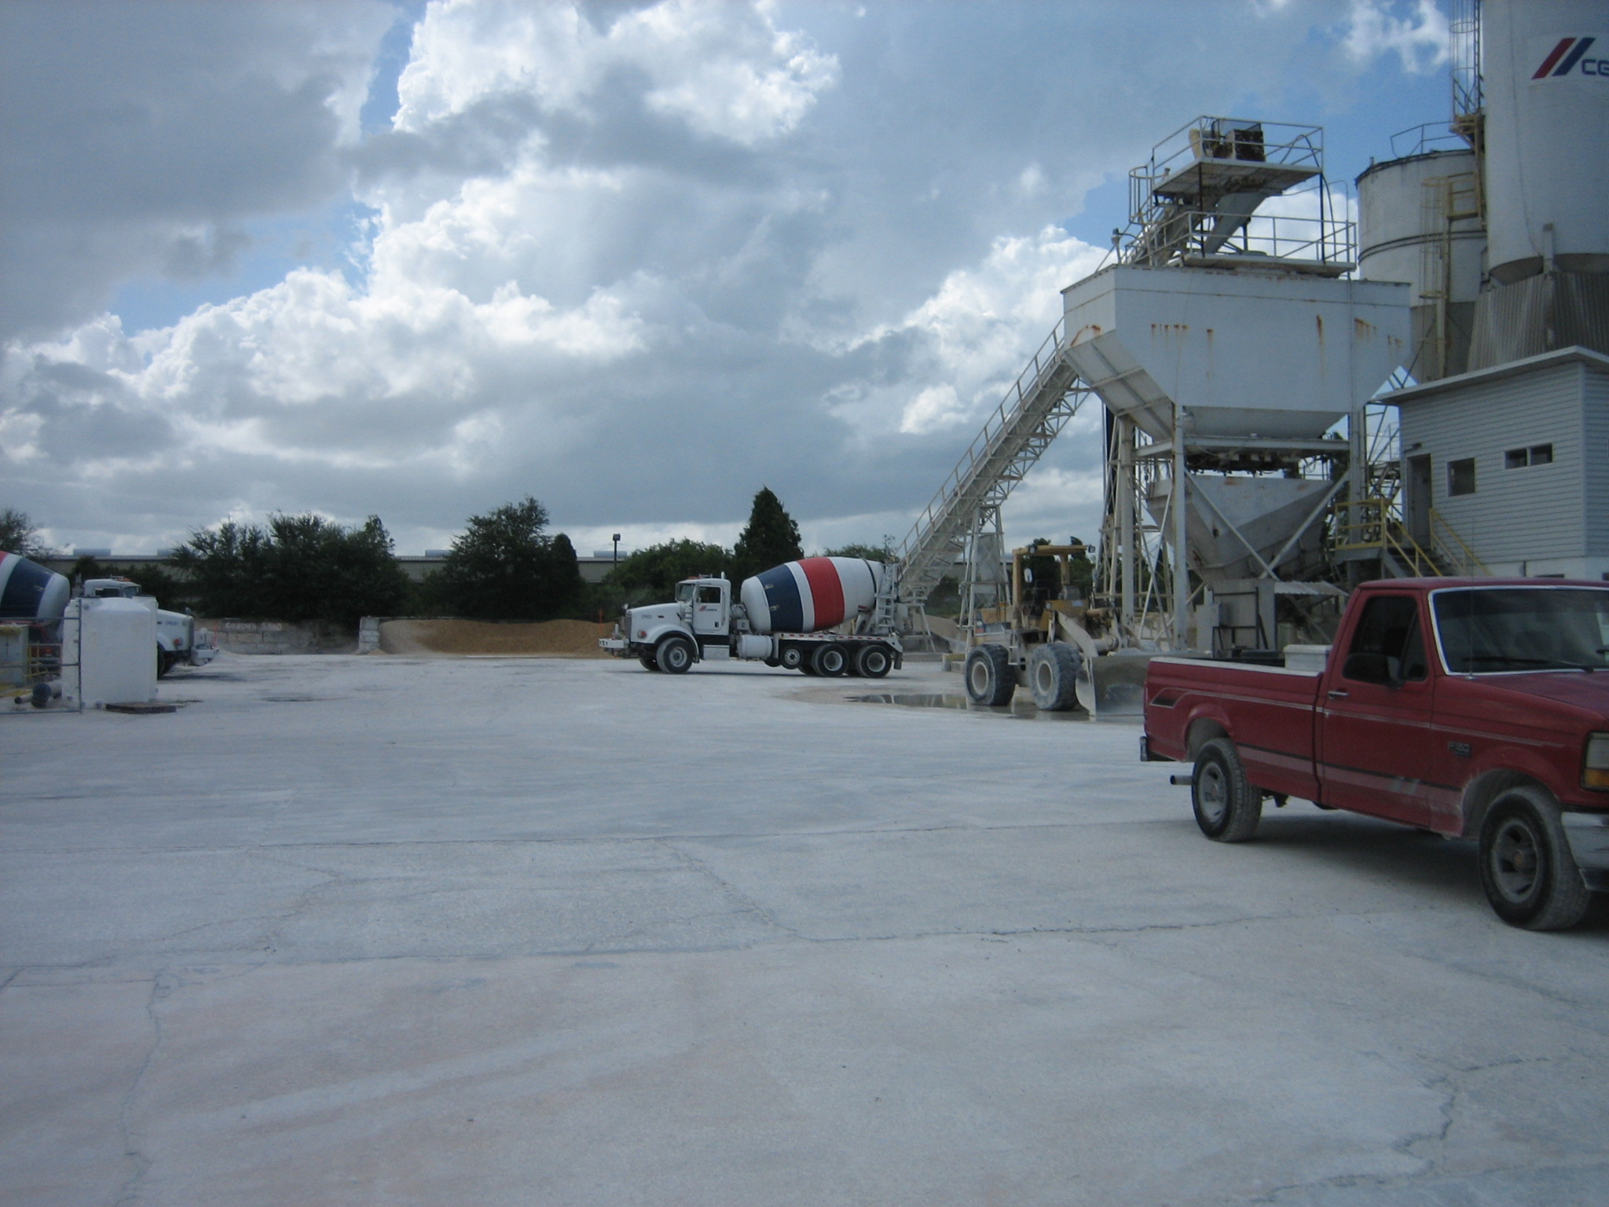
Wind breaks on Aggregate piles.
Sprinklers in operation.
Central Dust Collector controls all.
Two silos, no silo top dust collectors.
Silo on Right will be replaced soon.
Water Reclamation area.
Truck wash area.
Product reclamation area.
Newly registered silo and silo top dust collector.
Current silos, no silo top dust collectors.
Paved roadways.

