DIGITAL PHOTOGRAPHIC LOG

- Facility Name: CEMEX, Inc. Id# 0810043
- Facility Address: 4415 15th Street East, Bradenton, FL 33508
- County: Manatee County
- Inspection Type: INS 2
- Inspection Date: 01/27/2009
- Were the photos altered?: NO_X__ YES_____ explain yes:
- Photographer: Wendy D. Simmons
- Signature of Photographer:______________________________________________

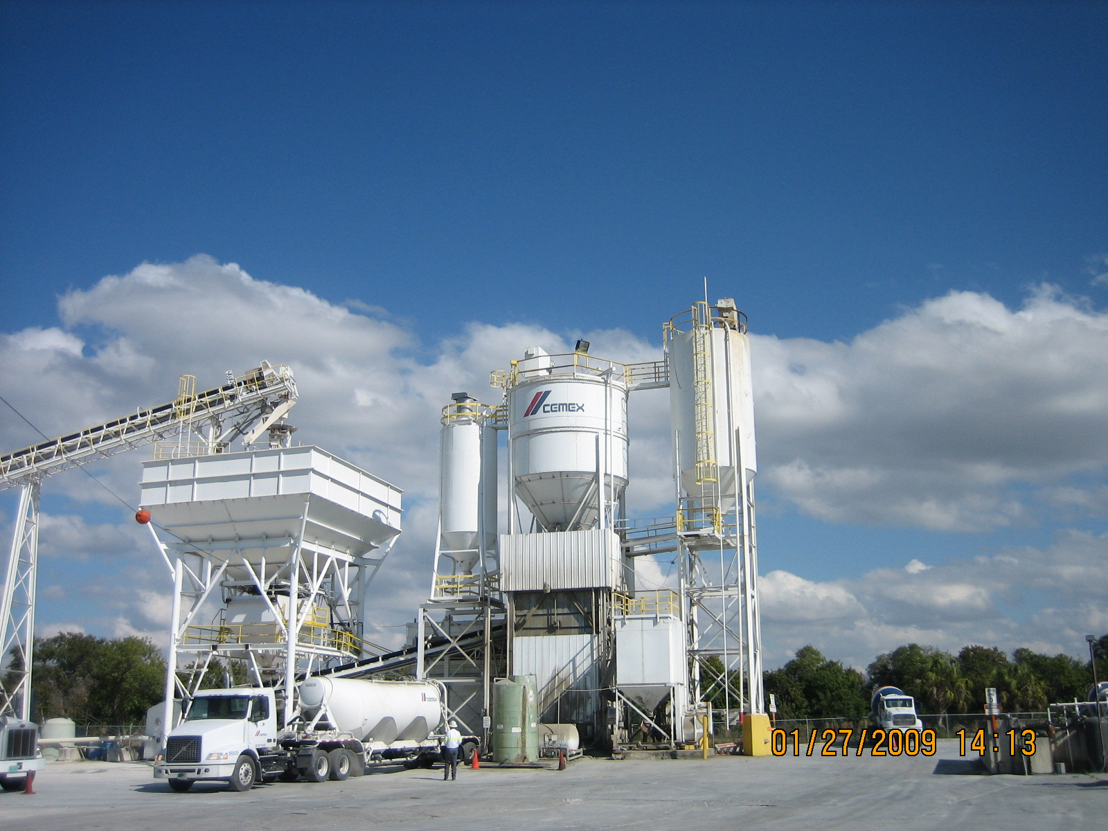
Photo ID No: IMG_0009/2:13pm – Full view concrete batch plant

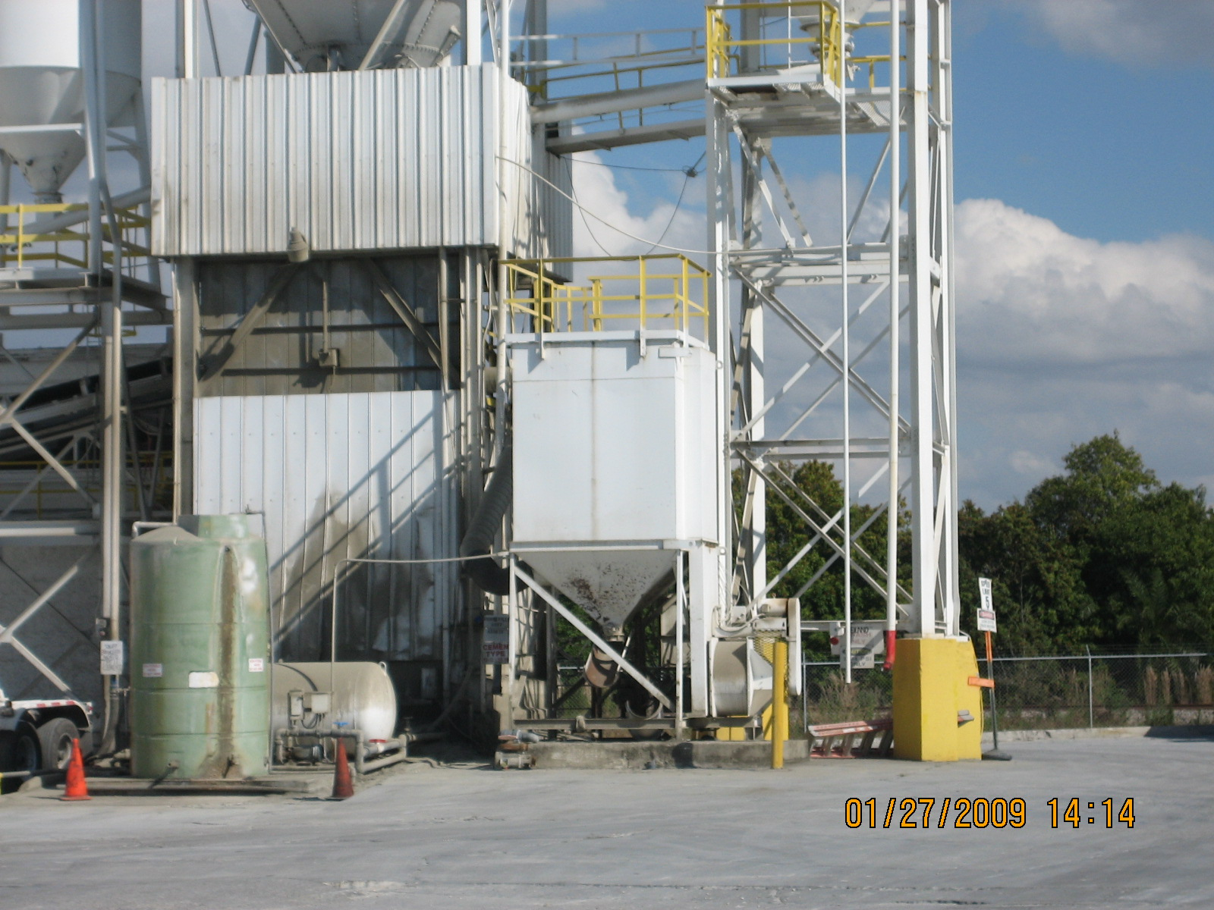
Photo ID No: IMG_0011/2:14pm – Central Dust collector that controls weigh hopper and truck load out.

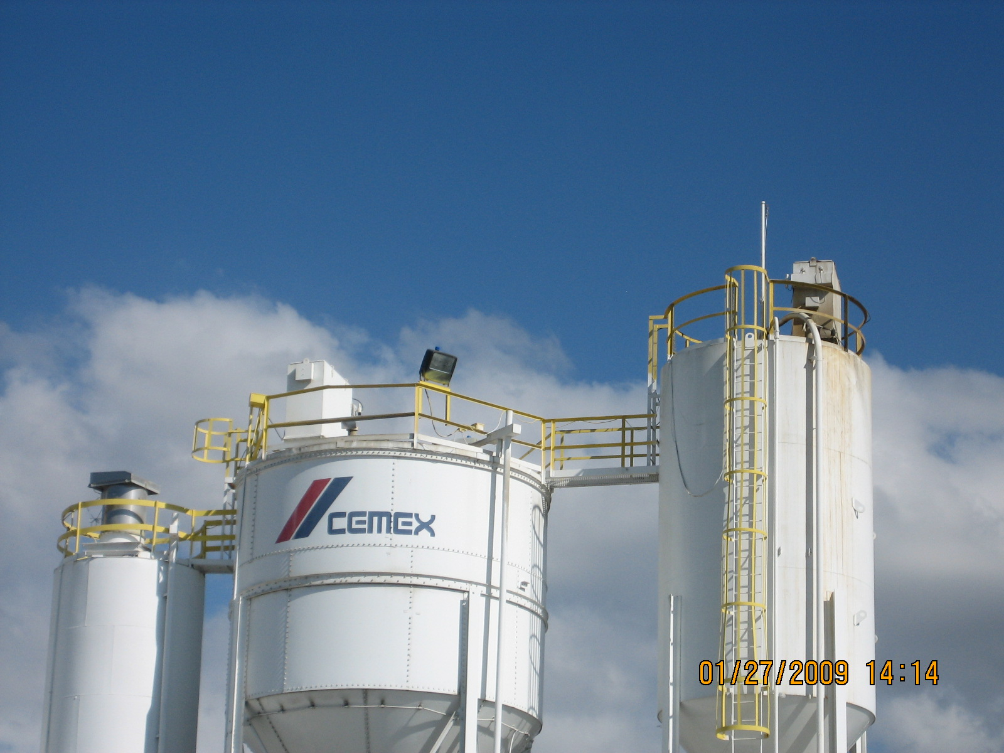
Photo ID No: IMG_0010/2:14PM – Silo top baghouses

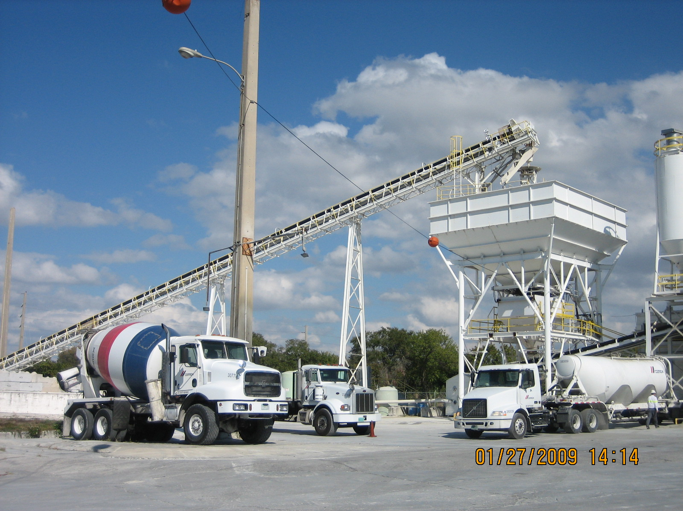
Photo ID No: IMG_0012/2:14pm – Weigh hopper and conveyors.

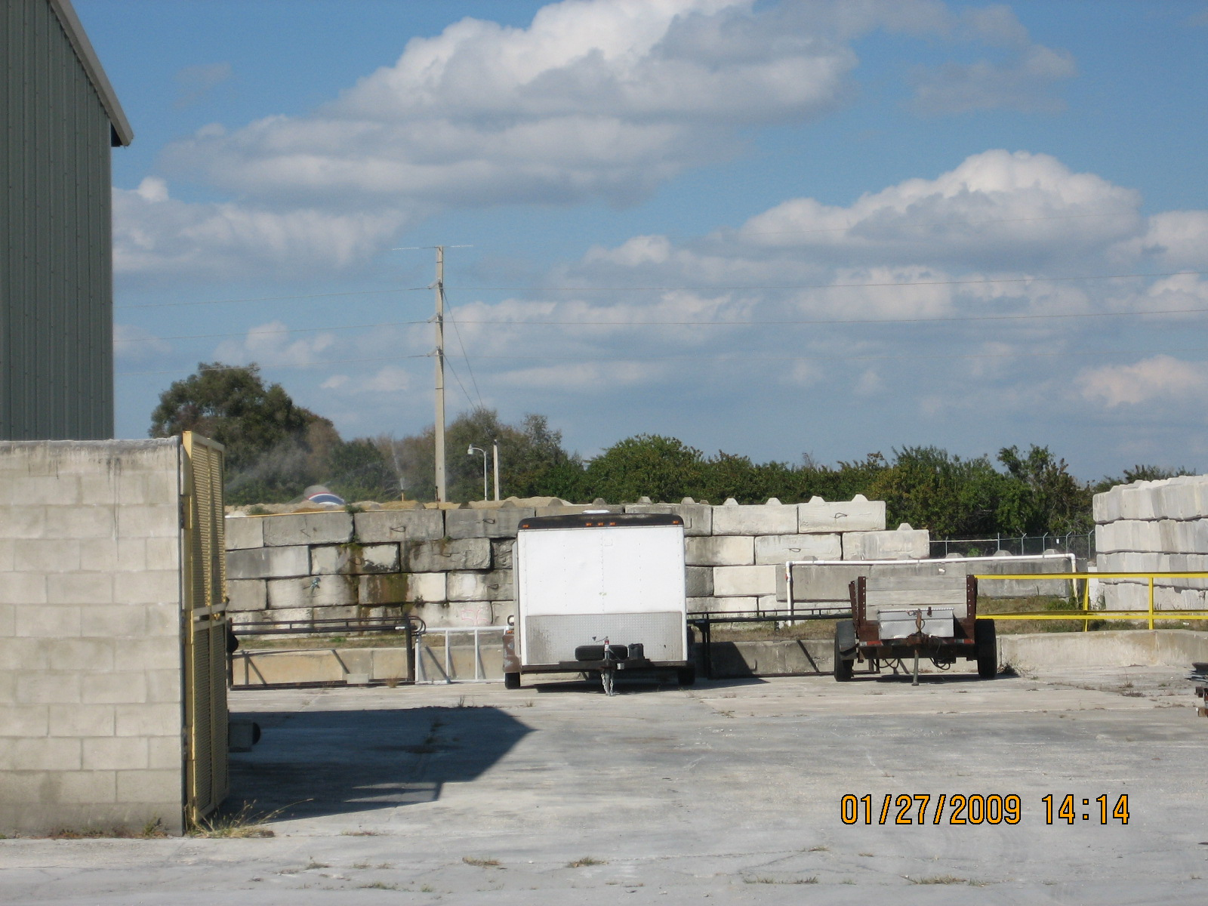
Photo ID No: IMG_0013/2:14pm – Wind breaks for aggregate piles and sprinklers.

